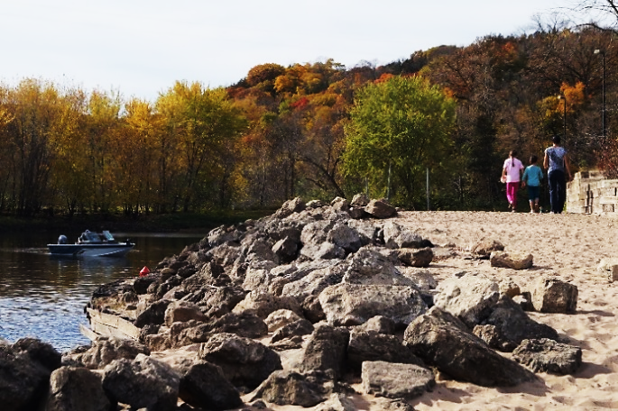
Youth & Parks Activity
Youth Serving Organization:
Park Agency:
Location:
10:00 am: Arrival at park. Gather, review schedule for the day
10:15 am: Environmental Science badge work with Naturalist
12:00 noon: Lunch at pavilion
1:00 pm: Sports time
2:00 pm: Group 1 – Field research challenge/park audit
Group 2 – Snack, small group focus group
3:00 pm: Group 1 – Snack, small group focus group
Group 2 – Field research challenge/park audit
4:00 pm: End of activities, depart for home

Youth & Parks Research Partnership

Schedule for Afternoon Field Research and Park Fun

Sample Schedule (half day experience)

Youth & Parks Activity
Date:
Youth Serving Organization:
Park Agency:
Location:
1:00 pm Arrive at Park, Icebreaker activity
1:30 pm Camera basics: How to take photos of nature and people in nature
2:00 pm Photo contest around the park/Parent conversation indoors
3:00 pm Food: Pizza, wings, fruit. Photo contest prizes and small group activity to talk about photos, park experience
4:00 pm Bonfire and story circle
5:00 pm Activity ends
Please make sure to dress for the weather. Some activities will be held outside.

