parks and trails policy recommendations from community leaders

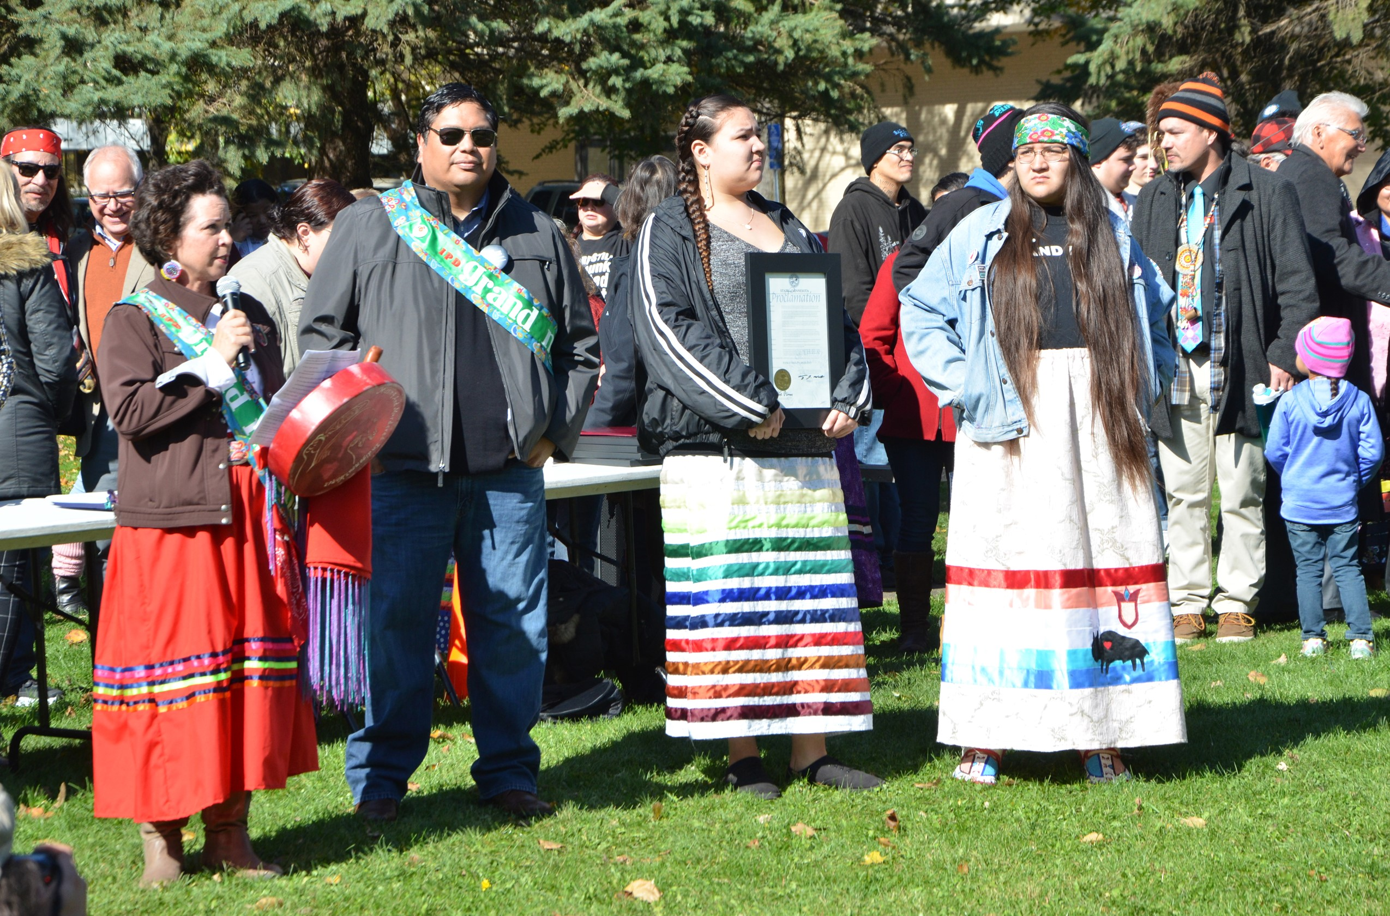

**Regional vision**

A prosperous, equitable, and resilient region   
with abundant opportunities for all to   
live, work, play, and thrive.

# Regional core values

## Equity | Leadership | Accountability | Stewardship

# Regional goals

## Our region is equitable and inclusive

Racial inequities and injustices experienced by historically marginalized communities have been eliminated; and all people feel welcome, included, and empowered.

## Our communities are healthy and safe

All our region’s residents live healthy and rewarding lives with a sense of dignity and wellbeing.

## Our region is dynamic and resilient

Our region meets the opportunities and challenges faced by our communities and economy including issues of choice, access, and affordability.

## We lead on addressing climate change

We have mitigated greenhouse gas emissions and have adapted to ensure our communities and systems are resilient to climate impacts.

## We protect and restore natural systems

We protect, integrate, and restore natural systems to protect habitat and ensure a high quality of life for the people of our region.



# Overview

To ensure that the Met Council heard community advice and incorporated it into *Imagine 2050* policy, we focused engagement efforts on groups historically overlooked in regional planning efforts, such as young people, people of color, and immigrant and American Indian communities. As part of this effort, Met Council staff convened a workshop series with Community Leaders in two phases. The first was in 2023, collaborating with five youth organizations in the Young Leaders Collaboration. In 2024, the Met Council collaborated with four groups focused on multi-generational immigrant and African American communities, the Community Leaders Collaboration. In this report, the two phases are referred to as the Community Leaders Collaboration. The purpose of this report is to summarize findings from Community Leaders Collaboration workshop and research processes around the parks and trails issues communities face in the region.

Community Leaders studied Met Council authorities, selected focus themes, conducted research on experiences of diverse youth (ages 14 to 24) and adults in the metro region. They presented results to Met Council members and staff. Participants designed research to learn the perspectives of young people or adults in their communities, interviewing more than 200 people in total. This report is organized to connect with existing parks and trails policy and identify the gaps in the current policy.

This report contains a comprehensive list of all themes mentioned by Community Leaders related to the report topic. Researchers and planners involved in the project reviewed all materials from the Community Leaders Collaboration workshops and presentations. A lead researcher used reflexive thematic analysis, considering policy area needs. The lead researcher then identified categorizing labels (codes) for ideas expressed by Community Leaders. These codes were then placed into themes (headers and subtopics presented in the report), which were then rigorously reviewed by the lead researcher and additional researchers or planners.

Community Leaders participated from these organizations:

* 4H, Scott and Carver County
* Community Resource Center and Shakopee Diversity Alliance (CRCSDA), Scott County
* COPAL, regionwide
* Environmental Stewardship Institute (ESI), regionwide
* Esperanza United, Dakota County
* Mi Casa, Scott County
* Raices Latinas, Hennepin County
* World Youth Connect (WYC), Ramsey County

# Key directives for parks policy in Imagine 2050

These recommendations were created through discussion, analysis, and independent research. The recommendation wording is crafted by the Environmental Stewardship Institute group. The examples include Environmental Stewardship Institute data and, where noted, data from young leaders from other groups:

* Parks are safe for everyone regardless of gender, race, or ability.
* Our parks are accessible and safe for the region’s residents, particularly those who don’t drive.
* Our parks are protected, biodiverse, clean, and well-kept; Our parks and trails receive adequate funding to maintain them free of litter or pollution.
* Our parks facilitate physical and mental health by providing a place to move, play, or just spend time outside.

## Table 1: Data from themes connected with “Directives for the 2050 Regional Parks Policy Plan”

| Directive | Example statements from Community Leaders |
| --- | --- |
| Parks are safe for everyone regardless of gender, race, or ability. | * “We want the vision to be: We strive to make safety and equality a priority for our parks.” (ESI recommendation) * “If a certain demographic can't go (the elderly, and people with disabilities) then not everyone can gather and have a place of community.” |
| Our parks are “accessible” and safe for the region’s residents, particularly those who don’t drive – Transportation infrastructure and pedestrian access | * “Where we live in Shakopee, residents who walk have to cross a busy highway and a construction site to get to green spaces. This makes it hard to get to.” * “There is very little public transit to parks. The Met Council does not adequately coordinate transportation planning, public transit, and regional parks planning.” * “If the park is far away and people have to bike/walk and don't have a safe way to do it most will choose to not go. Having designated sidewalks and bike lanes are important as well as drivers being aware of these sidewalks and bike lanes to make it safer for everyone.” |
| Our parks are “accessible” and safe for the region’s residents – Safety | * Safety is a multidimensional issue (see also Youth & Parks research, [chapter 2](https://metrocouncil.org/Parks/Publications-And-Resources/PARK-USE-REPORTS/YOUTH-AND-PARKS-REPORT/Chapter-2-Obstacles-to-Youth-Access-to-the-Outdoor.aspx)) * "Things that would stop us from going to parks would be rumors of violence or safety problems in the area." (Interview ESI) * "My family has always been wanting to go, but they want someone who has some experience in parks to feel safe with me [going]." (Interview ESI) |
| Our parks facilitate physical and mental health by providing a place to move, play, or just spend time outside. | * “Recreational areas are how we connect to our neighbors and grow as a community.” (CRCSDA) * “Parks and outdoor recreation spaces are important to destress, build communities, make friendships bloom.” * " Parks play a really important part of my life, like Como Lake it's like a safe space for me. I like going there running, seeing people you know, it's a place where I can have fresh air and look at the beauty of nature." (Interview ESI) * “A third place is where the community and people can go without having to pay or requirements to be there. Parks are one of the last free places to relax and be ourselves.” |
| Our parks are biodiverse, clean, and well-kept; Our parks and trails receive adequate funding to maintain them free of litter of pollution. | * "Pollution in parks include litter, water pollution, and noise pollution. Funding for maintenance is not adequate to handle trash or conserve natural resources. Parks have litter and water pollution. There’s algae, dead fish, and it smells bad due to fertilizer contamination. Noise pollution is also a factor, but litter and water pollution are the biggest problem.” * “There are issues for Como Park and Como Lake with litter, plastic pollution, and water quality. This creates a barrier to people accessing parks because they do not want to be exposed to garbage or illness due to unhealthy water and air.” * “Health of the river can affect parks and whether people want to visit the parks. We want to take care of the systems in parks along the river. The river has to be healthy for parks to be healthy.” |

## Regional growth and demographics

“Young people’s passion and care for parks grows from environmental education, resulting in better protection and accessibility of green spaces in the future.” – ESI Vision Statement

Young people and people of color visit the regional park and trail system less than expected given their proportion of the population.

The benefits of park and trail visitation for young people and all residents was emphasized in other organizations’ recommendations:

* Parks and trails create vitally needed community connection. (ESI, COPAL, CRCSDA, Raices Latinas, World Youth Connect)
* Parks and trails are important for teens who are responsible for sibling care, including siblings with special needs. (Raices Latinas, 4-H)
* Parks and trails are a place to hang out and just be in nature. (ESI, COPAL, CRCSDA, Raices Latinas, 4-H)
* Parks and trails are an important way to connect with family because they are accessible, affordable, and open to all. (COPAL, CRCSDA, World Youth Connect, Raices Latinas, Esperanza United, 4-H)
* Residents have a lack of awareness about parks and trails in the region. (Raices Latinas)
* Programming aimed at teens and young adults is needed: “Create a clear reason to visit the parks.” (Raices Latinas)

## Consideration of parks and trails in comprehensive planning

At the request of the Met Council parks staff, researchers analyzed how community leader recommendations align with review considerations in comprehensive planning:

## Table 2: Examples of how comprehensive plan review can establish the "3 Cs" with the Regional Park System

| Comp Plan Review Considerations | Examples from Community Leaders |
| --- | --- |
| Conformance | * “Health of the river can affect parks and whether people want to visit the parks. We want to take care of the systems in parks along the river. The river has to be healthy for parks to be healthy.” * “Proposed transit and environmental services construction, particularly within or adjacent to Regional Park System units, should consider how to preserve and restore habitat and create spaces for community gardens.” |
| Consistency | * "In my neighborhood there has been a lot of development, and some of this development will be at the wetland area, and we are currently lacking wetland in Minnesota." * “I really like to see in the community an open space with green grass/trees that I could use for a walk and not just for myself but for everyone.” * “Spaces for community gardens and habitat conservation should be important elements of comprehensive plans from local governments.” * “Community gardens are a place to create cultural meaning as they bring their neighborhood together. The community garden experience gives young people a better understanding of nature and the environment.” * “Cities should stop cutting down trees. They made roads and they’re still cutting down trees. The trees I saw everyday, I came home and they were gone. They started construction for new roads and cut the trees. Lower down the construction because we need trees.” |
| Compatibility | * “Habitat and community gardens are two solutions to heat islands. Heat islands create stress and affect communities of color more. One native plant investment that is needed is trees. With the growing shade data, you can tell the places that need the most trees. Start there. And then, work out from there.” * "I think our city is lacking a lot of biodiversity, there's so much development and such little trees." (Interview ESI) |

# Park and trails activities desired by Community Leaders participants

The Environmental Stewardship Initiative did extensive research on the need for environmental education. This youth organization advocated for education as a way to develop connections between people and nature.

## Table 3: Activity recommendations and examples from young leaders

| Activity type | Examples from Community Leaders |
| --- | --- |
| Education: Our region’s children and youth have knowledge of native plants, animals, and biodiversity through public education in regional parks. | * “Young people need direct exposure to plants and animals so they can develop a connection with nature and a desire to care for it.” * " I remember when I was little I would go on nature field trips, so if I ever have kids that's something that I will utilize to show them the importance of the environment and different conservation efforts." * “Humans have a tough relationship with nature. Especially in our current climate and the environment, many people see humans as only the problem, but not part of the solution.” * “People built memories in parks through wildlife educational programs.” (Interview ESI) * "In the future I would like to learn more about trees in our city, I think learning more about how we can protect our trees and what the overall forest ecosystem is." (Interview ESI) * “I think there should be a big effort to educate people on Indigenous land. Not only that there was people but their culture as well and how we can protect them better." |
| Activities to create social connection, gathering spaces | * “Communities are isolated. There aren’t enough spaces to connect and be together. Parks and green spaces are those places.” * “Community gatherings are in parks, and this is a way to get to know neighbors. School did multicultural gathering in the park, and they got to know people that way. Family reunions happen in parks. People meet friends in parks.” * "I grew up having picnics in the regional parks by me, and then when I learned to bike I would bike to regional parks. Parks, I can't live without because pretty much my whole life I have had at least one park that I regularly go to." (Interview ESI) * " My fiancé and I go on walks typically in the spring and summer time." |
| Doing nothing | * “You always have time, but you just don’t have money. You need access to free stuff, well maintained and safe. You could do community hammocking day. Everyone bring a hammock. Teenagers like taking pictures, too.” (Raices Latinas) * "Sometimes it gets super loud in parks, I wished they had a quiet area where people can relax and read books in a calm environment.” (Interview ESI) |
| Winter activities | * "It would be nice to have warming houses that can be a center during the winter." * “Winter is an important discussion. In the park in Richfield, the people in charge of that, they do programs, they encourage younger kids to interact with the nature they are in. It’s free. They provide hot cocoa. For the ages missing, in nature, all you need is proper covering up. The reason that people say there’s nothing to do is that they’re not teaching them how to interact during the winter.” |

## Strengthening equitable use

As demonstrated in the 2021 Visitor Study, young people and people of color do not visit parks and trails in proportion to their population. Young people’s visitation is tied to racial equity because their age demographic is more racially and ethnically diverse. Additionally, the Community and Youth Leaders Projects prioritized communities of color to reflect the demographics of the region in 2050. Barriers to park and trail visitation are also detailed in the 2021 Met Council study Youth & Parks*.*

Community Leaders mentioned the following barriers:

* Inequitable distribution of green spaces (CRCSDA)
* Litter and pollution in parks (ESI)
* Cultural barriers (ESI)
* Lack of awareness (ESI, Raices Latinas)
* Personal safety in parks (crime, feeling unwelcome) (WYC, ESI, Raices Latinas)
* Hard to access (CRCSDA, ESI)

## Table 4: Barriers to park and trail identified by Community Leaders

| Barriers | Examples from Community Leaders |
| --- | --- |
| Inequitable distribution of green spaces | * “A goal for the region is to work with communities to ensure that green spaces are equally distributed, ensuring accessibility to all residents.” (CRCSDA) * “Green spaces should be located in areas that bring diverse groups of people together to learn from and enjoy each other and the space.” (CRCSDA) |
| Litter and pollution | * “It’s important to have parks that have been tended to, including trees and grass.” (Raices Latinas) * "Something that keeps me from visiting parks, is the littering in parks." (Interview ESI) |
| Cultural barriers | * "I think that parks are places for communities to gather and connect, it's also interesting because there can be different cultural barriers in terms of accessing parks and feeling sense of belonging in the community. Which can be tied with who engages with park activities too, I have noticed in my previous work that there are certain demographics that think that they should come to events more and certain communities that are left out." * “Planning for programming requires including the community. Get a group involved in planning for it. We are part of a generation that wants to do stuff, make community better. Gen Z wants to make community better. Why aren’t we involving [Gen Z to plan] in what they like and don’t like?” |
| Lack of awareness | * “Parks are not very visible. I didn’t know anything about them.” (COPAL) * “Nine Mile Creek is amazing, but not a lot of people know about it.” (Raices Latinas) * “We are doomscrolling in the room. You need an Instagram ad and hiking social hour. A tub of hot chocolate mix and hot water. Handwarmers. Those two things are what it takes for a social hour to explore. Winter activities – you only need your body and glove warmers and incentives. People don’t know what to do or have creative ideas of things to bond over in snow.” (Raices Latinas) |
| Concerns about safety (Crime, feeling unwelcome) | * "When you attend a park where you are the only person of color it can be pretty uncomfortable." (ESI interview) * "I think safety is a big thing in parks, it's big for people to need to feel safe physically, but also emotionally and mentally. Like there in a place where they belong and that the people around them will be safe and nurturing." (Interview, ESI) * "One time I was with my friend at the park, and a guy asked us what time it was so my friend pulled her phone out to check the time and then the guy pushed her and robbed her phone." (WYC) * "When I was younger, I remember going to a park, and seeing a kid get jumped and it made me think it was normal to just fight back since it happened so often." (WYC) * " I don't like going to parks alone, because I am afraid I might meet someone bad - I just sometimes don't feel safe." (Interview ESI) |
| Hard to access without a car or ride. | * "Transportation keeps me from bringing [my sister] to Como, so if I don't have a ride I can't go." * "If there is public transportation like buses it makes it much easier to get to parks, especially cause for a long time I didn't have a car." * Transportation infrastructure does not adequately serve parks. In our interviews, we found that people who bike or walk feel that the roads aren’t safe. Cars don’t know what to do when there’s a biker around. There are dangerous roads and intersections for cyclists and pedestrians to reach regional parks. * The Met Council does not adequately coordinate transportation planning, public transit, and regional parks planning. if the park is far away and people have to bike/walk and don't have a safe way to do it most will choose to not go. |

# Recommendations

This section details youth perspectives on issues and questions identified as important by the Regional Parks Policy Plan. For each issue, several visions and goals that the young leaders developed are listed, giving insight into the changes youth would like to see in their communities and across the region.

## Natural systems protection

* Consider habitat preservation, well-being of nonhuman species, supporting tree survival in parks and trails.
* Consider including native species plantings as a specific callout for grant-eligible development costs in addition to fencing and screening.
* Articulate how trail corridors support habitat conservation efforts.
* Education of the next generation of parks advocates is an essential investment in regional parks.
* Adequate funding for natural systems care; pollution, including litter, water, and noise contamination, negatively impact user experience.

## Connecting people with parks

* Consider how long-range plans can support plans for building awareness and opportunities to connect to service and educational learning.
* Support amenities for aging population and those with limited mobility; youth supported these investments and noted that it also supports children.
* Support an activity structure that protects natural systems and nonhuman species while also neutralizing language that values technical expertise in recreation over other forms of connecting with the outdoors.

# **Goals**

Recommendations from young leaders and the data from the Community Leaders Collaboration point to goals to address the needs outlined in this memo. These include:

## Equitable access

**Direct goal written by Environmental Stewardship Institute: By 2030, every fifth grader studying in the Twin Cities seven-county metro has visited a regional park or trail.** In contrast to the National Park Services “[Every Kid Outdoors](https://everykidoutdoors.gov/index.htm)” program that invites individual fourth graders to visit public lands, this initiative could build on Park Agency and Park Ambassador systematic programming efforts, connecting with school classrooms as well as individual children.

### Additional goals articulated by Community Leaders or in response to their recommendations:

* All 10 park agencies have published procedures and supporting signage for how to report hate crimes and bias incidents in parks or on trails. (Youth & Parks recommendation, 2021 [chapter 2](https://metrocouncil.org/Parks/Publications-And-Resources/PARK-USE-REPORTS/YOUTH-AND-PARKS-REPORT/Chapter-2-Obstacles-to-Youth-Access-to-the-Outdoor.aspx) p. 19)
* 2025 Visitor Study measures feelings and perceptions of safety, disaggregated by social identity.
* Plans to raise awareness are clearly articulated in all long-range plans.
* Evidence of investments in raising awareness through Equity Grant funds.
* All park agencies report adequate funding for trash and litter removal.
* Service opportunities exist to reduce litter.
* Evidence of regular coordination between [Regional Bicycle Trail Network and regional trail system development.](https://metrocouncil.org/Handbook/PlanIt/Files/Webinar-RBTN-PPT.aspx)
* Regular coordination occurs between Metro Transit and the Met Council’s regional parks unit regarding transit stops at regional parks.
* 100% of suburban regional parks are accessible within .5 miles of transit by 2035.

### Natural habitat and systems protection in the Regional Parks Policy Plan

* All 10 parks agencies have opportunities for citizen science, environmental education, and environmental service. These opportunities expand over time.
* Habitat for pollinators and birds improves and/or expands in the regional system.
* Native and vulnerable species health continues or improves in the regional system.
* The Met Council convenes regular conversations with park implementing agencies about natural systems topics.
* The Met Council has an active and robust convening influence in the Metro Conservation Network.

# **Metrics**

Recommendations from Community Leaders and the data from the collaboration point to metrics to evaluate success of investments and plan compatibility requirements. Data for these metrics can be drawn using data including future youth cohorts, administrative records, park agency engagement, focus groups or survey data. Some suggestions here would only be possible with the sharing of administrative data from implementing parks agencies; some of the issues highlighted by youth participants (like litter in parks) would be hard to measure without support from the park implementing agencies. If that kind of support is not possible, the list of possible metrics shrinks.

Metrics are important to:

* Showcase the successful work of policy, investments, and collaborations
* Identify where the Regional Park System and implementing agencies are exceeding and where we are falling short of goals
* Help understand if actions/policies are having the intended effect, allowing staff and policymakers to revisit/revise as necessary and make better-informed decisions.

“You can’t track what you don’t measure.”

## Equitable access

* Number of schools or students visiting regional parks and trails; percent of schools or school districts
* Demographics of park and trail programming participation
* Demographics of programming staff change over time
* Demographics of park staff compared with agency geography demographics
* Amount of financial assistance awarded for programming year over year

## Cultural barriers

* Percent of park agencies with programming, outreach, or planning efforts addressing the topic of belonging and comfort in regional parks for people of color visitors

## Lack of awareness

* Percent of long-range plans describing plans to raise awareness
* Percent of the region’s residents having visited a regional park or trail increases (need general survey of region’s residents; no current data source)
* Percent of school districts with at least one field trip to a regional park or trail (summer intern research with implementing agencies. Data source: Implementing agency programming records)

## Litter and pollution

* Water quality of recreational waters located in Regional Parks
* Complaints about litter in the Visitor Study decrease between 2021 and 2025
* Intensity and amount of agency staff concern about litter and pollution changing over time (focus groups)

## Transportation

* Percent of regional parks or trails with transit stop access within .25 and .5 miles
* Percent of suburban regional parks and trails accessible within .5 miles of transit
* Percent of visitors accessing rural, suburban and urban parks and trails by public transit, bike, or walking/rolling as measured in Visitor Study or location-based services data

## Safety

* Number of pedestrian or bike injuries/deaths (either at regional parks or within a travelshed of a regional park)
* Number of formal complaints (or reported crime rate) at/near regional parks or trails

## Natural habitat and systems protection in the Regional Parks Policy Plan

* Metrics based on park agency and Met Council environmental scientists indicating restoration of habitat, health of native aquatic or land species, progress on cropland replacement with grassland, species resiliency (Note: Need to develop these metrics with parks agency partners.)
* Number of acres with completed habitat restoration
* Follow-up with agencies reveals improved conditions for climate adaptation and mitigation compared with 2021 session (funding barriers removed, programs expanded, staff hired, etc.)

## Natural habitat and systems protection in comprehensive plan review

* Number of comprehensive plans indicating efforts at natural habitat and systems protection; change across time
* Number of awards won in natural habitat and systems protection by communities and comprehensive plans before and after Imagine 2050

## Environmental education

* Number of environmental education and service opportunities created by parks ambassador and ES water ambassadors
* Change in assessment over time by young leaders in environmental organizations of access to environmental education in regional parks and trails
* Assessment by teachers in the region over time of access to environmental education
* Number of equity grants applied for with environmental education component
* Number of environmental education opportunities offered in park implementing agency programming
* Number of park agency service collaborations with youth from organizations, schools

# Further resources

Community Leaders and Young Leaders presented their recommendations to the Metropolitan Council. [Young Leaders’ Presentation at May 17, 2023 Committee of the Whole Meeting](https://www.youtube.com/live/wY3lvjJ53oc?feature=share) and [Community Leaders’ Presentations in March 2024 Committee of the Whole Meeting](https://www.youtube.com/live/PZtLvREv5_0?si=ZhjNUcAMia6PdZ6J) can be viewed online. The presentations describing parks policy recommendations are:

## 2023 Young Leaders Collaboration

* [Environmental](https://www.youtube.com/live/wY3lvjJ53oc?si=6OEoCkYaMgrqbq4O&t=2922) Stewardship Council (48:31)

## 2024 Community Leaders Collaboration [Community Resource Center & Shakopee Diversity Alliance presentation](https://www.youtube.com/live/PZtLvREv5_0) (31:48)

Please note that not all recommendations are attributed to specific organizations. If geographic distribution or identity is important to the application of this report, please contact us.

Report contacts

### Darcie Vandegrift

Principal Researcher, Community Development

darcie.vandegrift@metc.state.mn.us

### Sarah Gong

Researcher, Community Development

[sarah.gong@metc.state.mn.us](mailto:sarah.gong@metc.state.mn.us)

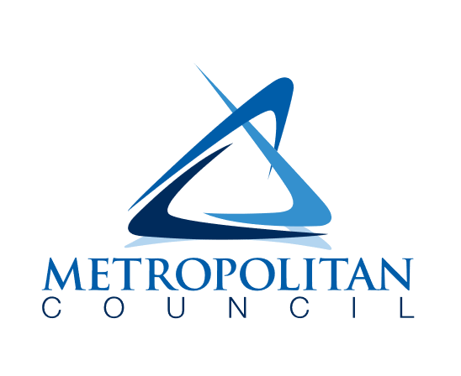

390 Robert Street North

Saint Paul, MN 55101-1805

651-602-1000

TTY 651-291-0904

public.info@metc.state.mn.us

metrocouncil.org/imagine2050