transportation policy recommendations from community leaders

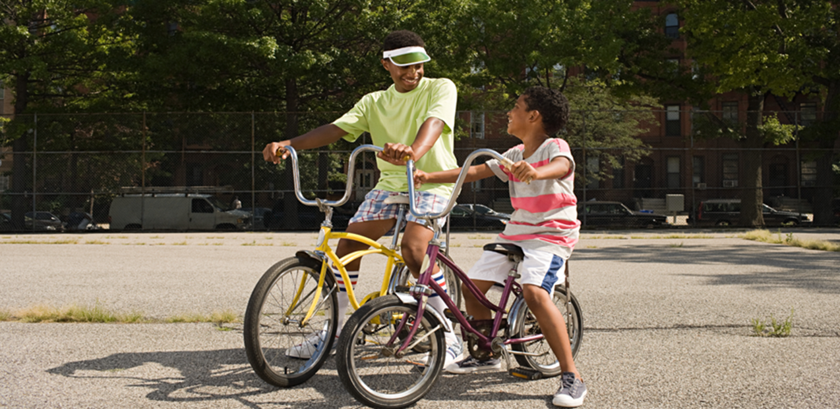

**Regional vision**

A prosperous, equitable, and resilient region   
with abundant opportunities for all to   
live, work, play, and thrive.

# Regional core values

## Equity | Leadership | Accountability | Stewardship

# Regional goals

## Our region is equitable and inclusive

Racial inequities and injustices experienced by historically marginalized communities have been eliminated; and all people feel welcome, included, and empowered.

## Our communities are healthy and safe

All our region’s residents live healthy and rewarding lives with a sense of dignity and wellbeing.

## Our region is dynamic and resilient

Our region meets the opportunities and challenges faced by our communities and economy including issues of choice, access, and affordability.

## We lead on addressing climate change

We have mitigated greenhouse gas emissions and have adapted to ensure our communities and systems are resilient to climate impacts.

## We protect and restore natural systems

We protect, integrate, and restore natural systems to protect habitat and ensure a high quality of life for the people of our region.



# Overview

To ensure that the Met Council heard community advice and incorporated it into *Imagine 2050* policy, we focused engagement efforts on groups historically overlooked in regional planning efforts, such as young people, people of color, and immigrant and American Indian communities. As part of this effort, Met Council staff convened a workshop series with Community Leaders in two phases. The first was in 2023, collaborating with five youth organizations in the Young Leaders Collaboration. In 2024, the Council collaborated with four groups focused on multi-generational immigrant and African American communities, the Community Leaders Collaboration. In this report, the two phases are referred to as the Community Leaders Collaboration. The purpose of this report is to summarize findings from Community Leaders Collaboration workshop and research processes around the transportation issues communities face in the region.

Community Leaders studied Met Council authorities, selected focus themes, conducted research on experiences of diverse youth (ages 14 to 24) and adults in the metro region. They presented results to Council members and staff. Participants designed research to learn the perspectives of young people or adults in their communities, interviewing more than 200 people in total. This report is organized to connect with existing transportation policy and identify the gaps in the current policy. After learning about Met Council authorities, four of the eight groups selected transportation as their primary issue. Although other organizations choose different policy areas, their insights on transportation emerged during research activities.

This report contains a comprehensive list of all themes mentioned by Community Leaders related to the report topic. Researchers and planners involved in the project reviewed all materials from the Community Leaders Collaboration workshops and presentations. A lead researcher used reflexive thematic analysis, considering policy area needs. The lead researcher then identified categorizing labels (codes) for ideas expressed by Community Leaders. These codes were then placed into themes (headers and subtopics presented in the report), which were then rigorously reviewed by the lead researcher and additional researchers or planners.

Community Leaders participated from these organizations:

* 4H, Scott and Carver County
* Community Resource Center and Shakopee Diversity Alliance, Scott County
* COPAL, regionwide
* Environmental Stewardship Institute, regionwide
* Esperanza United, Dakota County
* Mi Casa, Scott County
* Raices Latinas, Hennepin County
* World Youth Connect, Ramsey County

# Key concerns related to transportation

## Lack of pedestrian and cyclist safety due to inadequate transportation infrastructure.

People who do not have a driver’s license, access to a car, or transit often rely on walking, rolling, and biking as commuting methods. Others rely on pedestrian and cycling infrastructure for leisure and for their mental and physical well-being. During the engagement, workshop participants identified a gap in adequate pedestrian and cycling infrastructure, particularly in less urbanized areas of the region. As a result, some people are discouraged entirely from walking, rolling, or biking. Others create their own paths (“desire paths”) to compensate for lack of infrastructure. Oftentimes, these paths have proven to be unsafe as it can increase the likelihood of dangerous encounters with vehicles.

## People in suburban areas lack awareness of how to use transit.

Public transportation is essential for young individuals residing in less urbanized regions because many young people do not have a driver's license and/or access to a car. Community Leaders Collaboration adult participants also expressed a desire for less expensive transportation. During the workshop series, participants expressed their unfamiliarity with riding transit. Their perceptions of public transit were mainly shaped by the negative media coverage and anecdotes shared by other people. Nonetheless, they conveyed a strong desire to have accessible transit options in their areas. Awareness efforts can be a part of transportation planning.

## Transportation is key to connected communities, including access to work, school, and recreation areas.

Providing communities with access to job opportunities, educational institutions, and recreational spaces is crucial everywhere, but was a particular problem in the urban edge and suburban communities. Participants recounted instances when they attempted to take a bus but had to endure long walks to reach the nearest stop. Educational opportunities in the urban core are inaccessible to these communities. If public transportation extended its reach beyond the urban core and offered convenient stops, it would generate enthusiasm for using such services.Community Leaders prioritize having convenient access to parks, green spaces, and locations beyond their workplaces and residences. They emphasized the importance of extending transit services to accommodate the relocation of low-income families from the city to the suburbs. Transit emerges as the most cost-effective transportation option for families in need.

## Riders are concerned about safety on transit, but safety needs to come from alternatives to additional policing.

People living in Saint Paul frequently encounter instances of violence while using transit. Whether it is their family members or themselves, people recounted witnessing concerning behavior on transit. Consequently, their communities have developed a sense of fear on transit while lacking viable transportation alternatives. The observed violence was not limited to civilian misconduct; incidents involving law enforcement have also contributed to their experiences. Community Leaders consistently expressed a shattered trust between the community and the police. In their perspective, safety is a comprehensive approach encompassing community rehabilitation and healing. They also emphasized the need for community policing that prioritizes compassion while fulfilling the responsibility of protecting the public.

## Residents have mixed feelings about driving

Learning to drive and affording the costs of owning a car are necessities for most of the region’s residents. All organizations reported widespread car ownership among adults. Young people’s mobility is severely limited before they learn to drive. However, not everyone found driving to be safe and desirable. The lack of public transportation often forces residents to drive.

## Table 1: Key Community Leaders’ concerns related to transportation

| Concern | Examples from Community Leaders |
| --- | --- |
| Lack of pedestrian and cyclist safety due to inadequate transportation infrastructure | * “I got hit by a car in a crosswalk before. This was because of a driver with a blind spot not paying attention. This could have been prevented by a more visible sidewalk and teaching drivers to pay attention.” * “A lot of friends live on the border between Shakopee and Prior Lake. When they want to hang out and do that, it’s unsafe because they have to bike on the road.” |
| People in suburban areas lack awareness of how to use transit | * “I don’t know how to take the bus, do I buy ticket first, stand here? I don’t understand buses. Never taken bus except for the State Fair.” * During workshops, Dakota and Scott County youth were not familiar with the fact that mapping apps offered transit routes. |
| Transportation is key to connected communities, including access to work, school, and recreation areas | * “The public transportation is a catalyst for job creation. It is a link to jobs and opportunities for people from large and small communities. Having access to public transportation could give us more job opportunities.” * “I would like to be able to go straight [out of school to study at] to the University. I think that is huge, especially for students. I want to go back to school but one thing that stops me is the commute time. The universities are in Saint Paul and Minneapolis and there aren’t buses that go straight, and with a car, the commute time can take forever, especially in the winter.” * “Because buses go through set routes. If people want to do recreational things, it is harder to find buses that go there. Like if I want to go out to eat, I live far from any restaurants I want to go to. You could uber but it's expensive.” * “I wasn't able to get places because the adults in my life were always working, and the only option I had was public transportation. But in order to even get to public transportation, I had to walk at least one hour.” * “Public transit isn't really available because we live out in the suburbs. I would really prefer to have public transportation.” |
| Riders are concerned about transit safety, but safety needs to come from alternatives to additional policing | * “In my experience I was with my uncle when he got robbed on the light rail. So, for me that completely turned me out from ever wanting to use public transportation ever again.” * “Our interviews talked about witnessing the police doing frightening things such as shooting a deaf man and arresting an unconscious person on the metro. We can create a safer transit system by addressing basic needs that cause difficult behaviors and by investing in infrastructure improvements such as better lighting and security cameras at transit stations and stops.” * “More policing in transit would scare people away from transit.” |
| Mixed feelings about driving | * “I know there are other modes of transportation but I like to go out at certain times and to certain places and so it is easier to own your own vehicle.” * " I wish we had more scooters or bus stops. Even though I am learning how to drive, I really don’t like driving.” * "Maybe when they talk about drivers ed, there should be awareness for alternatives to driving." * "I learned to drive right away. I needed to get my license right away because I had to go to soccer.” |

# Emergent topics

Several salient issues emerged throughout the engagement process that historically have been less considered in policy making. Centering these issues in conversation and policymaking is necessary to address the gaps in transportation planning. Community outreach and engagement is important in the discovery of these emergent issues, allowing government agencies to better align our work with the needs of communities.

## Balance infrastructure investment with displacement mitigation.

Community Leaders Collaboration participants have expressed that due to the increasing cost of living, they must leave their neighborhoods in the city to move into areas in the region that lack cultural ties, resources, and access to transit. As the region addresses transit and transportation concerns, transportation planning should be coordinated with other planning stakeholders as well as other transportation investments in the region to reduce displacement. These efforts could ensure people who require these transportation resources can access them in their communities.

## Third spaces and recreation-oriented transit access are important for young people.

It is important for young people that policymakers coordinate third spaces and recreational spaces with the transit network to help foster community and social connection for young people. Third spaces refer to locations that exist beyond an individual's residence or workplace. This concept has gained prominence due to the growing desire among young people for alternative environments where they can get a break from the routines and responsibilities typically associated with their home and work lives. It is important for young people that policymakers coordinate third spaces and recreational spaces with the transit network to help foster community and social connection for young people. While attending school or fulfilling work obligations remains a priority for them, young people also place great importance on having a space where they can socialize and gather without the constraints imposed by the traditional domains of home and work.

## Community-based safety staff is a prioritized, preferred alternative to traditional policing for many residents.

A consistent sentiment heard throughout the workshop series about the issues surrounding safety on transit is that police doesn’t necessarily translate to safety. Police interactions with communities across the region have been contentious and have affected the relationship between neighborhoods and law enforcement. These hostile interactions and fractured relationships translate on transit as dangerous instances where riders feel unsafe. Many of the Community Leaders of color, in their community interviews about transit safety, shared multiple instances where informants witnessed hostile behavior from police, which contributed to their unsafe experiences on transit.

## Develop a “busing culture” by expanding suburban awareness-building and transit network.

“Busing culture” is a term coined by young leaders to describe a culture of community connection fostered by transit. They observed that in suburban areas, access to transit is often limited, leading many young residents to desire to use transit but left not knowing how. Participants made many comments about how in the suburbs there a lack of awareness on how to use transit resulting from the lack of access. Those who do not regularly rely on public transit yearn for a universal mode of transportation that facilitates social connections among individuals. The young leaders suggested more suburban outreach and engagement efforts to solve some of these issues surrounding access to transit and community connectedness.

## Table 2: Community-identified emergent topics about transportation

| Topic | Examples |
| --- | --- |
| Balance infrastructure investment with displacement mitigation | * “Immigrant families are getting phased out to outer suburbs…BIPOC are the ones that most use the transit systems, but we’re getting phased out of cities that have access to transit systems.” |
| Third spaces and recreation-oriented transit are important | * “Especially when you get to the ages of 17 and 18, you're going out more and you need to do things you get jobs and you need to ask your parents for rides, your friends for rides. We should have access to transportation." * "It can get pretty hard to get transportation if I am staying for extra curriculars." |
| Community-based safety staff is a prioritized, preferred alternative to traditional policing | * "I worry that if police are on transit, people will get arrested for no reason." * "There was a time when I was on bus there was a guy who passed out, and then a bunch of cops came in and it felt like they were just staring at us like we did something…" * “One thing that I did hear in all my interviews was that people want there to be like more- not particularly policing, but a form of community policing where it's members of the community who are in the transportation zones. Like at bus stops, light rail stops, and stuff like that. Like they're just monitoring the community, just seeing like making everybody okay and as well as being on the trains themselves.” |
| Develop a “busing culture” by expanding awareness and the transit network. | * “There is a certain “busing culture” that is present here in our state, that isn't present somewhere public transit is more popular...” * “I wasn’t able to get places because the adults in my life were always working, and the only option I had was public transportation. But in order to even get to public transportation, I had to walk at least one hour.” * “I don’t know how to take the bus, do I buy ticket first, stand here? I don’t understand buses. Never taken bus except for the State Fair.” |

# Recommendations

This section details community leader recommendations related to transportation policy and planning.

Address issues of violence and safety on transit through community intervention.  
Community leaders emphasized the importance of establishing a safe environment by highlighting the need for a fundamental level of respect and a genuine concern for the well-being of the community. What the Community Leaders have identified is that much of what happens on transit reflects what is happening in their community. They specifically pointed out that they feel most secure when they see fellow community members actively displaying respect and demonstrating a genuine care for the collective well-being. In other words, they believe that the residents themselves, who are part of the community, play a crucial role in creating a safe and supportive atmosphere.

## Prioritize emissions reduction and incorporate native habitat in transportation projects.

The environment and transportation are closely intertwined on a regional level. Community Leaders said that car pollution, caused by emissions from vehicles, significantly impacts air quality and contributes to climate change. They commented that sustainable transportation options like transit, cycling, and walking can reduce car dependence and lower pollution levels. Regional initiatives promoting sustainable and efficient transportation systems, along with public awareness campaigns, play a vital role in restoring the environment and improving the overall quality of life for communities.

## **Increase pedestrian safety through investment in pedestrian infrastructure**.

Pedestrian safety is a major concern for young people in the region. Pedestrian safety would allow them the freedom to walk/roll/bike without fear of being hit and injured by a car, allowing them to explore their neighborhoods, commute to school, and exercise while feeling protected and secure. They recommend well-designed and maintained sidewalks, crosswalks with clear signage, and traffic lights that prioritize pedestrian safety.

## **Expand access to different modes of transportation in various community types across the region**.

Available transportation is crucial for people throughout the region, including those residing in suburban and rural areas. By bridging transportation gaps, we empower people and promote equity, enabling them to access education, employment, healthcare, and recreational opportunities, regardless of their location or background. This extends to families of color and other underrepresented groups who are increasingly pushed to the suburbs due to housing costs. Adequate transportation options, such as affordable public transit, reliable school bus systems, and safe walking/cycling routes, are essential to connect these communities.

## Table 3: Community perspectives and policy recommendations

| Concern | Community Perspectives and Recommendations |
| --- | --- |
| Address issues of violence and safety on transit through community intervention | **Quotes:**   * "A safe community is having respect for everybody." * " One time I was with my friend [waiting for the bus], and a guy asked us what time it was so my friend pulled her phone out to check the time and then the guy pushed her towards the road and robbed her phone." * "A safe community to me means, being able to feel comfortable and safe, and freedom not being worried about being threaten or gun shootings, robberies." * "My perspective on transit is that there is always a risk for many bad things to happen." * "A safe community means that everyone knows each other and helps each other." * "There's a lot of police in the city but when you go to the suburbs you don't see any."   **Recommendations:**   * Safer transit system that addresses the issues of violence and crime. * Making all modes of transportation safe for everyone. * Create a transit system that prioritizes safety without escalating police involvement. * Investment in infrastructure improvements such as better lighting and security cameras at transit stations and stops. |
| Prioritize emissions reduction and incorporate native habitat in transportation projects | **Quotes:**   * “20 people stepping into their own car, versus 20 people stepping onto a bus – there’s much less pollution. Bike lanes are also more energy efficient.”   **Recommendations:**   * Incorporate native habitat in transportation projects. * Make our region a national leader for coexistence between human and nonhuman species. * Native plants and trees grow at every transit center and transportation investment in the region. |
| Increase pedestrian safety through investment in pedestrian infrastructure | **Quotes:**   * "I got hit by a car, because the sidewalk randomly just stopped." * "In my neighborhood there is only one sidewalk trail, so if you want to get anywhere you have to walk on the shoulder of the road.” * "I was walking home and had to walk in the street multiple times because the sidewalk would randomly end." * "I think there needs to be more bike lines, to make it safer for bicyclists."   **Recommendations**:   * Increase pedestrian transportation options, including more sidewalks, wider sidewalks, and enhanced safety features (blinking crosswalks, sidewalks, etc.). * Our region supports pedestrian infrastructure regardless of age, ability, or mode of transportation. * Infrastructure installed at busy or dangerous locations. |
| Expand access to different modes of transportation in various community types across the region | **Quotes:**   * **“**In Bloomington, it takes so long. No transit centers in winter. What happens to communities that lack a car? The isolation it creates. The time it takes to get to work. It inconveniences lower income communities more than anything else.” * “Dakota County public transit doesn’t have bus stops in front of the school. ...We use a lot of ride share, Uber, to get to work. Our parents are busy at work and can’t drive us. Our choices are walking, Uber, or biking. We want to be responsible and get to work on time."   **Recommendations**:   * Improve existing transit network outside of urban core. * Expand transit network to rural and suburban areas of the region. * Our region’s neighborhood has regular and public transit in and out of them. * Our region is safe, walkable, and accessible. * Engage underrepresented groups in suburban and rural areas. |

# Metrics

Recommendations from community leaders point to metrics to evaluate success of investments and plan compatibility requirements. Data for these metrics can be drawn using data including future community leader cohorts, administrative records, park agency engagement, focus groups, or survey data.

Metrics can:

* Showcase the successful work of policies, investments, and collaborations.
* Help understand if actions/policies are having the intended effect, allowing staff and policymakers to revisit/revise as necessary and make better-informed decisions.

## Awareness of transit

* Percent of suburban youth and adults using transit at least once a year
* Percent of suburban population that accesses Metro Transit app or other metric of percent of population using transit in suburban areas
* Percent of employed youth and adults from households living in poverty who report having easy transport access to work and school activities

## Pedestrian safety

* Zero pedestrian fatalities caused by vehicular incidents
* Survey data show an increased level of pedestrian satisfaction with pedestrian infrastructure

## Safety on transit

* Year-over-year reduction in the number of violent and nonviolent incidents on light rail and bus service
* Increase in public transit ridership
* Maintain a stable level of police presence on transit without any recorded increase of police presence
* Increased number of crisis intervention team staff and community de-escalation staff

## Availability

* Measure the level of engagement and participation of residents of color in the planning process through surveys or participation rates
* Growth in ridership outside of the urban core
* Measured increase in awareness of how to use transit among suburban residents, disaggregated by social identities including age

# Further resources

Community Leaders and Young Leaders presented their recommendations to the Metropolitan Council. [Young Leaders’ Presentation at May 17, 2023 Committee of the Whole Meeting](https://www.youtube.com/live/wY3lvjJ53oc?feature=share) and [Community Leaders’ Presentations in March 2024 Committee of the Whole Meeting](https://www.youtube.com/live/PZtLvREv5_0?si=ZhjNUcAMia6PdZ6J) can be viewed online. The presentations describing transportation policy recommendations are:

## 2023 Young Leaders Collaboration

* [4H presentation](https://www.youtube.com/live/wY3lvjJ53oc?feature=share&t=930) (15:30)
* [Raices Latinas presentation](https://www.youtube.com/live/wY3lvjJ53oc?feature=share&t=1630) (27:10)
* [Esperanza United presentation](https://www.youtube.com/live/wY3lvjJ53oc?feature=share&t=4040) (1:07:20)
* [World Youth Connect presentation](https://www.youtube.com/live/wY3lvjJ53oc?feature=share&t=4980) (1:23:00)

## 2024 Community Leaders Collaboration

## [Mi Casa presentation](https://www.youtube.com/live/PZtLvREv5_0) (15:25)

* [Community Resource Center Shakopee Diversity Alliance presentation](https://www.youtube.com/live/PZtLvREv5_0) (31:48)
* [COPAL presentation](https://www.youtube.com/live/PZtLvREv5_0) (53:01)

Please note that not all recommendations are attributed to specific organizations. If geographic distribution or identity is important to the application of this report, please contact us.

Report contacts

### Darcie Vandegrift

Principal Researcher, Community Development

[darcie.vandegrift@metc.state.mn.us](mailto:darcie.vandegrift@metc.state.mn.us)

### Gabriela Olvera

Planner, Community Development

[gabriela.olvera@metc.state.mn.us](mailto:gabriela.olvera@metc.state.mn.us)

### Sarah Gong

Researcher, Community Development

[sarah.gong@metc.state.mn.us](mailto:sarah.gong@metc.state.mn.us)

### Mulki Haile

Intern, Community Development

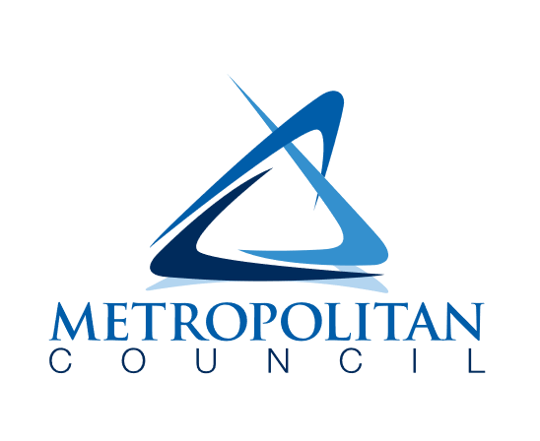

390 Robert Street North

Saint Paul, MN 55101-1805

651-602-1000

TTY 651-291-0904

public.info@metc.state.mn.us

metrocouncil.org/imagine2050