2013 APPLICATION

FOR

FEDERAL TRANSPORTATION PROJECT

FUNDING

Under the Following Programs:

JOB ACCESS AND REVERSE COMMUTE (JARC)
NEW FREEDOM (NF)

MINNEAPOLIS-ST. PAUL METROPOLITAN AREA, MINNESOTA

Table of Contents
I. FEDERAL PROGRAM OVERVIEWS 1
1. Job Access and Reverse Commute (JARC) 1
2. New Freedom (NF) 1
II. REGIONAL SOLICITATION PROCESS 2
1. Funding Announcement 2
2. Local Share and Local Funding Requirements 2
3. Project Selection Criteria 2
4. Project Selection Recommendation Committee 3
5. Available Funding for Solicitation 3
6. Technical Assistance 4
III. GENERAL POLICIES 5
1. Application Limit 5
2. Application Submittal Materials 5
3. Eligible Subrecipients 5
4. Federal Funds Match Requirements 5
5. Grant Activity Period 5
6. Application Timeline 6
7. Project Ranking Petition Process 7
8. Programming Requirements 7
9. Grant Award Requirements 7
10. Regional Transportation Policy Compliance 8
11. Civil Rights Requirements 8
12. Confidentiality Notice 8
IV. JOB ACCESS AND REVERSE COMMUTE PROGRAM (JARC) 9
1. Previous Grant Recipient Eligibility 9
2. Jobs Access and Reverse Commute Matching Requirements 9
3. Eligible Use of Funds 10
V. New Freedom Program 11
1. Previous Grant Recipient Eligibility 11
2. New Freedom Matching Requirements 11
3. Eligible Use of Funds 11
VI. JARC AND NEW FREEDOM APPLICATION CHECKLIST 13
VII. JARC AND NEW FREEDOM QUALIFYING CRITERIA 14
VIII. PROJECT SCORING NARRATIVE 15
1. Application and Project Clarity 16
2. Populations and Destinations Served 16
3. Service Coordination, Gaps, and Outreach 16
4. Effectiveness and Performance Measures 17
5. Project Sustainability 17
6. Implementation Plan 17
7. Innovation 17

Introduction

FEDERAL PROGRAM OVERVIEWS
In 2005, the Safe, Accountable, Flexible, Efficient Transportation Equity Act: A Legacy for Users (SAFETEA-LU) was passed. Title III, Public Transportation Assistance, addresses the JARC and New Freedom programs. Title III, section 3018, Job Access Reverse Commute Formula Grants, and section 3019, New Freedom Program, established new formula programs for JARC and New Freedom funding with local and statewide solicitation requirements.
The FTA has a website portal for information related to the JARC and New Freedom programs including frequently asked questions (FAQ), circulars related to program guidance and policies, and other technical assistance. The FTA websites can be found below:
JARC Portal: http://www.fta.dot.gov/funding/grants/grants_financing_3550.html
JARC Program Guidance: http://www.fta.dot.gov/documents/FTA_C_9050.1_JARC(1).pdf
New Freedom Portal: http://www.fta.dot.gov/funding/grants/grants_financing_3549.html
New Freedom Program Guidance: http://www.fta.dot.gov/documents/FTA_C_9045.1_New_Freedom(1).pdf

Job Access and Reverse Commute (JARC)
The goal of the JARC program is to improve access to employment and employment related activities for welfare recipients and low-income individuals. Toward this goal, the Federal Transit Administration (FTA) provides financial assistance for transportation services that meet the transportation needs of eligible low-income individuals. The program requires coordination of federally assisted programs and services in order to make the most efficient use of Federal resources.

New Freedom (NF)
The goal of the New Freedom program is to provide additional tools for Americans with disabilities trying to overcome barriers in their integration into the work force and their full participation in society. Toward this goal, FTA provides financial assistance to implement transportation services that expand transportation options for persons with disabilities in all areas of the country – urbanized, small urban, and rural. New Freedom funds are available to increase accessibility for persons with disabilities, but they need not be those who are ADA-certified. The program requires coordination of federally assisted programs and services in order to make the most efficient use of Federal resources.
Notice of Federal Grant Requirements
All proposed projects will be subject to a Federal Transit Administration review for eligibility prior to final selection by the Metropolitan Council. Potential applicants should review the FTA’s regulations at http://www.fta.dot.gov/laws/leg_reg_808.html and required Certifications and Assurances at http://www.fta.dot.gov/funding/grants_financing_93.html prior to applying. Selected recipients will be required to comply with all applicable FTA regulations and agree to applicable Certifications and Assurances in order to be eligible for a grant award.

REGIONAL SOLICITATION PROCESS

Funding Announcement
The announcement of funding availability is published in the State Register, posted on the Metropolitan Council website’s homepage, and released via email to a list of existing and past private providers of public transportation on file with the Metropolitan Council.

Local Share and Local Funding Requirements
The minimum required local match is 50% for net operating costs and 20% for net capital costs. Examples of eligible local matches include tax revenues, State or local appropriations, private donations, and contract revenue. Non-DOT Federal funds are also eligible as local match.

Project Selection Criteria
The Metropolitan Council staff will determine project eligibility during the selection process. All projects must identify needs and strategies that are being addressed and these must be consistent with the Twin Cities’ Public Transit and Human Services Transportation Coordination Action Plan. The project selection criteria will consist of the follow areas of focus:
- Application and Project Clarity (10% of total) – Completeness and understandability of the application and project
- Populations and Destinations Served (25%) – Ability to serve targeted population groups and destinations, including specific sites
- Service Coordination, Gaps, and Outreach (20%) – Project cohesiveness with other transit programs and its ability to fill regional transportation needs and gaps
- Effectiveness and Performance Measures (10%) – Project cost effectiveness and ability of applicant to measure performance and provide summaries
- Project Sustainability (10%) – Long-term project outlook for continuing service and funding beyond FTA grants
- Implementation Plan (20%) – Applicant staff plan, organization, timeline, and processes in place to ensure a successful project implementation and ongoing management
- Innovation (5%) – New or innovative approaches to expand transportation access for the targeted populations

Project Selection Recommendation Committee
A selection recommendation committee will be formed to score the project applications and make a recommendation to the Metropolitan Council. The committee will be made up of at least the following representatives (subject to availability):
- One representative from the Suburban Transit Association (STA)
- One representative from the Transportation Accessibility Advisory Committee (TAAC)
- One staff from MnDOT Office of Transit
- One Metropolitan Council staff member
- Two at-large members to bring the total to a minimum of six
Metropolitan Council staff will oversee the ranking process and provide the necessary information to the committee members. The same committee will be used for JARC and New Freedom.
The selection recommendation committee will assemble a list of projects for approval by the Metropolitan Council, who will subsequently approve the list of projects. The list of recommended projects may include contingency projects, which would be eligible to receive funding if a selected project is cancelled or additional funding is available. The recommendation will have to be revisited if the Metropolitan Council does not approve the list. After the list is approved, Metropolitan Council staff prepares a Program of Projects (POP) as required by FTA and brings the list to the Transportation Advisory Board (TAB), which is comprised of transportation agency representatives and elected officials, as a TIP amendment. The POP will be included with the FTA application for funding for the approved projects.

Available Funding for Solicitation
The Twin Cities seven county metropolitan area is allocated JARC and New Freedom funds as a large urban area with a population greater than 200,000. The Metropolitan Council is the recipient for JARC and New Freedom funds in the metro area, based on the governor's designation. A copy of this designation is included in Appendix A.
Funds available for the current RFP process include Federal Fiscal Years (FFY) 2011 and 2012 metropolitan area apportionments.
Federal Fiscal Year of Allocation | JARC Apportionment
2011 Remaining | $0
2012 | $922,151
Solicitation Total | $922,151

Federal Fiscal Year of Allocation | New Freedom Apportionment
2011 Remaining | $644,186
2012 | $651,674
Solicitation Total | $1,295,860

Projects are not guaranteed future funding as a part of this solicitation and all projects must resubmit during the biennial solicitation in order to receive future grants. As a result, selected and ongoing projects should be prepared to identify and secure funding from other sources beside these or in addition to these funding programs. The grant period for this application will be determined on a project-by-project basis and will commence with the date of project award notifications (typically 3-5 months after project selection by the Metropolitan Council).

Technical Assistance
Applicants requiring technical assistance should contact Elaine Koutsoukos, the Metropolitan Council’s JARC and New Freedom programs administrator:

Elaine Koutsoukos
Senior Planner
Metropolitan Council
390 North Robert St.
St. Paul, MN 55101
(651) 602-1717
elaine.koutsoukos@metc.state.mn.us

GENERAL POLICIES

Application Limit
JARC and New Freedom funds require separate applications. Agencies and organizations are allowed to submit as many applications for funding as desired. An application must be submitted entirely under one program (JARC or New Freedom). The same project application cannot be submitted under both programs.

Application Submittal Materials
All applications must include the requested documentation or the application will be considered incomplete and disqualified (after the submittal deadline date). An application checklist is included within the application package (see page 10) to help ensure the completeness of the application and coordinate the arrangement of the application packet and the required materials. Materials must be submitted in compliance with the Americans with Disabilities Act (ADA).

Eligible Subrecipients
All projects must be located within the seven-county metropolitan region of Minneapolis-St. Paul, including the counties of Anoka, Carver, Dakota, Hennepin, Ramsey, Scott, and Washington.
JARC and New Freedom funds are available to:
- Local government agencies;
- Non-profit agencies;
- Public and private providers of public transportation;
- Tribal governments

Federal Funds Match Requirements
Farebox revenue is not an eligible match for operating costs; however, revenues from service contracts can be used as local match. Federal funding for any selected project will not exceed 80% in capital projects and 50% in net operating assistance. A project with a mix of capital and operating budgets will have to match each individual line item at the appropriate match level. Capital projects include planning and mobility management.
No grant will be officially awarded (i.e., funding agreement signed) until the local match requirements are met and identified by the applicant. Failure to do so in a timely manner may result in the reallocation of funds to another project.

Grant Activity Period
Selected projects will only be eligible for reimbursement of expenses made during the designated federal grant period. The federal grant period does not start until funds are awarded from the FTA, through either pre-award authority or a federal grant award. The grant activity period for this solicitation will begin October 1, 2013, or later. This grant activity period is subject to change so the utmost flexibility is encouraged among program applicants.

Application Timeline
DATE |  | PHASE
February 14, 2013 |  | - Request For Proposals Released, Available on Met Council website
Late February 2013 |  | - Application Information Sessions and Workshops
Workshop Location |  | Workshop Date and Time
East Metro | Metropolitan Council – LLA  390 North Robert St.  Saint Paul, MN 55101  (651) 602-1000 | Tuesday, February 26, 2013  1:00 PM – 3:00 PM
West Metro | Metro Transit – Chambers  570 6th Avenue N.  Minneapolis, MN 55411  (612) 349-7400 | Thursday, February 28, 2013  9:00 AM – 11:00 AM
Potential applicants are encouraged to attend workshops to get on the mailing list for future events and FAQ updates. If you are unable to attend, please contact the programs administrator for details about these resources.
March 29, 2013, 4:00 PM |  | - Applications due to Met. Council office
April 12, 2013, 4:00 PM |  | - Unqualified Project Petition Submittal Deadline
April 15, 2013 |  | - List of Qualified Projects Notification
April 15 – 26, 2013 |  | - Application Scoring Process
April 29, 2013 |  | - Application Scores Public Release
May 3, 2013, 4:00 PM |  | - Project Score Petition Submittal Deadline
May 10, 2013 |  | - Final List of Projects

Project Ranking Petition Process
Project qualification and scoring will each be eligible for a separate appeal process as outlined in the Application Timeline (section G). The appeal process will adhere to the following guidelines:
- A request for an appeal must be submitted in writing to the programs administrator through U.S. Mail, fax, email, or direct delivery to the Metropolitan Council office. Disqualified project applicants will be notified of their project status within a week after the project application due date. The request should state the specific reason or reasons for the petition including:
  - Response to any disqualification based on the qualifying criteria
  - Explanation of which scores specifically are being challenged and why the applicant believes the scores warrant a review (e.g., a misinterpretation of data or a failure to consider information included in the application)
- An appeal does not allow applicants to submit additional information, nor does it extend the project deadline if minimal qualifications are not met. All materials must be submitted by the project application deadline.
- Appeals are intended to provide an opportunity to clarify the original outcome of the qualifying and scoring processes. Applicants must state their petitions and provide an explanation to the programs administrator, who will work directly with the selection recommendation committee. The programs administrator and Metropolitan Council staff will review the methodology and math of the selection recommendation committee and facilitate the response to each petition.
- Applicants are not allowed to petition the status or scores of a project they do not officially represent.
- The decision to change a project’s score will be at the digression of the selection committee and the programs administrator. The result of the appeal process is considered final and no additional appeals will be allowed.

Programming Requirements
The Metropolitan Council will program approved funds into the appropriate Metropolitan Council budget, either operating or capital.

Grant Award Requirements
Approved applicants will be required to enter into a contractual agreement with the Metropolitan Council and should be prepared to meet all requirements, including the extensive requirements of the Federal Transit Administration. An example of the contractual agreement for the New Freedom program is included in Appendix C. Additional subrecipient grant requirements are listed in Appendix E. For more information on these requirements, contact the program administrator.
Funding recipients could be subject to random audits by the Federal Transit Administration and the Metropolitan Council.

Regional Transportation Policy Compliance
Projects must comply with the policies set forth in the Met Council’s 2030 Transportation Policy Plan. Specific attention should be paid to Chapters 2-7, 9, and 11 and Appendix G.
In addition, projects must comply with the requirements set forth in the 2030 Park and Ride Plan: http://www.metrocouncil.org/planning/transportation/ParknRide/ParknRidePlan.htm.

Civil Rights Requirements
The federal government has numerous statutes in place (Title VI, Title IX, ADA) to ensure that programs or activities with federal funding or a federal interest are not distributed discriminatorily on the basis of race, national origin, class, or disability. Applicants should consider the distribution of these various populations throughout the metropolitan area when preparing project applications. The Metropolitan Council reserves the right to give preference to applications targeting minority groups. The maps in Appendix D are intended to provide potential applicants with a general idea of the distribution of minority, low-income, and other population groups in the metropolitan area. Those unfamiliar with Civil Rights and Civil Rights compliance should contact the Metropolitan Council programs administer for more information.

Confidentiality Notice
All application materials will become public property as soon as they are submitted to the Metropolitan Council for formal review. Applicants should use caution when including confidential information with their application materials.

JOB ACCESS AND REVERSE COMMUTE PROGRAM (JARC)

Previous Grant Recipient Eligibility
Previously funded JARC project recipients that are able to document successful implementation will be eligible to submit applications for their current projects, but must complete all application material and will compete for funding with new projects.

Jobs Access and Reverse Commute Matching Requirements
- General. JARC funds may be used to finance capital, planning and operating expenses. The Federal share of eligible capital and planning costs may not exceed 80 percent of the net cost of the activity. The Federal share of the eligible operating costs may not exceed 50 percent of the net operating costs of the activity.
- The local share of eligible capital and planning costs shall be no less than 20 percent of the net cost of the activity, and the local share for eligible operating costs shall be no less than 50 percent of the net operating costs. All of the local share must be provided from sources other than Federal DOT funds. Some examples of sources of local match which may be used for any or all of the local share include: State or local appropriations; other non-DOT Federal funds; dedicated tax revenues; private donations; revenue from human service contracts; toll revenue credits; and net income generated from advertising and concessions. Non-cash share such as donations, volunteered services, or in-kind contributions is eligible to be counted toward the local match as long as the value of each is documented and supported, represents a cost which would otherwise be eligible under the program, and is included in the net project costs in the project budget.
- Income from contracts to provide human service transportation may be used either to reduce the net project cost (treated as revenue) or to provide local match for JARC operating assistance. In either case, the cost of providing the contract service is included in the total project cost. No FTA program funds can be used as a source of local match for other FTA programs, even when used to contract for service.
- Use of Other Federal Funds. Local match may be derived from other Federal funds derived from Federal programs that are eligible to be expended for transportation, other than from the DOT programs. Examples of types of programs that are potential sources of local match include: employment training, aging, community services, vocational rehabilitation services, and Temporary Assistance for Needy Families (TANF). To be eligible for local match for FTA funds, the other Federal funds must be used for activities included in the total net project costs of the FTA grant. Expenditure of other Federal funds for transportation outside of the scope of the project cannot be applied as a credit for local match in the FTA grant.

Eligible Use of Funds
New projects must relate to “the development and maintenance of transportation services designed to transport welfare recipients and eligible low-income individuals to and from jobs and activities related to their employment.” Examples of eligible projects targeted at welfare recipients and eligible low-income individuals transitioning into work include:
- Public transit late-night and weekend service;
- Public transit guaranteed ride home service;
- Expanding fixed-route mass transit routes;
- Demand-responsive van service;
- Ridesharing and carpooling activities;
- Promotion of public transit for non-traditional work schedules;
- Voucher programs targeted to persons entering the workforce or on welfare.

New Freedom Program

Previous Grant Recipient Eligibility
Previously funded New Freedom projects that are able to document successful implementation will be eligible to submit applications for their current projects, but must complete all application material and will compete for funding with new projects. Eligible projects funded with New Freedom funds may continue to be eligible for New Freedom funding indefinitely as long as the project continues to be part of the coordinated plan.

New Freedom Matching Requirements
- General. New Freedom funds may be used to finance capital and operating expenses. The Federal share of eligible capital and planning costs may not exceed 80 percent of the net cost of the activity. The Federal share of the eligible operating costs may not exceed 50 percent of the net operating costs of the activity
- The local share of eligible capital costs shall be no less than 20 percent of the net cost of the activity, and the local share for eligible operating costs shall be no less than 50 percent of the net operating costs. All of the local share must be provided from sources other than Federal DOT funds. Some examples of sources of local match which may be used for any or all of the local share include: State or local appropriations; other non-DOT Federal funds; dedicated tax revenues; private donations; revenue from human service contracts; toll revenue credits; and net income generated from advertising and concessions. Non-cash share such as donations, volunteer services, or in-kind contributions is eligible to be counted toward the local match as long as the value of each is documented and supported, represents a cost which would otherwise be eligible under the program, and is included in the net project costs in the project budget.
- Income from contracts to provide human service transportation may be used either to reduce the net project cost (treated as revenue) or to provide local match for New Freedom operating assistance. In either case, the cost of providing the contract service is included in the total project cost. No FTA program funds can be used as a source of local match for other FTA programs, even when used to contract for service.
- Use of Other Federal Funds. Local match may be derived from other Federal programs that are eligible to be expended for transportation, other than funds from DOT programs. Examples of types of programs that are potential sources of local match include: employment, training, aging, medical, community services, and rehabilitation services. To be eligible for local match for FTA funds, the other Federal funds must be used for activities included in the total net project costs of the FTA grant. Expenditure of other Federal funds for transportation outside of the scope of the project cannot be applied as a credit for local match in the FTA grant.

Eligible Use of Funds
New projects under the New Freedom program are intended to “support new public transportation services beyond those required by the Americans with Disabilities Act of 1990 (ADA) and new public transportation alternatives beyond those required by the ADA designed to assist individuals with disabilities with accessing transportation services, including transportation to and from jobs and employment support services.” Both new public transportation services and new public transportation alternatives are required to go beyond the requirements of the ADA and must (1) be targeted toward individuals with disabilities; and (2) meet the intent of the program by removing barriers to transportation and assisting persons with disabilities with transportation, including transportation to and from jobs and employment services. Examples of eligible New Freedom project:
- Enhancing paratransit beyond minimum requirements of the ADA;
- New “feeder” service (transit service that provides access) to commuter rail, commuter bus, intercity rail, and intercity bus stations, for which complementary paratransit service is not required under the ADA;
- Making accessibility improvements to transit and intermodal stations not designated as key stations;
- New training programs for individual users on awareness, knowledge, and skills of public and alternative transportation options available in their communities;
- Supporting the administration and expenses related to new voucher programs for transportation services offered by human service providers;
- Supporting new volunteer driver and aide programs;
- Supporting new mobility management and coordination programs among public transportation providers and other human service agencies providing transportation.

JARC AND NEW FREEDOM APPLICATION CHECKLIST
The following information must be included in the final JARC or New Freedom application packet to be considered complete. Incomplete applications will be disqualified after the application deadline has passed. All materials must be submitted on 8 ½ x 11 inch paper and bounded with a paper clip or black binder clip and in electronic format on a CD. Failure to provide either will disqualify project from consideration. If you submit oversized pages in your application, you MUST submit 10 copies/sets of the oversized pages.
all project Applications MUST be Received at the Metropolitan Council office by MARCH 29, 2013, at 4:00 PM.
Completed Project Application Form (Form 1)
Written Responses to the Qualifying Criteria
Written Project Narrative
Completed Project Budget and Milestone Forms (Form 2)
Commitment Letters and/or Letters of Support from Coordinating Agencies
Depending on the type of project, applicants may be instructed to provide maps and graphics detailing proposed projects (e.g., regular-route bus line or job site locations). Any additional information should be included as part of the project narrative.
ADA Accessibility Submittal Requirements
All materials submitted on the CD should have a consistent naming structure, including the agency name and the program. Images and maps should have an accompanying written description that would allow a visually impaired individual to understand them.
JARC AND NEW FREEDOM QUALIFYING CRITERIA
The applicant must show that the project meets all the following criteria to qualify for evaluation. Answer each criterion in a numbered sequence. Failure to respond to any of the qualifying criteria will result in a recommendation to disqualify the project.
- The project must be within the metropolitan region of Minneapolis-St. Paul that includes the seven counties of Anoka, Carver, Dakota, Hennepin, Ramsey, Scott, and Washington.
- The project applicant must be a local government agency, federal funding-eligible non-profit agency, public and private provider of public transportation, or tribal government.
- The project’s minimum total cost, including local match, must meet or exceed $50,000. No project will be awarded more than the federal portion of the biennial seven-county metro area allocation for JARC or New Freedom. The maximum federal allocation for any project proposal will be the total two-year appropriation for the region under each program. It is expected that the maximum JARC allocation will be $922,151 and the maximum New Freedom allocation will be $1,295,860.
- The project must address a need and fall under a strategy identified in the Metro Area Public Transit and Human Services Transportation Coordination Action Plan (available online http://www.metrocouncil.org/planning/transportation/CoordinationPlan.pdf, or through the Metropolitan Council Data Center at 651-602-1140). The specific need and strategy should be identified using the following table scheme. Multiple needs and strategies may be listed for each project.
Twin Cities Metro Area Public Transit and Human Services Coordination Plan
Project Description | Identified Needs | Identified Strategies
e.g., (Hennepin County workforce van pool program) | - Insufficient connections between under- and unemployed persons and entry-level jobs.  - Lower level of service in off-peak times or weekends | Use reverse-commute routes, vanpools, route deviation, smaller transit vehicles, carpooling, or other innovative transit services to provide mobility in lower density areas.
- The applicant is responsible for the local (non-federal) share. If the applicant expects any other agency to provide part of the local match, the applicant must include a letter or resolution from the other agency agreeing to participate financially in the application.

PROJECT SCORING NARRATIVE
The project narrative should provide a thorough explanation of the project being proposed in this application. The questions listed under each category are meant to guide you in writing your project narrative. The descriptive boxes are also meant to help you understand each criterion. Applicants are encouraged to provide data, maps, and spreadsheets to better explain the project and how it will benefit the region. Sources for data must be cited or risk receiving a reduced score during the scoring process. Examples of potential data sources included the Minnesota Department of Employment and Economic Development (DEED), U.S. Census 2000, and U.S. Census Estimates.
The applicant must respond to each category in a numbered sequence. Failure to respond to the questions will significantly hinder the chances of project approval.
The following are descriptions of project types and the various ways to classify project activities. Projects may contain a mixture of operating, capital, and mobility management.
- Operating
  - (Jobs Access): Refers to a project relating to the development and maintenance of transportation services that transport welfare recipients and eligible low-income individuals to and from jobs and activities related to their employment using non-traditional public transit services.
  - (Reverse Commute): Refers to a public transportation project designed to transport residents of urbanized areas to suburban employment opportunities using traditional public transit services.
  - (New Freedom): Refers to operation of new service above and beyond the requirements of ADA.
- Capital
  - Fixed Asset: Refers to a project where one-time investments are made not in direct relation to any specific operation of service. FTA guidelines mandate that capital expenses must be at least $5,000 in value and have a useful life of more than one-year.
  - Mobility Management: Mobility management is an eligible capital expense. Mobility management includes one-time investments that will achieve or assist in the achievement of the program goals. This includes such activities as planning, service coordination, inventory collection, infrastructure conversion, etc. Mobility management cannot include any ongoing expenses such as staff time unless the staff are contracted exclusively for the project.
The Project scoring Narrative Should be no MORE than 10 pages, including any Data Summaries, Tables, maps, and other images. Letters of Support are not included in the 10 page limit.
Application and Project Clarity |  | 10 Points
- What are the main components of the project?
A clearly defined project and clear objectives are essential to the project recommendation committee. While this category is only a portion of the overall application score, it is invaluable to the recommendation committee in understanding each project application. The project description and purpose should directly relate to the purpose of the appropriate funding program.
- What are the objectives of the project?
- Where does this project fit within your agency’s goals and objectives?

Populations and Destinations Served |  | 25 Points
- What is the geographic area (county, community, origin, and destination) served in the project and the demographics of the service area? Include significant locations and areas where this project will serve.
- What are the needs of the targeted population (low-income and/or persons with disabilities) in the service area?
- How will the project serve the needs of the targeted population?
The JARC and New Freedom programs have been designed to serve specific populations: in the case of JARC, low-income residents and families not living near suburban job concentrations; in the case of New Freedom, persons with disabilities. Each population group has specific destinations that are important for them to access, the primary focus being social services and employment. The application should describe, in detail, what populations and major destinations its project intends to serve. Applicants are encouraged to use data resources available (please site sources) and provide documentation. Within this section, the application should also describe how the project will improve access to the populations and destinations served.

Service Coordination, Gaps, and Outreach |  | 20 Points
- Does this project address a gap in the transportation system? Please describe the gap.
- How will this project address that gap and prove beneficial for the regional transportation system?
- How will this project coordinate with public and/or private transportation and human services agencies serving low income populations and people with disabilities?
- How will the project engage key stakeholders and promote public awareness of the service?
The application should outline what other transportation resources exist in the areas to be targeted by the project. The application should also describe what pervious steps have been taken and what future steps will be taken to ensure proper coordination of resources that will maximize efficiency and simplification of transportation services for the populations served. Letters of support are encouraged and should be attached to the application packet. The Twin Cities Metro Area Public Transit and Human Services Transportation Coordination Action Plan developed a list of gaps and service shortfalls for the populations these programs are designated to serve. The application should indicate how the project will address gaps in the system using the plan as guidance.

Effectiveness and Performance Measures | 10 Points
- Does the project make use of federal and local funds in an efficient and cost effective manner?
The JARC and New Freedom programs have established means of measuring the performance of projects, as outlined in section 10 of General Policies. Each application should describe how they plan to measure the appropriate program measures. The application should also describe any additional measures that will be used to evaluate the effectiveness of achieving the overall project goals. Performance measures should be directly linked to the goals of the program.
- What performance measures will be used to measure the effectiveness of this project during its operation?
- How will the achievement of the project goals be measured against the overall program goals?
Project Sustainability | 10 Points
- What is the long-term potential of this project (potential future funding sources)?
Federal funding for JARC and New Freedom projects is not guaranteed beyond the award. Applicants should provide a thorough explanation of potential future funding sources should the project be deemed successful. Sustainable projects (i.e., those with reliable funding options) will score higher for this category. Agencies with limited options are encouraged to create partnerships with government and garner support for potential future funding.
- Have any commitments been made by local partners and to what extent (timeframe and value)?

Implementation Plan | 20 Points
- What is the work plan for this project, including what staff will be assigned to manage it?
- What are the details of the service or capital investment that you plan to implement (i.e., the service hours, hours of day, location, capital improvements, etc.)?
- What experience and procedures does your agency have in place to manage a federal grant in the areas of financial management, procurement, auditing, and other requirements outlined in federal guidelines?
- How does you agency plan to manage federal Title VI and ADA compliance? (The Metropolitan Council reserves the right to give priority to projects serving a high proportion of Title VI population groups.)
The application should describe how the agency plans to manage the project including what staff will be assigned. The implementation plan should include at least a description of all of the following aspects of the project:
  - Timeline of the project with key milestones
  - Any work to be contracted out
  - Service plan including route maps or service area (project location and construction plan for capital project)
  - Evidence of experience and/or knowledge of federal grant requirements and rules (all grant award recipients will be required to attend a Metropolitan Council-sponsored federal grant management course)

Innovation | 5 Points
- Does the project offer any new or innovative approaches, service concepts, or facilities that have the potential for improving access and mobility for the target population?
- Could these innovative approaches be applied elsewhere in the region?
The application should describe these new and innovative approaches currently not implemented in service in the region. The application should identify how these approaches will enhance service to the targeted population. The application should also include examples of other regions where similar approaches have been used.

Program (Check Only One)
Job Access and Reverse Commute Project (Section 5316)
New Freedom Project (Section 5317)
Applicant Information
Agency:
Agency Type: State or Local Government Private Non-profit
Public Transportation Provider Tribal Government
Jurisdictional Agency (if different):
Address:
City/State/Zip:
Authorized Signer (and title):
E-mail: Phone: Fax:
Project Manager (if different):
E-mail: Phone: Fax:
Project Information
Project Title:
Brief Project Description:

Project Type: Operating Capital Mobility Management
Service Area
Describe Areas Served by the Project (Attach Map if Possible):
Operating Project Funding
Federal Grant Funding Request: $
Local Match Funding (at least 50%): $ Local Match Source(s):
Projected Fare Revenue (Not an Eligible Match): $
Total Operating Amount (Federal + Local + Fares): $
Capital or Mobility Management Project Funding
Federal Grant Funding: $
Local Match Funding (at least 20%): $ Local Match Source(s):
Total Capital Amount (Federal + Local): $
Total Project Funding (Capital and Operating)
Total Federal Funding: $
Total Local Match: $
Total Grant Project: $

Budget Item: All budget items with an asterisk requires milestone information | Item Description or Purpose | FTA or Federal Funding | Match or Other Funding | Total Project Funding
Personnel (Salary):

Project Admin

Force Account
Fringe Benefit
*Consultant:

Planning

Engineer & Design

Construction Mgmt

*Contractor:

Construction

Services

*Lease/Rental Costs
*Bus Purchase | (specify type)

*Spare Parts

*3rd Party Bus Inspection

*Staff Travel:

Local

Non-local

*Staff Training: Tuition

*Insurance

*Real Estate:

Acquisition

Appraisal

ROW

*Equipment (list items w/useful life of more than 1 year & cost greater than $5000)

*Project Supplies & Material (list items consumable and/or unit cost under $5000)

*Computer Hardware

*Computer Software

Other Costs
Grant Project Total (should match Form 1)

Milestone Information

Provide milestone information for each budget item from the Budget Page

Budget Item—Bus Only | Item Description or Purpose | Total Budget Amount
 | Bus Purchase | $
 | Milestone Description | Milestone Dates
1 | RFP/IFB Issued
2 | Contract Award Date
3 | First Bus Delivery
4 | All Bus Delivered
5 | Contract Complete Date

Budget Item #1 | Item Description or Purpose | Total Budget Amount
 |  | $
 | Milestone Description | Milestone Dates
1 | RFP/IFB Issued
2 | Contract Award Date
3 | Contract Complete Date

Budget Item #2 | Item Description or Purpose | Total Budget Amount
 |  | $
 | Milestone Description | Milestone Dates
1 | RFP/IFB Issued
2 | Contract Award Date
3 | Contract Complete Date

Budget Item #3 | Item Description or Purpose | Total Budget Amount
 |  | $
 | Milestone Description | Milestone Dates
1 | RFP/IFB Issued
2 | Contract Award Date
3 | Contract Complete Date

___________________________________________________ ______________________
DEPARTMENTAL APPROVAL DATE

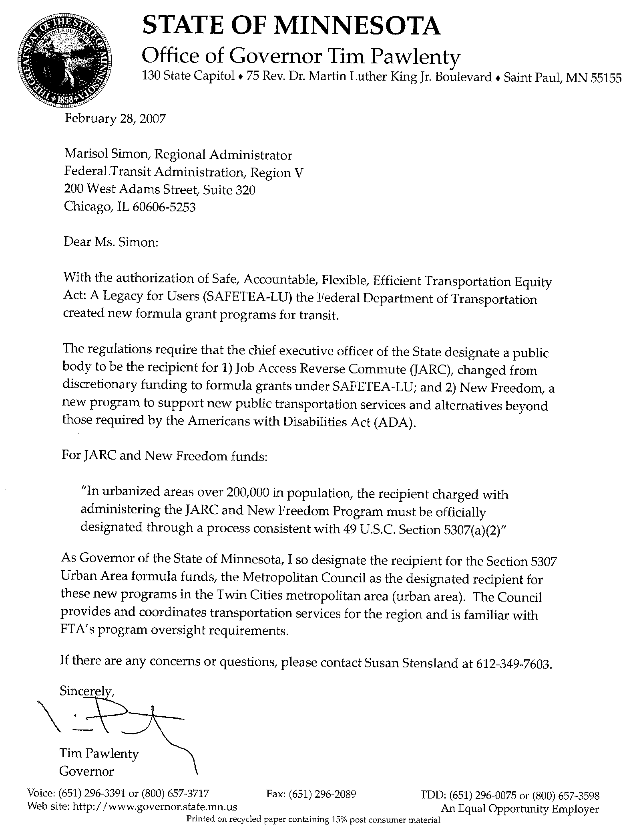

- ELIGIBLE ACTIVITIES. Funds from the JARC program are available for capital, planning, and operating expenses that support the development and maintenance of transportation services designed to transport low-income individuals to and from jobs and activities related to their employment and to support reverse commute projects.
In the conference report accompanying SAFETEA–LU, the conferees stated an expectation that FTA would “continue its practice of providing maximum flexibility to job access projects that are designed to meet the needs of individuals who are not effectively served by public transportation, consistent with the use of funds described in the Federal Register, Volume 67 (April 8, 2002)” (H.R. Report 109–203, at Section 3018 (July 28, 2005)). Therefore, eligible projects may include, but are not limited to capital, planning, and operating assistance to support activities such as:
  - Late-night and weekend service;
  - Guaranteed ride home service;
  - Shuttle service;
  - Expanding fixed-route public transit routes;
  - Demand-responsive van service;
  - Ridesharing and carpooling activities;
  - Transit-related aspects of bicycling (such as adding bicycle racks to vehicles to support individuals that bicycle a portion of their commute or providing bicycle storage at transit stations);
  - Local car loan programs that assist individuals in purchasing and maintaining vehicles for shared rides;
  - Promotion, through marketing efforts, of the:
    - use of transit by workers with non-traditional work schedules;
    - use of transit voucher programs by appropriate agencies for welfare recipients and other low-income individuals;
    - development of employer-provided transportation such as shuttles, ridesharing, carpooling; or
    - use of transit pass programs and benefits under Section 132 of the Internal Revenue Code of 1986;
  - Supporting the administration and expenses related to voucher programs. This activity is intended to supplement existing transportation services by expanding the number of providers available or the number of passengers receiving transportation services. Vouchers can be used as an administrative mechanism for payment to providers of alternative transportation services. The JARC program can provide vouchers to low-income individuals to purchase rides, including (1) mileage reimbursement as part of a volunteer driver program, (2) a taxi trip, or (3) trips provided by a human service agency. Providers of transportation can then submit the voucher to the JARC project administering agency for payment based on pre-determined rates or contractual arrangements. Transit passes for use on fixed route or Americans with Disabilities Act of 1990 (ADA) complementary paratransit service are not eligible. Vouchers are an operational expense which requires a 50/50 (Federal/local) match;
  - Acquiring Geographic Information System (GIS) tools;
  - Implementing Intelligent Transportation Systems (ITS), including customer trip information technology;
  - Integrating automated regional public transit and human service transportation information, scheduling and dispatch functions;
  - Deploying vehicle position-monitoring systems;
  - Subsidizing the costs associated with adding reverse commute bus, train, carpool van routes or service from urbanized areas and nonurbanized areas to suburban work places;
  - Subsidizing the purchase or lease by a non-profit organization or public agency of a van or bus dedicated to shuttling employees from their residences to a suburban workplace;
  - Otherwise facilitating the provision of public transportation services to suburban employment opportunities;
  - Supporting new mobility management and coordination programs among public transportation providers and other human service agencies providing transportation. Mobility management is an eligible capital cost. Mobility management techniques may enhance transportation access for populations beyond those served by one agency or organization within a community. For example, a non-profit agency could receive JARC funding to support the administrative costs of sharing services it provides to its own clientele with other low-income individuals and coordinate usage of vehicles with other non-profits, but not the operating costs of the service. Mobility management is intended to build coordination among existing public transportation providers and other transportation service providers with the result of expanding the availability of service. Mobility management activities may include:
      - The promotion, enhancement, and facilitation of access to transportation services, including the integration and coordination of services for individuals with disabilities, older adults, and low-income individuals;
      - Support for short term management activities to plan and implement coordinated services;
      - The support of State and local coordination policy bodies and councils;
      - The operation of transportation brokerages to coordinate providers, funding agencies and customers;
      - The provision of coordination services, including employer-oriented Transportation Management Organizations’ and Human Service Organizations’ customer-oriented travel navigator systems and neighborhood travel coordination activities such as coordinating individualized travel training and trip planning activities for customers;
      - The development and operation of one-stop transportation traveler call centers to coordinate transportation information on all travel modes and to manage eligibility requirements and arrangements for customers among supporting programs; and
      - Operational planning for the acquisition of intelligent transportation technologies to help plan and operate coordinated systems inclusive of Geographic Information Systems (GIS) mapping, Global Positioning System technology, coordinated vehicle scheduling, dispatching and monitoring technologies as well as technologies to track costs and billing in a coordinated system and single smart customer payment systems (acquisition of technology is also eligible as a stand alone capital expense).

- ELIGIBLE ACTIVITIES. New Freedom Program funds are available for capital and operating expenses that support new public transportation services beyond those required by the Americans with Disabilities Act of 1990 (ADA and new public transportation alternatives beyond those required by the ADA designed to assist individuals with disabilities with accessing transportation services, including transportation to and from jobs and employment support services. For the purpose of the New Freedom Program, “new” service is any service or activity that was not operational on August 10, 2005, and did not have an identified funding source as of August 10, 2005, as evidenced by inclusion in the Transportation Improvement Plan (TIP) or the STIP. In other words, if not for the New Freedom Program, these projects would not have consideration for funding and proposed service enhancements would not be available for individuals with disabilities.
Maintenance of Effort: Recipients or subrecipients may not terminate ADA paratransit enhancements or other services funded as of August 10, 2005, in an effort to reintroduce the services as “new” and then receive New Freedom funds for those services.
Eligible projects funded with New Freedom funds may continue to be eligible for New Freedom funding indefinitely as long as the project(s) continue to be part of the coordinated plan.
Both new public transportation services and new public transportation alternatives are required to go beyond the requirements of the ADA and must (1) be targeted toward individuals with disabilities; and (2) meet the intent of the program by removing barriers to transportation and assisting persons with disabilities with transportation, including transportation to and from jobs and employment services.
The list of eligible activities is intended to be illustrative, not exhaustive. Recipients are encouraged to develop innovative solutions to meet the needs of individuals with disabilities in their communities.
  - New Public Transportation Services Beyond the ADA The following activities are examples of eligible projects meeting the definition of new public transportation.
    - Enhancing paratransit beyond minimum requirements of the ADA. ADA complementary paratransit services can be eligible under New Freedom in several ways as long as the services provided meet the definition of “new:”
      - Expansion of paratransit service parameters beyond the three-fourths mile required by the ADA;
      - Expansion of current hours of operation for ADA paratransit services that are beyond those provided on the fixed-route services;
      - The incremental cost of providing same day service;
      - The incremental cost of making door-to-door service available to all eligible ADA paratransit riders, but not as a reasonable modification for individual riders in an otherwise curb-to-curb system;
      - Enhancement of the level of service by providing escorts or assisting riders through the door of their destination;
      - Acquisition of vehicles and equipment designed to accommodate mobility aids that exceed the dimensions and weight ratings established for common wheelchairs under the ADA and labor costs of aides to help drivers assist passengers with over-sized wheelchairs. This would permit the acquisition of lifts with a larger capacity, as well as modifications to lifts with a 600 lb design load, and the acquisition of heavier-duty vehicles for paratransit and/or demand-response service; and
      - Installation of additional securement locations in public buses beyond what is required by the ADA.
    - Feeder services. New “feeder” service (transit service that provides access) to commuter rail, commuter bus, intercity rail, and intercity bus stations, for which complementary paratransit service is not required under the ADA.
    - Making accessibility improvements to transit and intermodal stations not designated as key stations. Improvements for accessibility at existing transportation facilities that are not designated as key stations established under 49 CFR 37.47, 37.51, or 37.53, and that are not required under 49 CFR 37.43 as part of an alteration or renovation to an existing station, so long as the projects are clearly intended to remove barriers that would otherwise have remained. New Freedom funds are eligible to be used for new accessibility enhancements that remove barriers to individuals with disabilities so they may access greater portions of public transportation systems, such as fixed-route bus service, commuter rail, light rail and rapid rail. This may include:
      - Building an accessible path to a bus stop that is currently inaccessible, including curbcuts, sidewalks, accessible pedestrian signals or other accessible features,
      - Adding an elevator or ramps, detectable warnings, or other accessibility improvements to a non-key station that are not otherwise required under the ADA ,
      - Improving signage, or wayfinding technology, or
      - Implementation of other technology improvements that enhance accessibility for people with disabilities including Intelligent Transportation Systems (ITS .
    - Travel training. New training programs for individual users on awareness, knowledge, and skills of public and alternative transportation options available in their communities. This includes travel instruction and travel training services.
  - New Public Transportation Alternatives Beyond the ADA. The following activities are examples of projects that are eligible as new public transportation alternatives beyond the ADA under the New Freedom Program :
    - Purchasing vehicles to support new accessible taxi, ride sharing, and/or vanpooling programs. New Freedom funds can be used to purchase and operate accessible vehicles for use in taxi, ridesharing and/or van pool programs provided that the vehicle has the capacity to accommodate a passenger who uses a “common wheelchair” as defined under 49 CFR 37.3, at a minimum, while remaining in his/her personal mobility device inside the vehicle, and meeting the same requirements for lifts, ramps and securement systems specified in 49 CFR part 38, subpart B.
    - Supporting the administration and expenses related to new voucher programs for transportation services offered by human service providers. This activity is intended to support and supplement existing transportation services by expanding the number of providers available or the number of passengers receiving transportation services. Only new voucher programs or expansion of existing programs are eligible under the New Freedom Program. Vouchers can be used as an administrative mechanism for payment of alternative transportation services to supplement available public transportation. The New Freedom Program can provide vouchers to individuals with disabilities to purchase rides, including: (a) mileage reimbursement as part of a volunteer driver program; (b) a taxi trip; or (c) trips provided by a human service agency. Providers of transportation can then submit the voucher for reimbursement to the recipient for payment based on pre-determined rates or contractual arrangements. Transit passes for use on existing fixed route or ADA complementary paratransit service are not eligible. Vouchers are an operational expense which requires a 50/50 (Federal/local) match.
    - Supporting new volunteer driver and aide programs. New volunteer driver programs are eligible and include support for costs associated with the administration, management of driver recruitment, safety, background checks, scheduling, coordination with passengers, and other related support functions, mileage reimbursement, and insurance associated with volunteer driver programs. The costs of new enhancements to increase capacity of existing volunteer driver programs are also eligible. FTA notes that any volunteer program supported by New Freedom must meet the requirements of both “new” and “beyond the ADA.” FTA encourages communities to offer consideration for utilizing all available funding resources as an integrated part of the design and delivery of any volunteer driver/aide program.
    - Supporting new mobility management and coordination programs among public transportation providers and other human service agencies providing transportation. Mobility management is an eligible capital cost. Mobility management techniques may enhance transportation access for populations beyond those served by one agency or organization within a community. For example, a non-profit agency could receive New Freedom funding to support the administrative costs of sharing services it provides to its own clientele with other individuals with disabilities and coordinate usage of vehicles with other non-profits, but not the operating costs of the service. Mobility management is intended to build coordination among existing public transportation providers and other transportation service providers with the result of expanding the availability of service. Mobility management activities may include:
      - The promotion, enhancement, and facilitation of access to transportation services, including the integration and coordination of services for individuals with disabilities, older adults, and low-income individuals;
      - Support for short term management activities to plan and implement coordinated services;
      - The support of State and local coordination policy bodies and councils;
      - The operation of transportation brokerages to coordinate providers, funding agencies and customers;
      - The provision of coordination services, including employer-oriented Transportation Management Organizations’ and Human Service Organizations’ customer-oriented travel navigator systems and neighborhood travel coordination activities such as coordinating individualized travel training and trip planning activities for customers;
      - The development and operation of one-stop transportation traveler call centers to coordinate transportation information on all travel modes and to manage eligibility requirements and arrangements for customers among supporting programs; and
      - Operational planning for the acquisition of intelligent transportation technologies to help plan and operate coordinated systems inclusive of Geographic Information Systems (GIS) mapping , Global Positioning System Technology , coordinated vehicle scheduling, dispatching and monitoring technologies as well as technologies to track costs and billing in a coordinated system and single smart customer payment systems (acquisition of technology is also eligible as a stand alone capital expense).

SUBRECIPIENT AGREEMENT

Subrecipient: | The Agency |  |  |  |  | Grant Number
Address:
Workscope:
Project Activity Period: |  | October 1, 2013, though __
Estimated Project Amount:  FTA 5317 Funds:  Local Match:  Federal Grant No.:  CFDA No.: |  |  | $  $  $ | Council Action  Item No.:  Date:

AGREEMENT
THIS AGREEMENT is made and entered into by and between the Metropolitan Council ("Council") and The Agency ("Subrecipient") each acting by and through its duly authorized officers.

WHEREAS:

- The Council, acting in its role as the Twin Cities Metropolitan Planning Organization submitted an application to the Federal Transit Administration (“FTA”) for federal grant funds under the FTA’s New Freedom Program pursuant to 49 U.S.C. Section 5317, which included the Subrecipient’s project as described herein.

- The FTA’s New Freedom Program is authorized under the provisions set forth in the Safe, Accountable, Flexible, Efficient Transportation Equity Act: A Legacy for Users, (SAFETEA–LU), enacted on August 10, 2005, as codified at 49 U.S.C. 5317.
- The FTA’s New Freedom Program aims to provide additional tools to overcome existing barriers facing Americans with disabilities seeking integration into the work force and full participation in society. Lack of adequate transportation is a primary barrier to work for individuals with disabilities. The New Freedom Program seeks to reduce barriers to transportation services and expand the transportation mobility options available to people with disabilities beyond the requirements of the Americans with Disabilities Act.

- The Council received New Freedom grant funds from the FTA pursuant to grant number ____________.

- This Agreement is intended to memorialize the terms under which the Subrecipient is to receive the FTA grant funds.

NOW, THEREFORE, the Council and the Subrecipient agree as follows:

I. SUBRECIPIENT WORKSCOPE; APPROVED BUDGET AND MATERIAL REPRESENTATIONS

1.01 Workscope. The Subrecipient agrees to perform and complete in a satisfactory and proper manner the Workscope specified on Exhibit A (“FTA Grant Application Information”) in accordance with the terms and conditions of this Agreement. The Workscope details the activities to be completed by the Subrecipient and a proposed schedule for the completion of the Workscope. All Workscope activities must be consistent with the approved Workscope and the approved budget detailed below. Any proposed change in the scope of work must be submitted to the Council’s Project Manager for written approval. A change in the scope of work is not effective until the Subrecipient receives written approval from the Council’s Project Manager.

1.02 Approved Budget. The Subrecipient agrees to complete the Workscope in accordance with the approved budget specified on Exhibit A. The Approved Budget details the cost associated with each scope of work activity. Any request for re-budgeting in excess of twenty percent (20%) of the Approved Budget must be in writing and approved in writing by the Council’s Project Manager. Re-budgeting of project funds among the existing Approved Budget lines of the Workscope are allowable without prior approval if the amount of project funds to be transferred is less than twenty percent (20%) of the Approved Budget. However, re-budgeting between operating and capital line items is not allowable due to differing match requirements.

1.03 Material Representations. The Subrecipient agrees that all representations contained in its application for grant assistance are material representations of fact upon which the Council relied in awarding this grant and are incorporated by reference into this agreement.

II. AUTHORIZED USE OF GRANT AND MATCHING FUNDS; ELIGIBILITY OF COSTS
2.01 Authorized Use of Grant and Matching Funds. The Subrecipient is only authorized to use the grant funds awarded under this agreement for costs directly incurred for the performance of the Workscope during the Project Activity Period as specified in Section 6.01, and in accordance with the Approved Budget.
2.02 Eligibility of Costs. All expenses are subject to FTA regulations including:

- FTA Master Agreement (http://www.fta.dot.gov/documents/14-Master.pdf)
- Uniform Administrative Requirements for Grants and Cooperative Agreements to State and Local Governments, 49 CFR Part 18 (http://www.access.gpo.gov/nara/cfr/waisidx_06/49cfr18_06.html)
- Grant Management Guidelines, FTA Circular 5010.1C (http://www.fta.dot.gov/laws/circulars/leg_reg_4114.html)
- Third Party Contracting Requirements, FTA Circular 4220.1E, (http://www.fta.dot.gov/laws/circulars/leg_reg_4063.html) (See also paragraph 10.05)
- New Freedom Program Guidance, FTA Circular C 9045.1

The Subrecipient acknowledges that the federal requirements in this article and throughout this Agreement are subject to change and agrees that the most recent of these requirements shall govern this Agreement at any particular time.

III. GRANT AMOUNT, MATCH AND PAYMENT

3.01 Estimated Project Amount. The total estimated cost of the Workscope is $_______, consisting of the Maximum Federal Grant Amount and the Subrecipient’s required match.

3.02 Maximum Federal Grant Amount. The Council awards to the Subrecipient a grant of up to $_______ for the Workscope. In no event will the Council's obligation under this agreement exceed the lesser of the following:

A. The Maximum Federal Grant Amount; or

B. The combination of 50% of the total net operating Workscope expenditures plus 80% of capital Workscope expenditures.

The Council shall bear no responsibility for cost overruns that may be incurred by the Subrecipient in performance of the Workscope. If it appears likely that additional funds will be needed to complete the Workscope, the parties will meet to discuss the possibility of amending this Agreement.

  - Subrecipient Match. The Subrecipient has an obligation under this agreement to share in the costs of the project by providing a local match from sources other than from FTA funds, i.e., not less than $__ against the Maximum Grant Amount. The eligibility and use of matching funds shall be governed by applicable federal law, regulations and guidance. If the final expenses for the Workscope are less than the Estimated Project Amount, then local match shall be reduced to fifty percent (50%) of the final Workscope amount. If the final expenses for the Workscope exceed the Estimated Project Amount, the Subrecipient is responsible for providing the funds to cover the final costs and expenses.

3.04 Reimbursement. Expenses will be reimbursed by the Council based on submission of an invoice from the Subrecipient using the form attached hereto as Exhibit B. Invoices should be submitted in triplicate on the approved form with the following attachments on each copy:
A. Copies of all receipts for expenses paid during the period; and

B. Monthly DBE report for each third party contract using the approved form attached hereto as Exhibit C.

The Subrecipient shall submit any additional data and/or information requested by the Council to support the Subrecipient’s reimbursement request and shall submit any additional data and/or information that may be required by the federal government for reporting to the FTA.

Upon the Council’s review and approval of the Subrecipient’s reimbursement request, the Council will distribute to the Subrecipient the approved reimbursement amount. The Council may deny part or all of any reimbursement request if it reasonably believes that it is not a supportable Workscope expense. No reimbursement will be made which would cause the distribution of grant funds to exceed, cumulatively, through such payment, the limits in Article III. The Council may withhold payment if the Subrecipient is not current in its reporting requirements under Article V. Distribution of any funds or approval of any report is not to be construed as a Council waiver of any Subrecipient noncompliance with this Agreement.

3.05 Repayment of Unauthorized Use of Grant Funds. Upon a finding by the Council that the Subrecipient has made an unauthorized or undocumented use of grant funds, and upon a demand for repayment issued by the Council, the Subrecipient agrees to promptly repay such amounts to the Council.

3.06 Reversion of Unexpended Grant Funds. All funds granted by the Council under this agreement that have not been expended for Workscope activities taking place during the Project Activity Period shall revert to the Council.

3.07 Grant Contingent on Federal Funding. The Subrecipient acknowledges and agrees that the Council’s payment of funds under this Agreement is contingent on the Council receiving grant funds from the FTA. If, for any reason, the FTA reduces the amount of the Council’s FTA Grant, or otherwise fails to pay any part of the cost or expense of the Workscope in this agreement, only outstanding incurred cost shall be eligible for reimbursement. The Subrecipient and its contractors and subcontractors further agree to pay any and all lawful claims arising out of or incidental to the performance of the Workscope covered by this Agreement in the event that the FTA does not pay the same and, in all events, agree to hold the Council harmless from those claims and from any claims arising out of this Agreement. Notwithstanding any other provisions of this Agreement, in the event the FTA rescinds funding for the FTA Grant, the Council may immediately terminate this Agreement by written notice to the Subrecipient.

IV. ACCOUNTING AND RECORDKEEPING REQUIREMENTS

4.01 Documentation of Workscope Costs. All costs charged to the Workscope, whether paid with grant funds or charged as the Subrecipient's match, must be supported by proper documentation, including properly executed payrolls, time records, invoices, contracts, receipts for expenses, or vouchers, evidencing in detail the nature and propriety of the charges.

4.02 Establishment and Maintenance of Workscope Information. The Subrecipient agrees to establish and maintain accurate, detailed, and complete separate books, accounts, financial records, documentation, and other evidence relating to: (a) Subrecipient’s performance under this Agreement, and (b) to the receipt and expenditure of all grant funds and the Subrecipient's match under this Agreement. These documents shall include the property records required by Article VIII of this Agreement. The Subrecipient shall establish and maintain all such information in accordance with generally accepted accounting principles and practices and shall retain intact all Workscope information until the latest of:

A. Six (6) years following the term of this Agreement; or

B. If any litigation, claim, or audit is commenced during either such period, when all such litigation, claims or audits have been resolved.

4.03 Audit. The accounts and records of the parties relating to this Agreement shall be audited in the same manner as all other accounts and records of the Subrecipient are audited. During the time of maintenance of information under paragraph 4.02, authorized representatives of the Council, the Legislative Auditor and/or State Auditor in accordance with Minnesota Statutes, section 16C.05, subdivision 5, the United States Secretary of Transportation, the FTA Administrator, and the United States Comptroller General will have access to all such books, records, documents, accounting practices and procedures, and other information for the purpose of inspection, audit, and copying during normal business hours. The parties will provide proper facilities for such access and inspection.

V. REPORTING AND MONITORING REQUIREMENTS
5.01 Quarterly Milestone Progress Reports. The Subrecipient shall submit quarterly milestone progress reports to the Council. The Council shall provide the Subrecipient with an electronic version of the milestone progress report that the Subrecipient must complete. Each quarterly progress report must include a detailed summary of the completed Workscope activities and a report on the Workscope schedule. Both the Council and the Subrecipient must approve each quarterly milestone progress report. The quarterly progress reports are due as follows:

- January 15 for quarter October 1 - December 31
- April 15 for quarter January 1 – March 31
- July 15 for quarter April 1 - June 30
- September 15 for quarter July 1 – September 30

5.02 Final Reports. Upon completion of the Workscope and not later than sixty (60) calendar days after the end of the Project Activity Period, the Subrecipient must submit a final progress report and a final financial status report of expenditures for the full Workscope and containing a final accounting of the grant and matching expenditures. If outstanding claims related to work occurring during the Project Activity Period still exist sixty (60) days following the end of the Project Activity Period, the submission of the Final Report shall automatically extend until all outstanding claims have been resolved. The final report must include inventory of Workscope property as required by Article VIII of this Agreement.

5.03 Content of Reports; Copies. The Subrecipient agrees to report completely and to provide the Council with any additional or follow-up information as may be requested by the Council. The Subrecipient agrees to provide copies of the reports specified in paragraphs 5.01 and 5.02 to organizations and individuals upon request during the term of this Agreement as required by the Minnesota Government Data Practices Act.

5.04 Monthly DBE Reporting Requirements. The Subrecipient shall provide the Council with monthly reports on all DBE activity (see section 10.05 E) on third party agreements in the form attached hereto as Exhibit C and based on the procurement process established for the Subrecipient in the “Federal Procurement Basics” which is attached hereto as Exhibit D.

5.05 Other Monitoring Activities. To assist the Council in monitoring compliance with this Agreement, the Subrecipient agrees to attend Subrecipient meetings as requested by the Council and to permit site visits by Council staff, during business hours, upon reasonable notice. The Subrecipient agrees to submit to the Council a copy of any promotional information regarding the Workscope disseminated by the Subrecipient during the term of this Agreement.

5.06 Changed Conditions. The Subrecipient agrees to notify the Council immediately of any change in conditions, law, ordinance, or regulation, or any other event that may affect the Subrecipient's ability to perform the Workscope in accordance with the terms of this Agreement.

5.07 Special Reporting Requirements. The Council is required to report to the FTA regarding Workscope activities. Accordingly, the Subrecipient agrees to provide the Council with any additional or follow-up information reasonably requested by the Council, in order to meet the Council’s FTA reporting requirements. Specific reporting requirements are included in Exhibit I.

VI. PROJECT ACTIVITY PERIOD; TERM; TERMINATION

6.01 Project Activity Period. The Subrecipient agrees to complete all Workscope activities during the period from October 1, 2013, to __________ ("Project Activity Period"). Grant funds may not be used to reimburse costs for any Workscope activities taking place before the beginning or after the end of the Project Activity Period.

6.02 Term. The term of this agreement shall extend from the effective date of this Agreement to a date sixty (60) calendar days following the end of the Project Activity Period to permit close out of this Agreement. If outstanding claims related to work occurring during the Project Activity Period still exist sixty (60) calendar days following the end of the Project Activity Period, the Term of this Agreement shall automatically extend for an additional ninety (90) calendar days in order to resolve any and all outstanding claims.

6.03 Termination by Council for Convenience. The Council may terminate this Agreement at any time and for any reason by providing Subrecipient written notice of such termination at least ninety (90) calendar days prior to the effective date of such termination. Upon such termination Subrecipient shall be entitled to compensation for Workscope activities in accordance with this Agreement which were incurred prior to the effective date of the termination, but not exceeding the limits in paragraph 3.02.

6.04 Termination by Council for Noncompliance. If the Council reasonably finds that there has been a failure to comply with the provisions of this Agreement, the Council may terminate the Agreement at any time following seven (7) calendar days written notice to the Subrecipient and upon failure of the Subrecipient to cure the noncompliance within the seven-day period. Noncompliance includes failure to make reasonable progress toward completion of the Workscope. At the Council’s option, the Council may cease payment of invoices during any period in which the Subrecipient is not in compliance with this agreement. If the Council finds that the Subrecipient's noncompliance is willful and unreasonable, the Council may terminate or rescind this Agreement and require the Subrecipient to repay the grant funds in full or in a portion determined by the Council. Nothing herein shall be construed so as to limit the Council's legal remedies to recover grant funds.

6.05 Effect of Workscope Closeout or Termination. The Subrecipient agrees that Workscope closeout or termination of this agreement does not invalidate continuing obligations imposed on the Subrecipient by this Agreement. Project closeout or termination of this Agreement does not alter the Council's authority to disallow costs and recover funds on the basis of a later audit or other review, and does not alter the Subrecipient's obligation to return any funds due to the Council as a result of later refunds, corrections, or other transactions.
VII. CONTACT PERSONS; PROJECT MANAGER
7.01 Contact Persons. The authorized contact persons for receipt of notices, reports, invoices, and approvals under this agreement are the following:
The Council:

Name:
Title:
Mailing Address:
Phone:
E-mail:

The Subrecipient:

Name:
Title:
Mailing Address:
Phone:
E-mail:

or such other person as may be designated in writing for itself by either party.

7.02 Council Project Manager. For purposes of administration of this Agreement, the contact person listed in paragraph 7.01, or such other person as may be designated in writing by the Council’s Regional Administrator shall be the Project Manager. Nothing, however, in this Agreement will be deemed to authorize the Council’s Project Manager to execute amendments to this agreement on behalf of the Council.

7.03 Subrecipient Project Manager. For purposes of administration of this Agreement, the contact person listed in paragraph 7.01, or such other person as may be designated in writing by the Subrecipient, shall be the Project Manager. The Subrecipient Project Manager shall coordinate Workscope activity with the Council Project Manager and complete the project manager training provided by the Council to ensure compliance with all federal requirements.
VIII. GRANT PROPERTY
The title, acquisition, use, management, and disposition of all property acquired or constructed with grant funds under this agreement shall be governed by applicable federal law, rule, and guidance including, without limitation, the provisions of:

- Uniform Administrative Requirements for Grants and Cooperative Agreements to State and Local Governments 49 C.F.R. Parts 18.31, 18.32, and 18.33 (www.access.gpo.gov/nara/cfr/waisidx_98/49cfr18_98.html)
- FTA Circular 5010.1C (http://www.fta.dot.gov/laws/circulars/leg_reg_4114.html)

The listed documents are incorporated by reference into this Agreement. Copies of these documents are available at the internet websites indicated or, upon request by the Subrecipient, from the Council.

IX. GENERAL CONDITIONS

9.01 Amendments. The terms of this Agreement may be changed only by mutual agreement of the parties. Such changes shall be effective only upon the execution of written amendments signed by authorized officers of the parties to this Agreement.

9.02 Assignment Prohibited. The Subrecipient shall not assign, subgrant or transfer any Workscope activities without receiving the express written consent of the Council. The Council may condition such consent on compliance by the Subrecipient with terms and conditions specified by the Council.

9.03 Indemnification. The Subrecipient assumes liability for and agrees to defend, indemnify and hold harmless the Council, its members, officers, employees and agents, from and against all losses, damages, expenses, liability, claims, suits, or demands including, without limitation, attorney's fees, arising out of, resulting from, or relating to the performance of the Grant Project by Subrecipient or Subrecipient’s employees, agents, or subcontractors.

9.04 Workscope Data. The Subrecipient agrees that the results of the Workscope, the reports submitted, and any new information or technology that is developed with the assistance of this grant is in the public domain and may not be copyrighted or patented by Subrecipient. The Subrecipient shall comply with the Minnesota Government Data Practices Act, Minnesota Statutes, Chapter 13, in administering data under this Agreement.

9.05 Nondiscrimination. The Subrecipient agrees to comply with all applicable laws relating to nondiscrimination and affirmative action. In particular, the Subrecipient agrees not to discriminate against any employee, applicant for employment, or participant in this Workscope because of race, color, creed, religion, national origin, sex, marital status, status with regard to public assistance, membership or activity in a local civil rights commission, disability, sexual orientation, or age; and further agrees to take action to ensure that applicants and employees are treated equally with respect to all aspects of employment, including selection for training, rates of pay, and other forms of compensation. In undertaking the Workscope activities, the Subrecipient agrees to comply with Minnesota Statutes, section 363A.12 regarding non-discrimination in the provision of public services if applicable.

9.06 Acknowledgment. The Subrecipient shall appropriately acknowledge the grant assistance made by the Council and the FTA under this agreement in any promotional materials, reports, and publications relating to the Workscope.

9.07 Compliance with Law; Obtaining Permits, Licenses, and Authorizations. The Subrecipient agrees to conduct the Workscope in compliance with all applicable provisions of federal and state laws, rules or regulations. The Subrecipient is responsible for obtaining and complying with all federal or state permits, licenses, and authorizations necessary for performing the Workscope.

9.08 Workers Compensation; Tax Withholding. The Subrecipient represents that it is compliance with the workers compensation coverage requirements of Minnesota Statutes, section 176.181, subdivision 2, and that it, and any of its contractors or material suppliers, if any, under this contract, are in compliance with the tax withholding on wages requirements of Minnesota Statutes, section 290.92.

9.09 Jurisdiction, Venue, and Applicable Law. Venue for all legal proceedings arising out of this agreement, or breach of this agreement, shall be in the state or federal court with competent jurisdiction in Ramsey County, Minnesota. All matters relating to the performance of this agreement shall be controlled by and determined in accordance with the laws of the State of Minnesota.

9.10 Incorporation of Exhibits. All Exhibits attached to this Agreement will be deemed incorporated into this Agreement.

- GENERAL FEDERAL REQUIREMENTS

10.01 Federal Requirements. The requirements in this Article X are in addition to and, unless inconsistent and irreconcilable, do not supplant requirements found elsewhere in this Agreement. If any requirement in this article is inconsistent with a provision found elsewhere in this Agreement and is irreconcilable with such provision, the requirement in this article shall prevail. When performing work or expending funds for Project activities, the Subrecipient agrees to comply with all applicable terms and conditions referenced herein. The Subrecipient acknowledges that federal requirements in this article X are subject to change and agrees that the most recent of these requirements shall govern this Agreement at any particular time.

10.02 Incorporation of Specific Federal Requirements. Specifically, and without limitation, the Subrecipient agrees to comply with the federal requirements set forth in Exhibit E and agrees to require, unless specifically exempted, sub-recipients (if authorized) and third party contractors at every tier to comply with the same. These requirements include, but are not limited to, the following:
Debarment and Suspension. The Subrecipient agrees to comply, and assures the compliance of each subrecipient, lessee, or third party contractor at any tier, with Executive Orders Nos. 12549 and 12689, “Debarment and Suspension,” 31 U.S.C. § 6101 note, and U.S. DOT regulations, “Government wide Debarment and Suspension (Nonprocurement),” 49 C.F.R. Part 29. The Subrecipient agrees to, and assures that its subrecipients, lessees, and third party contractors will review the “Excluded Parties Listing System” at http://epls.gov/ before entering into any third subagreement, lease or third party contract. [U.S. DOT issued a new amendment to these regulations adopting the optional lower tier coverage for tiers lower than the first tier below a covered nonprocurement transaction. See, 71 Fed. Reg. 62394, October 25, 2006.]
Integrity Certification. By signing this Agreement, the Subrecipient certifies that neither it nor its principals is presently debarred, suspended, proposed for debarment, declared ineligible, or voluntarily excluded from participation in this contract by any Federal department or agency. This certification is a material representation of fact upon which the COUNCIL relies in entering this contract. If it is later determined that the Subrecipient knowingly rendered an erroneous certification, in addition to other remedies available to the Federal Government, the department or agency with which this transaction originated may pursue available remedies, including suspension and/or debarment. The Subrecipient shall provide to the COUNCIL immediate written notice if at any time the Subrecipient learns that its certification was erroneous when submitted or has become erroneous by reason of changed circumstances.
Certification of Restrictions on Lobbying; Disclosure. The provisions of this section apply only if the amount of this contract (including the value of any amendments thereto) is equal to, or exceeds $100,000.
The Subrecipient certifies that no federal appropriated funds have been paid or will be paid by or on behalf of the Subrecipient for influencing or attempting to influence an officer or employee of any federal agency, a member of Congress, an officer or employee of Congress, or an employee of a member of Congress in connection with the awarding of any federal contract, the making of any federal grant, the making of any federal loan, the entering into of any cooperative agreement, and the extension, continuation, renewal, amendment, or modification of any federal contract, grant, loan, or cooperative agreement. The certification of this compliance ("Lobbying Restriction Certification") submitted by the Subrecipient in connection with this project is incorporated in, and made a part of, this contract.
The Subrecipient further certifies that, if any funds other than federal appropriated funds have been paid or will be paid to any person for influencing or attempting to influence an officer or employee or any federal agency, a member of Congress, an officer or employee of Congress, or an employee of a member of Congress in connection with the projects funded by the funds allocated to the Subrecipient in this agreement, the Subrecipient shall complete and submit to the Council, Standard Form-LLL, “Disclosure Form to Report Lobbying,” in accordance with its instructions.
The Subrecipient certifies that it will require the language of this certification be included in the award documents for any subcontracts equal to or in excess of $100,000.00 under this agreement, and that all subcontractors shall certify and disclose accordingly to the Subrecipinet. All certifications and disclosures shall be forwarded to the Council by the Subrecipinet.

The certifications referred to in this section (including the "Lobbying Restriction Certification" submitted by the Subrecipient in connection with this project and incorporated in, and made a part of, this contract) are material representations of fact upon which the Council relies when this contract is made.

10.03 Federal Certifications and Assurances (C & A); Execution and Incorporation. The Subrecipient agrees to comply with and to certify compliance with the current Federal Annual List of Certifications and Assurances for Federal Transit Administration Grants and Cooperative Agreements (“C & A”) attached hereto and incorporated herein as Exhibit F. The Subrecipient must certify compliance with the applicable provisions by signing the appropriate certification(s) and returning the signed certification(s) as part of the execution of this Agreement. During the term of this Agreement, the Subrecipient shall annually execute the most current C & A document and provide the same to the Council.

10.04 Compliance with Federal Requirements; Incorporation of Specific Documents by Reference. The Subrecipient agrees to comply with all federal statutes, rules, FTA Circulars, Executive Orders, guidance, and other requirements that may be applicable to this grant. In particular, and without limitation, the Subrecipient agrees to comply with the terms and conditions of the following documents when performing work or expending funds for Workscope activities:

- FTA Master Agreement (www.fta.dot.gov/library/legal/agree.htm)
- Uniform Administrative Requirements for Grants and Cooperative Agreements to State and Local Governments, 49 CFR Part 18 (www.access.gpo.gov/nara/cfr/waisidx_98/49cfr18_98.html)
- Grant Management Guidelines, FTA Circular 5010.1C (www.fta.dot.gov/library/policy/5010.1C/cover.htm)

The listed documents are incorporated by reference into this agreement. Copies of these documents are available at the internet websites indicated or, upon request by the Subrecipient, from the Council.

10.05 Compliance with Federal Procurement Requirements. Subrecipient will comply with all applicable federal law, rules, and guidance relating to such procurement including, without limitation, the provisions of Third Party Contracting Requirements, FTA Circular 4220.1E, which document is incorporated by reference into this agreement. A copy of this document is available at the FTA internet website, www.fta.gov/indicated or, upon request by the Subrecipient, from the Council. The “Federal Procurement Basics” is attached hereto as Exhibit D to provide the Subrecipient process for procurements under this Agreement.

A. Certification of Subrecipient’s Procurement System. Subrecipient certifies that its procurement system complies with the standards described in the previous paragraph.

B. Council Approval of Contracts. The Subrecipient shall not execute any third party contract or otherwise enter into a binding agreement until it has first received written approval from the Council’s Project Manager.

C. Subrecipient Contract Initiation Memo. Subrecipient shall use the Contract Initiation Memo attached hereto as Exhibit G for all procurements of $50,000 or more. It is understood, that no procurement shall be split in order to fall beneath this threshold.

D. Inclusion of Provisions in Lower Tier Contracts. The Subrecipient agrees to include adequate provisions to ensure compliance with applicable federal requirements in each lower tier third party contract financed in whole or in part with financial assistance under this agreement including all applicable provisions of this Agreement.

E. Disadvantaged Business Enterprise Requirements. For all work performed under this grant agreement, Subrecipient will comply with the Council’s Disadvantaged Business Enterprise (DBE) Program. In particular, Subrecipient agrees to comply with the requirements of the Council’s “Disadvantaged Business Enterprise (DBE) Program” document which is attached to and incorporated into this Agreement as Exhibit H.

On a monthly basis, the subrecipient will submit a report that includes all DBE activity on their third party agreements. Subrecipient invoices will not be reimbursed until this report is submitted.

10.06 No Federal Obligation. This grant is financed by federal funds. However, payments to the Subrecipient will be made by the Council. The United States is not a party to this agreement and no reference in this agreement to the United States, USDOT, FTA, or any representatives of the federal government makes the United States a party to this agreement. The Subrecipient shall include this clause in any contracts or agreements under this Agreement.

IN WITNESS WHEREOF, the parties have caused this agreement to be executed by their duly authorized officers on the dates set forth below. This agreement is effective upon final execution by both parties.

Date ______________________ | SUBRECIPIENT  _________________________________________
Date ______________________ | METROPOLITAN COUNCIL  By __________________________________________  Regional Administrator
Approved as to form:

_____________________________________
Metropolitan Council
Office of General Counsel

Persons Ages 16-64 with a Disability

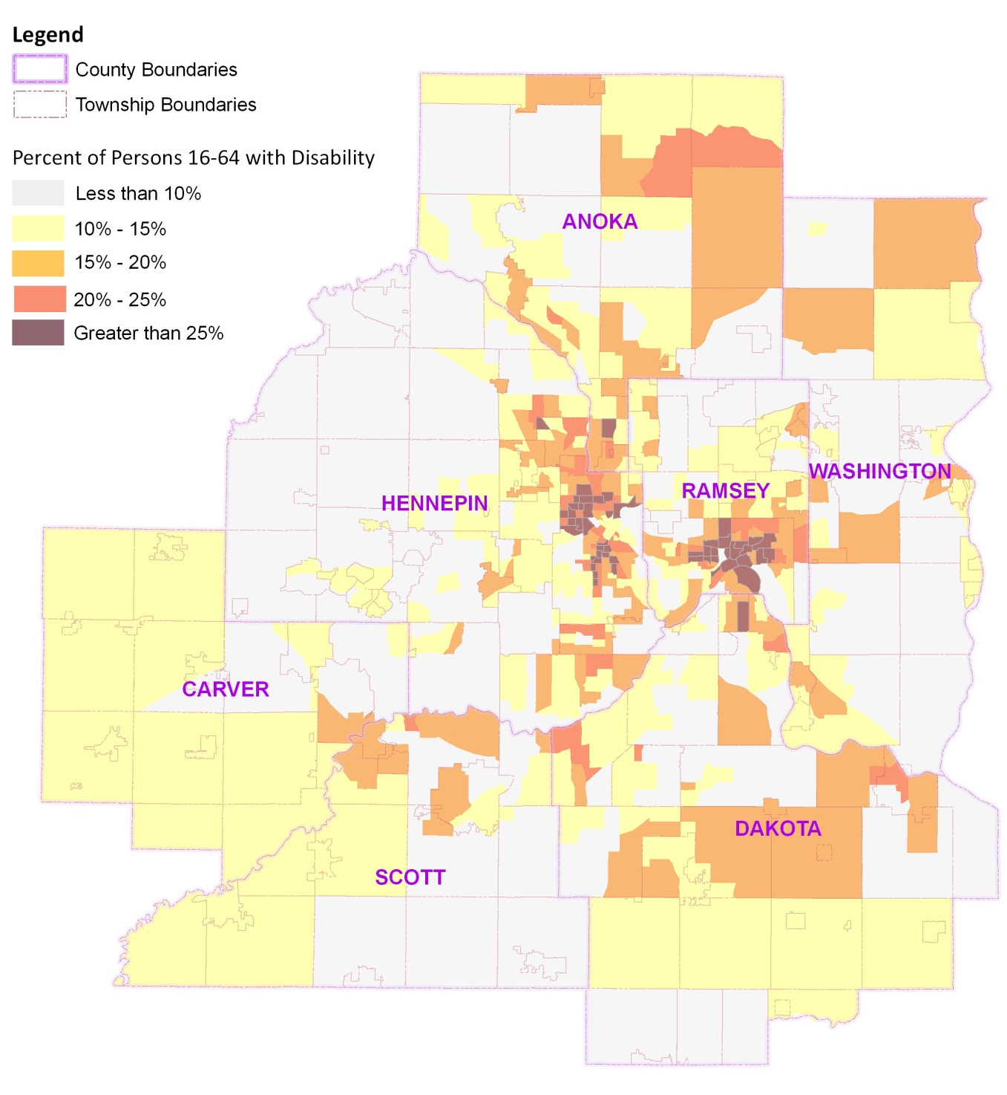

Poverty Threshold
(Share of Population 0-150% of Federal Poverty Level)

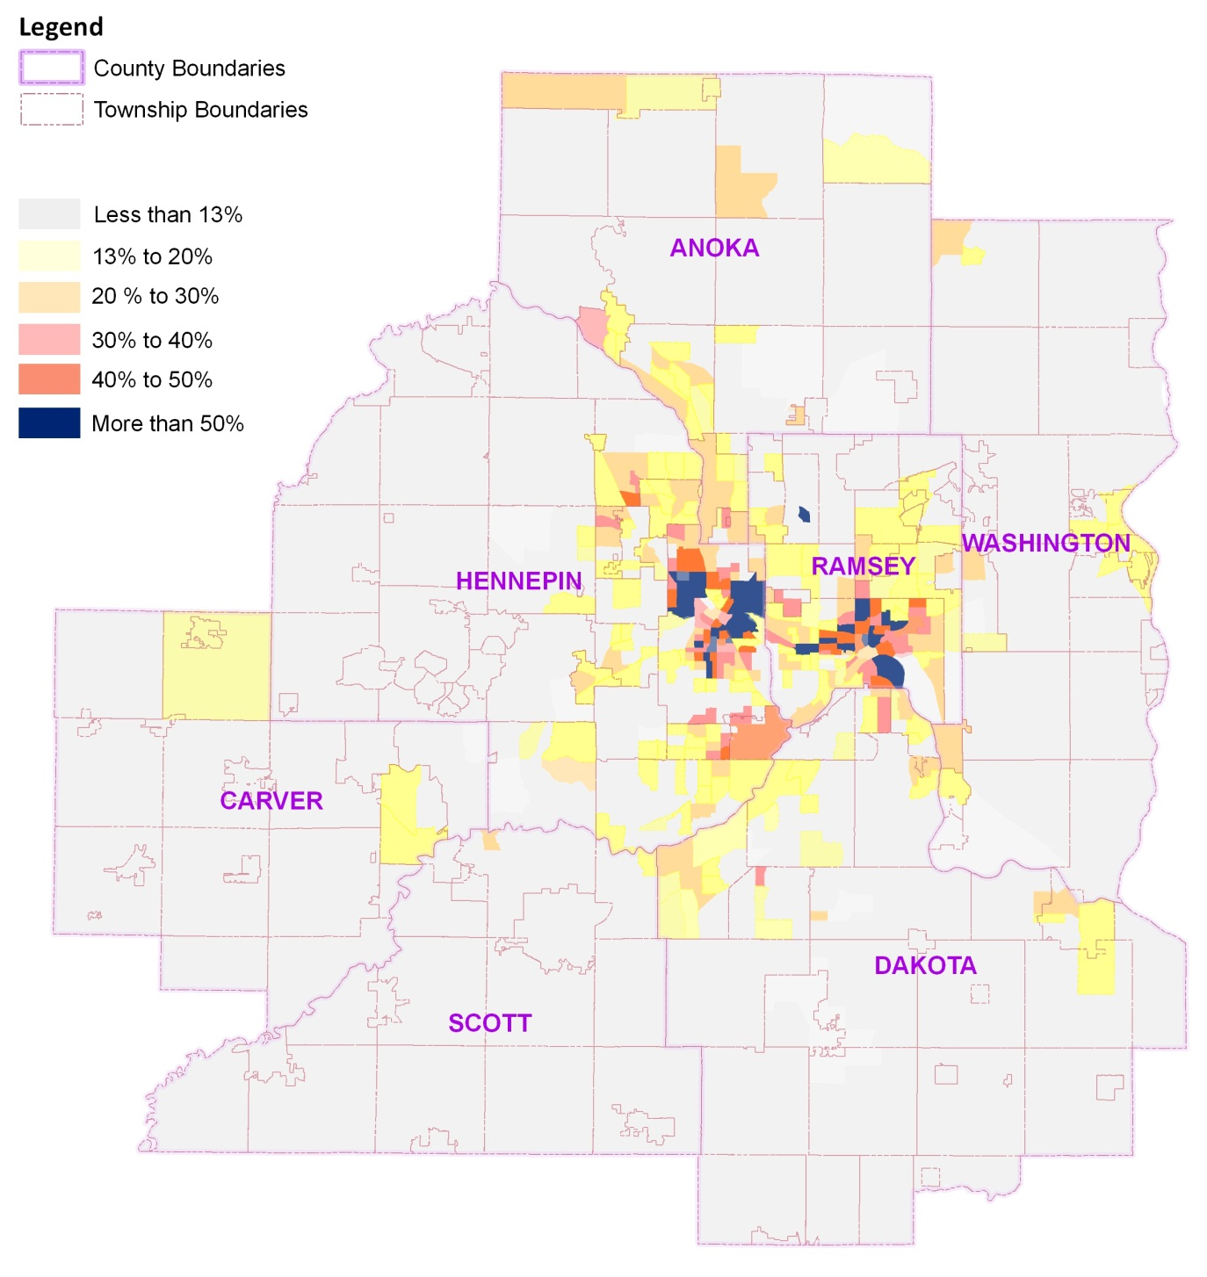

Number of Household without a Vehicle

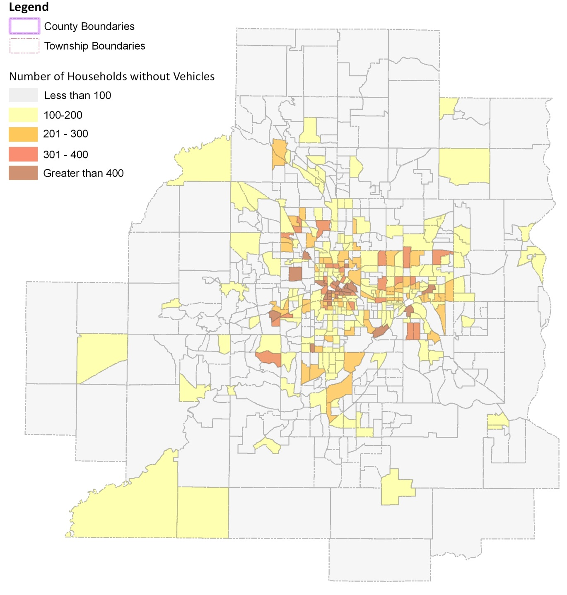

Older Adult Population, 2010

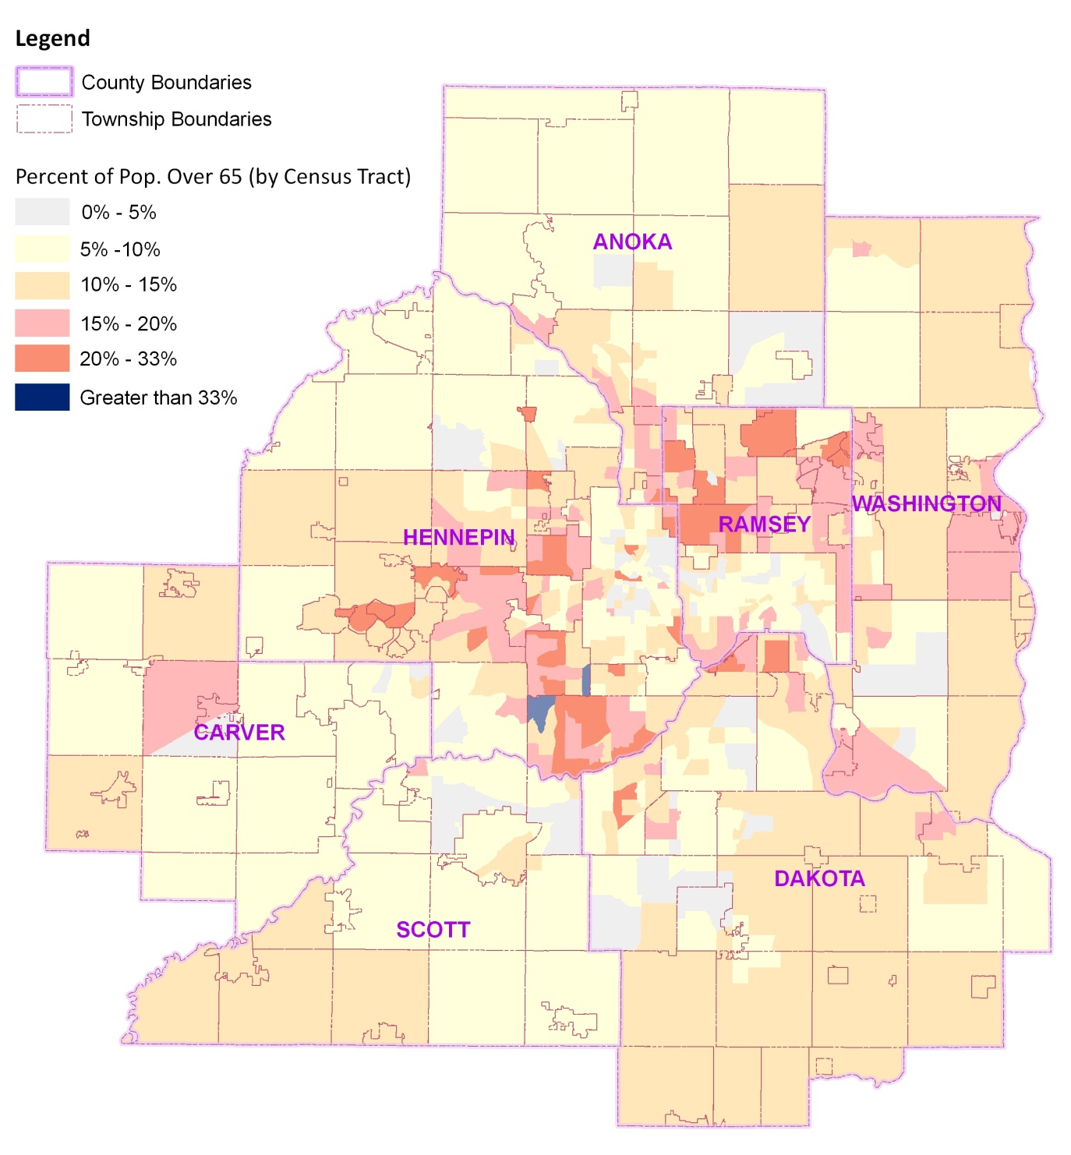

Subrecipient Requirements and Monitoring

Definition of Subrecipient from FTA Master Agreement:
Subrecipient means any entity that receives Federal assistance awarded by a FTA Recipient, rather than FTA directly. The term "subrecipient" also includes the term "subgrantee," but does not include "third party contractor" or "third party subcontractor."
Subagreement means an agreement through which a Recipient awards financial assistance derived from FTA to the subrecipient as defined in the FTA Master Agreement. The term "subagreement" also includes the term "subgrant," but does not include the term "third party subcontract."

Application Process
- All projects – complete forms for project description/detail and budget and timeline/milestones.
- FTA Certifications and Assurances – should be completed annually for each new federal fiscal year, which begins on October 1. Forms will be provided by the Council. Section numbers one and three must be completed by all subrecipients; other sections to be certified are determined by the nature of the project. Note that these will be held in the Grants administration files.
- Proof of acceptable A-133 audit if over $500,000 of federal funds are received on an annual basis (includes all federal sources). Note that these will be held in the Grants administration files.
- Construction projects/environmental requirements – Categorical exclusions, State Historic Preservation Office, etc.
- Revenue vehicles – changes to fleet plan.

Award Process
- Federal notice of award is received. Note that this must occur before all subsequent steps.
- Council issues to the Subrecipient the Subrecipient Agreement that flows through FTA requirements, including:
  - Title VI of the Civil Rights Act of 1964
  - Equal Employment Opportunity (EEO)
  - Boilerplate FTA language must be included and flowed through to all levels
  - Disclosure Form to Report Lobbying (FTA Form LLL)

Grant Administration Process (through Council staff)
- Procurement rules and guidance questions to Council
- Prior approvals – Buy America waivers, scope changes, etc.
- Rebudgeting, revision or amendment
- Record keeping
- Reporting – financial and milestone
- Other – DBE reporting
- Closeout
- Audit

