# Engagement Strategies and Approach

**May – October 2024**

Since August 2020, the project team, along with the community engagement cohort, Cultivate artists, Anti-Displacement Work Group, and committee members, have engaged with communities through a variety of activities, including in-person and virtual community meetings, door knocking, attending community events, online and paper surveys, and interactive maps. See below for the timing and project updates shared during each round of engagement.

* **Round 1** (August 2020 through January 2021): Input on project goals, concerns, opportunities, and thoughts on potential new routes
* **Round 2** (March to June 2021): Input on new route options released as part of the Initial Route Modification Report
* **Round 3** (July to August 2021): Input on the connections that light rail would make within communities and station locations within those areas
* **Round 4** (September to December 2021): Input on updated design concepts and potential opportunities and impacts of light rail options
* **Round 5** (April to May 2022): Input on the route recommendation as part of the Final Route Modification Report
* **Round 6 (**September to December 2022):

**September** – Input on three route options between Target Field Station and West Broadway and four route options between Washington Avenue and Irving Avenue in Minneapolis**.**

**October – December** – Input on route options that will be studied in the environmental document, share updates on the anti-displacement working group’s work, and discuss next steps for the project.

* **Round 7** (January to May 2023): Input on the two route options between Target Field Station and West Broadway (East of I-94 or Lyndale Avenue) and two route options between Washington Avenue and Irving Avenue in Minneapolis (21st Avenue or West Broadway). Updated designs and options were also presented in Brooklyn Park, Crystal, and Robbinsdale for feedback.
* **Round 8** (June to August 2023): Input on the east of I-94 route options between Target Field Station and West Broadway:

**Option1:** east of I-94 connection would run alongside the highway to become at grade and center running on Washington Avenue

**Option 2:** 10th Avenue to Washington Avenue (either with 10th Avenue being a transit mall or one-way northbound traffic)

Both would require a crossing over I-94 to either 21st Avenue or West Broadway Avenue.

Public input was solicited again on placing tracks on 21st Avenue instead of West Broadway in north Minneapolis.

* **Round 9** (September to December 2023): Feedback from business owners along the corridor. Staff also received feedback on two proposed route options in the North Loop neighborhood of Minneapolis.
* **Round 10** (January to May 2024): Shared 30% design plans and solicited feedback on how BLE infrastructure can improve local neighborhoods through engineering design, anti-displacement initiatives, station design, and station area planning work.
* **Round 11** (May to October 2024): Shared environmental impacts through the Supplemental Draft Impact Statement (SDEIS) publication and preliminary design plans for municipal consent and solicited feedback through two comment periods on these topics. Staff also gathered input from North Minneapolis residents regarding their vision for the future of the BLE corridor during DREAMNorth events.

**July 16 – August 5**: Comment Period for the SDEIS

**July 26 – October 10**: Comment period on preliminary design plans for municipal consent.

This document summarizes the feedback received during Round 11 of public engagement from May to October 2024, including a summary of community meetings, comment sessions, public hearings, and city council meetings. Project staff have engaged with the public about the project through the following events:

## Public meetings (16 in-person, 1 virtual)

### Virtual Meetings

* METRO Blue Line Extension SDEIS Virtual Learning Session (~5 attendees)
  + Thurs, June 27, 2024, from 5:30 – 7:30 p.m.

### In-person meetings

* METRO Blue Line Extension Quarterly Meeting
  + Wed, May 15 from 5 – 7 p.m. at Capri Theater (~27 attendees)
* METRO Blue Line Extension SDEIS Public Hearing #1 (~30 attendees)
  + Tues, July 16 from 5 – 7 p.m. at North Point Conference Center
* METRO Blue Line Extension SDEIS Public Hearing #2 (~20 attendees)
  + Tues, July 23 from 10 a.m. – 12 p.m. at Brooklyn Park Library
* DREAMNorth Sessions at the University of Minnesota Urban Outreach Research Center (UROC)
  + Session #1: Thurs, July 25 from 5 – 8 p.m. (~40 attendees)
  + Session # 2: Sat, July 27 from 9 a.m. – noon (~25 attendees)
  + Session #3: Thurs, August 1 from 5 – 8 p.m. (~12 attendees)
  + Session #4: Thurs, August 8 from 9 a.m. – 12 p.m. (~30 attendees)
* Session #5: Wed, August 21 from 5 – 7 p.m. Report Release
* Crystal Municipal Consent Open House and Public Hearing (~50 attendees)
  + Open House Tues, August 20 from 4 – 6 p.m. at Crystal Community Center
  + Public Hearing: Tues, August 20 starting at 5 p.m. at City Hall
* Robbinsdale Municipal Consent Public Open House (~300 attendees)
  + Wed, August 21, 2024, from 6 – 8 p.m. at Elim Lutheran Church
* Hennepin County Board/Met Council Municipal Consent Public Hearing (~40 attendees)
  + Mon, August 26, 2024, from 6 - 8 p.m. at NorthPoint Health and Wellness Conference Center
* Robbinsdale Municipal Consent Public Hearing
  + Tues, September 3, 2024, from 7- 9 p.m. at Robbinsdale City Hall
* Brooklyn Park Municipal Consent Open House and Public Hearing (~55 attendees)
  + Open House: Mon, September 9, 2024, from 4-6 p.m. at Brooklyn Park Community Activity Center
  + Public Hearing: Mon, September 9, 2024, from 6 - 8p.m. at Brooklyn Park City Hall (~40 attendees)
* Minneapolis Municipal Consent Public Hearing
  + Thurs, September 12, 2024, from 1:30 – 3:30 p.m. at Public Service Center, Room 350

### Meeting Types

* Virtual Learning Session – hosted on Microsoft Teams, staff shared information on how to provide comments on the SDEIS.
* DREAMNorth Sessions - standing for Develop Recommendations, Empower, Action, and Mobilize, DREAMNorth was a community-led process that explored opportunities for the design and development of the Blue Line Extension in a way that would benefit the people in the communities it will serve.
* Supplemental Draft Environmental Impact Statement (SDEIS) Public Hearings - staff presented an overview of the project and information about the SDEIS. The public was given the opportunity to provide verbal and written comments on the SDEIS in front of Hennepin County Commissioners and Corridor Management Committee members.
* Municipal Consent Open Houses - open houses featured informational boards and municipal consent layouts. Staff were present to answer questions and take notes from community members as they explored the information.
* Municipal Consent Public Hearings - each city along the route held separate hearings before taking action on preliminary design plans. The public was given the opportunity to provide verbal and written comments on preliminary design plans for the BLE project.

### Other Meeting Metrics:

* 18 pop-up events
* 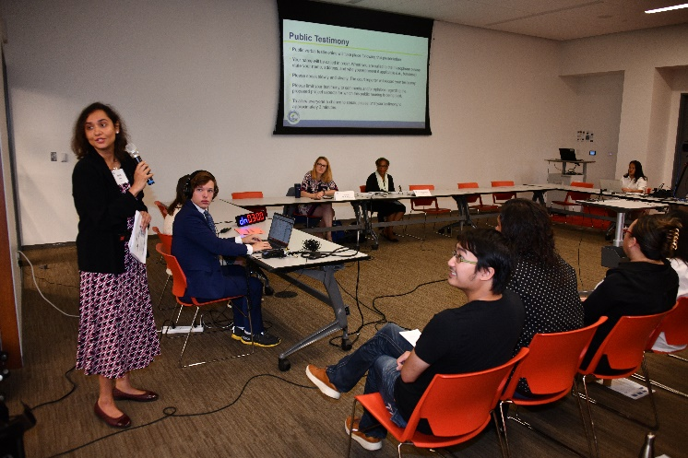5 cohort meetings
* 7 events with stakeholder and business representatives
* 5 Advisory Committee meetings
* Many more questions, one one-on-one stakeholder meetings, office hours and phone calls

### Engagement Metrics from August 2020 – October 2024

|  |  |
| --- | --- |
| * **922** events resulting in nearly **39,925** points of contact with the public​ * **80,000** reach on social media and **6.5 million+** reach through newsletters and paid ads on community and cultural media​ * Approximately **4,790** survey responses​ * **+3,800** comments on the interactive map​ * **+4,700** comments from comment forms​ * Corridor postcards mailed to **+250,000​** * Over **5,000** emails and phone calls | Figure 1. Image of SDEIS Hearing on July 23, 2024. |

## Common Engagement Themes

Below are common themes that emerged from feedback during this round of engagement.

* Anti-displacement
  + Hope that the Anti-Displacement Coordinated Action Plan will yield positive results for the community
  + Desire to take advantage of the initiatives described in the Anti-Displacement Coordinated Action plan
  + Concerns regarding property and community impacts
* Community Development
  + Understanding that the BLE will improve mobility and connectivity
  + Excitement for the BLE to bring customers and visitors to the businesses along the route
* Engagement and Communications Strategies
  + Desire to speak directly to engineers at public events
  + Requests for alternative communication methods to reach those who do not have access to the internet

## Feedback from DREAMNorth Sessions

Standing for **D**evelop **R**ecommendations, **E**mpower, **A**ction, and **M**obilize (DREAM) North was a community-led process led by a BLE cohort One MN that explored ways the BLE could benefit communities in North Minneapolis. Community leaders facilitated four sessions in July and August at the UROC. Participants were asked to imagine what opportunities a large transportation project like the BLE could bring to the North Minneapolis community. Following the sessions, a report summarizing the vision of how the BLE can benefit North Minneapolis was developed. Below is a summary of the report:

### North Minneapolis Transit Users Like to See

* *Homeowners* want financial and resource support in the event of displacement, want to know provisions for access to their home, and believe more transit will address traffic growing congestion.
* *Renters* are concerned about absentee landlords not sharing BLE information with them, want to know what displacement support will be available, want to know about BLE job opportunities, and would like to explore homeownership opportunities.
* *Elderly* want accessible parking near stations, shuttles going to grocery stores and parking spots, ADA accessibility, public restrooms, proximity to diverse use businesses (i.e. healthcare, grocery stores, post office, etc.), and resources for addicts and homeless.
* *Business owners* want to be consulted in the decision-making process, to have business disruption mitigation support like shuttles for employees and temporary parking solutions, to know the anti-displacement resources available, and welcome the increased business from the BLE completion.
* *Youth* appreciate transit options and want Wi-Fi access, job opportunities for the city or county and around BLE, and recreation spaces to connect with friends and family.
* *The disability community* wants accessibility features such as ramps, elevators, verbal commands, payment accessibility, language options, legible and textured maps, color cues, and the same benefits as teens and the elderly.

*Community Vision*

During the sessions, Northsiders created a vision of their community in the present and for the future.

* **Living** communally with community mixed-use workforce housing and lifestyle complexes that include bodegas, cafes, senior and adult lifestyle centers, hotels, healthcare services, and more.
* Strong **work** center for finance, insurance, and real estate businesses as well as an advanced manufacturing district.
* A place for **play** with many arts, cultural, dining, and entertainment opportunities as well as its local gardens and open space.
* A neighborhood that **evolves** and grows through the use of youth and family centers and their trades education centers.
* They want **policy** acknowledging emerging community corridors and integrated development strategies throughout the Northside.
* **Service** is one of the values of this area as it is reflected in their several food spaces, wellness and movement centers, and other spaces that help improve the quality of life for residents.
* The **people and spaces** have a close relationship in their vision as they have cultural learning experience centers, and the Northside market mall and they would like this value to represented even more with the creation of sidewalk stalls near the stations.
* There is a hope for the **stations, infrastructure, and environment** to be improved by the project activities like widening Broadway, integrating community security, improving stations, and increasing the art and light in the neighborhoods to promote safety and vibrancy.

## Feedback from the SDEIS Comment Period

The Supplemental Draft Environmental Impact Statement (SDEIS) is a document required by the Federal Transit Administration (FTA) for the METRO Blue Line Extension Project that evaluates the impact of the project including its potential social, economic, and environmental benefits and impact due to the design, construction, and operation of the Blue Line Extension.

The SDEIS was published in June 2024 and the public comment period ended on August 6, 2024. Project staff held two public hearings in July, providing an opportunity for the public to submit verbal and written comments. Below are two maps showing the location of SDEIS commenters in relation to the route and whether the commenter is in support, opposition, or unsure of the BLE project.

### Commenter Locations

Figure 3. The map shows the distribution of commenter locations based on their support type. The majority of oppositional comments were concentrated in Robbinsdale, while the most supportive comments were made in and throughout Minneapolis.

Figure 2. The map shows the locations of all commenters, with a majority of them being located near and along the route. Notably, the community members of Robbinsdale contributed the most comments on the SDEIS, followed by North Minneapolis and Crystal.

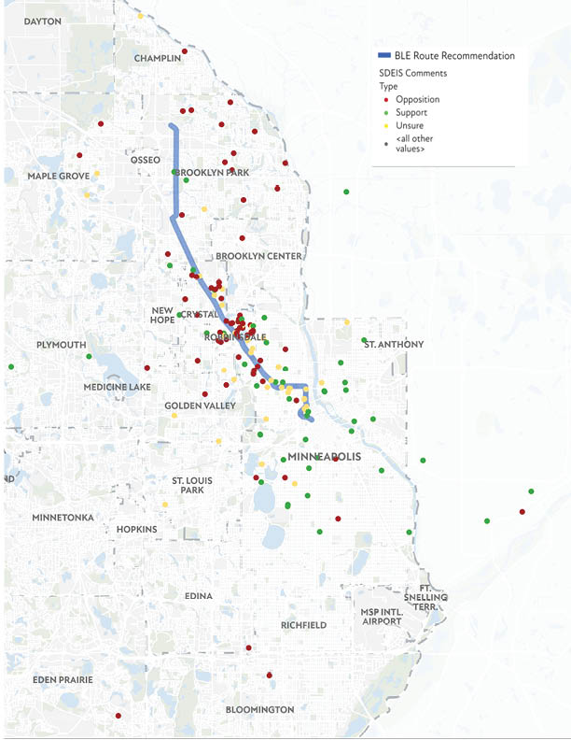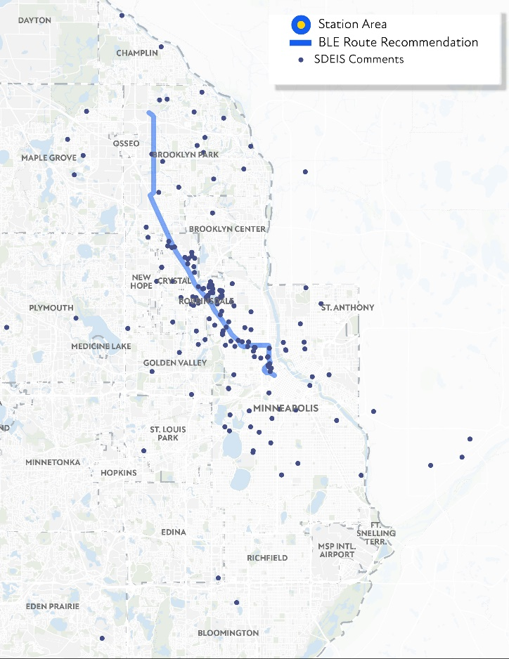

## Feedback from Municipal Consent

Hennepin County and each corridor city along the BLE route (Brooklyn Park, Crystal, Robbinsdale, and Minneapolis) held open houses and/or public hearings allowing the public to view and ask questions on the preliminary design plans for municipal consent ahead of their action. In September and October 2024, the cities of Brooklyn Park, Crystal, Robbinsdale, Minneapolis and Hennepin County voted to approve the preliminary design plans for the Blue Line Extension. Of the 38 elected officials responsible for voting on these plans, 33 voted to approve the plans. Visit [BlueLineExt.org](https://BlueLineExt.org) for links to each agency’s resolution of support.

### Comment Themes

Below is a summary of community feedback received by project staff during the municipal consent process. Each corridor city also solicited feedback from their respective residents and is not included in this summary. The project team received a total of 21 verbal comments and 16 written comments and common themes included the following:

* Financing the project and the overall budget.
* Concerns over crime and safety, specifically with drug use.
* Concerns about not being heard or adequately represented during the entire engagement process.
* Concern over ridership numbers given the rise of remote work.
* Concern over the displacement of homes and businesses and desire for clarification around future anti-displacement efforts.
* Support for connectivity through the Metro area to the northern suburbs.
* Small business impacts and concerns during construction.
* Traffic congestion and emergency vehicle access as a result of lane removal to accommodate LRT tracks.
* Preference for an improved BRT system as opposed to expanding LRT.
* Noise impacts due to the proximity of the alignment to existing housing.
* Low-emissions transit opportunities for people without cars.
* Opportunity for Transit Oriented Development along the corridor.
* Pedestrian safety concerns while crossing the street to arrive at the station.

## Community Cohort Updates

Since 2020, the METRO Blue Line Extension Project has extended the reach of their communications and public involvement by directly contracting with community and cultural groups. These groups’ experience, expertise, and trusted relationship networks in the corridor are essential to ensuring that the needs and concerns of all communities are understood and incorporated into project development. Community cohort organizations meet monthly with project staff to report community feedback, share upcoming events, and learn about timely project updates. Community cohort organizations meet monthly with project staff to report community feedback, share upcoming events, and learn about timely project updates. Organizations participating in the current community engagement cohort include:

* A Mother's Love
* Asian Media Access Inc.
* Heritage Park Association
* Juxtaposition Arts
* Lao Assistance Center of MN
* Liberian Business Association
* NEON
* Pueblos de Lucha y Esperanza
* One MN

During cohort check-in meetings, cohort members gave an overview of the communities they have been reaching and the tactics they use. Cohort members reach the community via social media, in-person engagement, door-knocking at homes and businesses, events, and relationships with other community institutions like churches and schools.

During the cohort's monthly meetings from May to October 2024, members shared feedback they had received during their engagement efforts. Feedback included:

* Potential Mitigation - Property
  + Give people choice to leave or stay
  + Inquiries about if all phases of the project are considered when discussing impacts
  + Inquiries about the list of properties impacted and what will happen to them after the project
    - Request to have left-over parcels remain in community for reinvestment
  + Question if noise walls can be more aesthetic
* Potential Mitigation - Business
  + Suggestion to keep parking free on West Broadway
  + Questions about what resources are there for small businesses during construction
* Anti-Displacement
  + Considering how to reach people and help them understand what the Coordinated Action Plan is
  + Questions on how impacts are identified and studied
  + DREAMNorth was a successful in generating ideas for initiatives, policies, and concepts for how they would like to see happen around the Blue Line Extension corridor in North Minneapolis
  + Concerns from community about financial support and what resources will be available during construction
* SDEIS Comment Period
  + Request to expand comment period to 60 days
  + Discussion about social media notices and receiving comments
  + Discussion on how to make the SDEIS more approachable through reading and learning sessions
* Community
  + Mentions that the Asian community should be engaged on the economic development that comes with the Blue Line Extension
  + Suggestion that the youth should be engaged with more since they are the next generation of riders
  + Requests for shuttles and circulators for movement during construction and operation
  + Clarification is needed on how cohort members communicate questions from community with project staff