How to Apply for the 2023 I/I Grant in the MCES Customer Portal

- Go to the following link: MCES Customer Portal.

- Sign in if you are a returning user or select “Create Account” if you are a new user. Returning users may also use the “Forget Password?” link to reset their password.

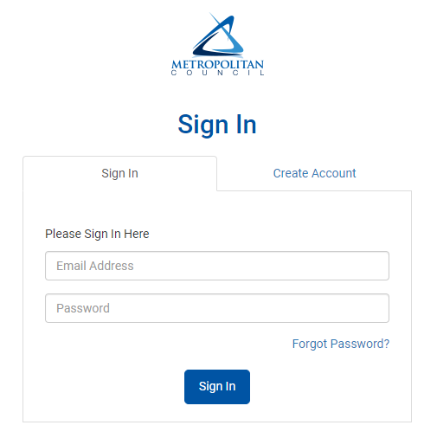

- Click on the applications dropdown and then click on grants.

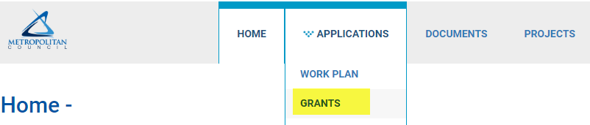

- Expand the grant you are interested in applying to, and click “start” to begin your application

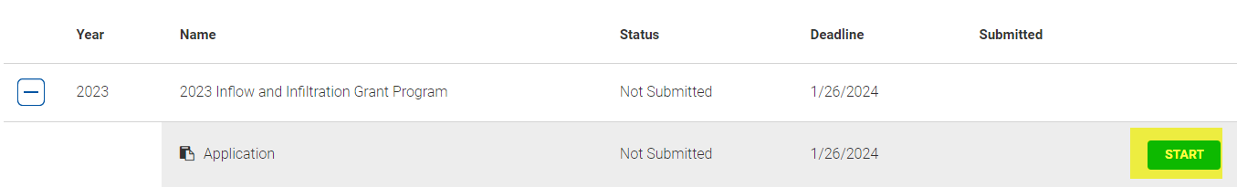
- Within the application, enter your estimated project work description (e.g. In 2024 we plan to line 300 feet of pipe on Jackson Street. This will start in May 2024 and will be complete by August 2024).

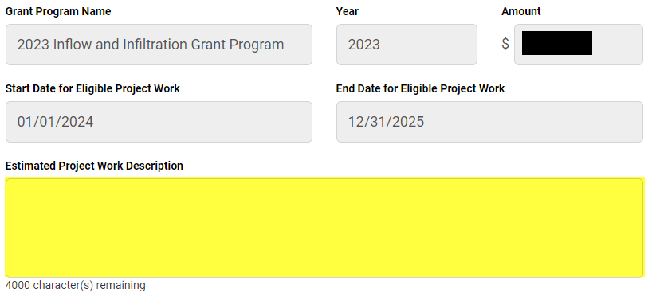

- In the bottom of the application, enter your estimated project costs.

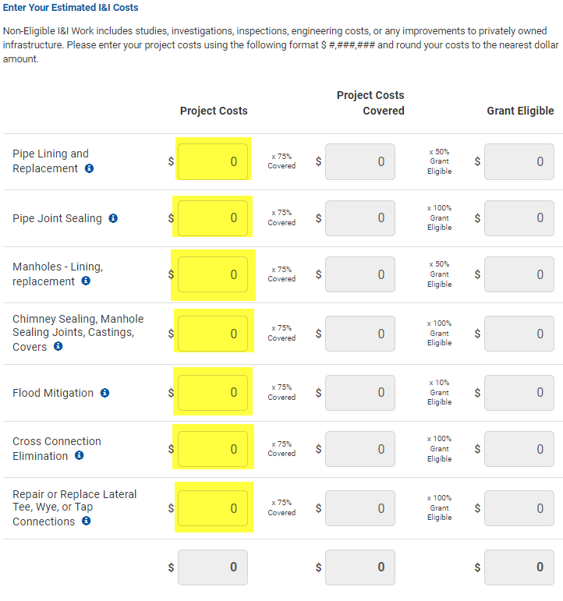

- When finished, click “Apply” at the bottom of the screen.

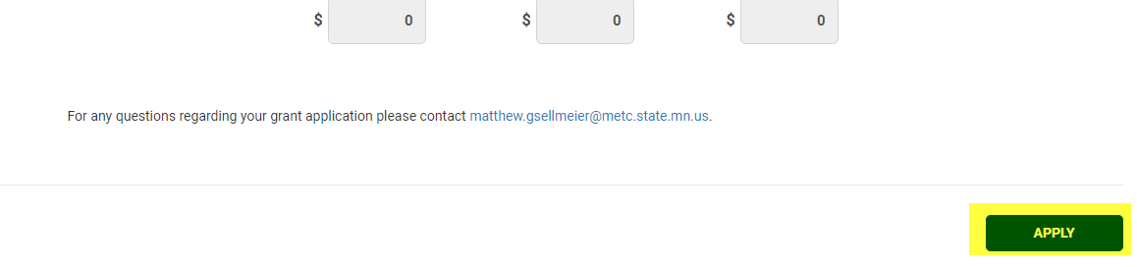

For any questions regarding your grant application, please contact Matt Gsellmeier at matthew.gsellmeier@metc.state.mn.us or 651-602-1802.

