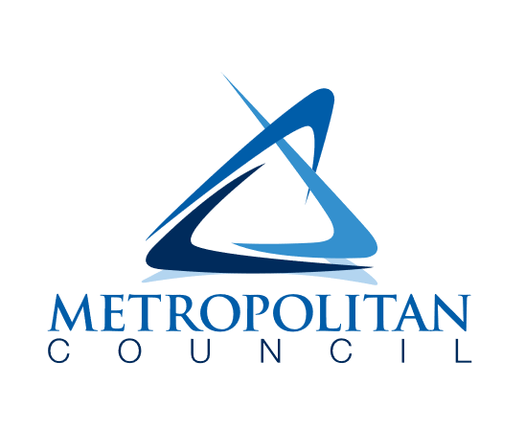
Private Property Inflow & infiltration grant program
MCUB List - 2025

Information
This list contains verified Metropolitan Council Underutilized Business (MCUB) that perform water and sewer work. This list has been provided as a reference and resource. It is not required to solicit quotes or use the businesses on this list.

Met Council has a goal to consider equity in this grant program and see this as an opportunity to increase the equity impacts by providing this list for applying municipalities.

COMPANY | PHONE | EMAIL
BKJ LAND COMPANY II DBA BKJ EXCAVATING | 952-496-1060 | amjohnson@bkjlandco.com
CASTREJON INCORPORATED | 763-450-2055 | monica@castrejoninc.com
DULAS EXCAVATING INC | 507-553-3938 | crystal@dulasexcavating.com
GM CONTRACTING INC | 507-726-6433 | sharazin@gmcontractinginc.com
PWS INC | 612-789-6162 | lmeyer@petesws.com
QUAD E COMPANIES INC | 612-462-0629 | elizabeth.ennenga@quadecompanies.com

