Permit Renewal Application for Water Treatment Plants
Log into the Industrial Online Reporting System at: metrocouncil.org/IORS

Opening the Permit Renewal Application
From the “My Dashboard” tab, look for the submittal type “Permit Renewal Application – Water Treatment Plants.”
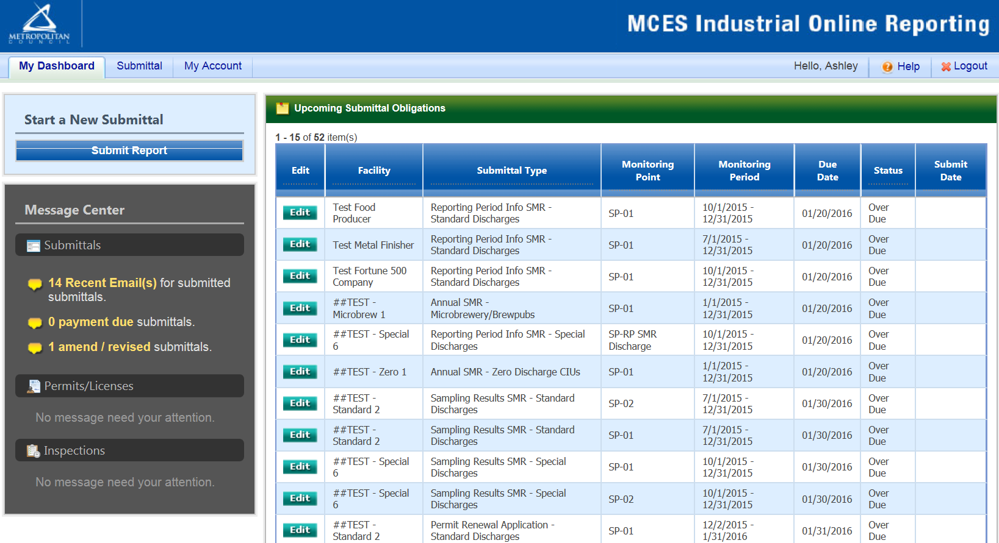
Click on the edit button in the “Edit” column for the respective submittal.

Completing the Permit Renewal Application
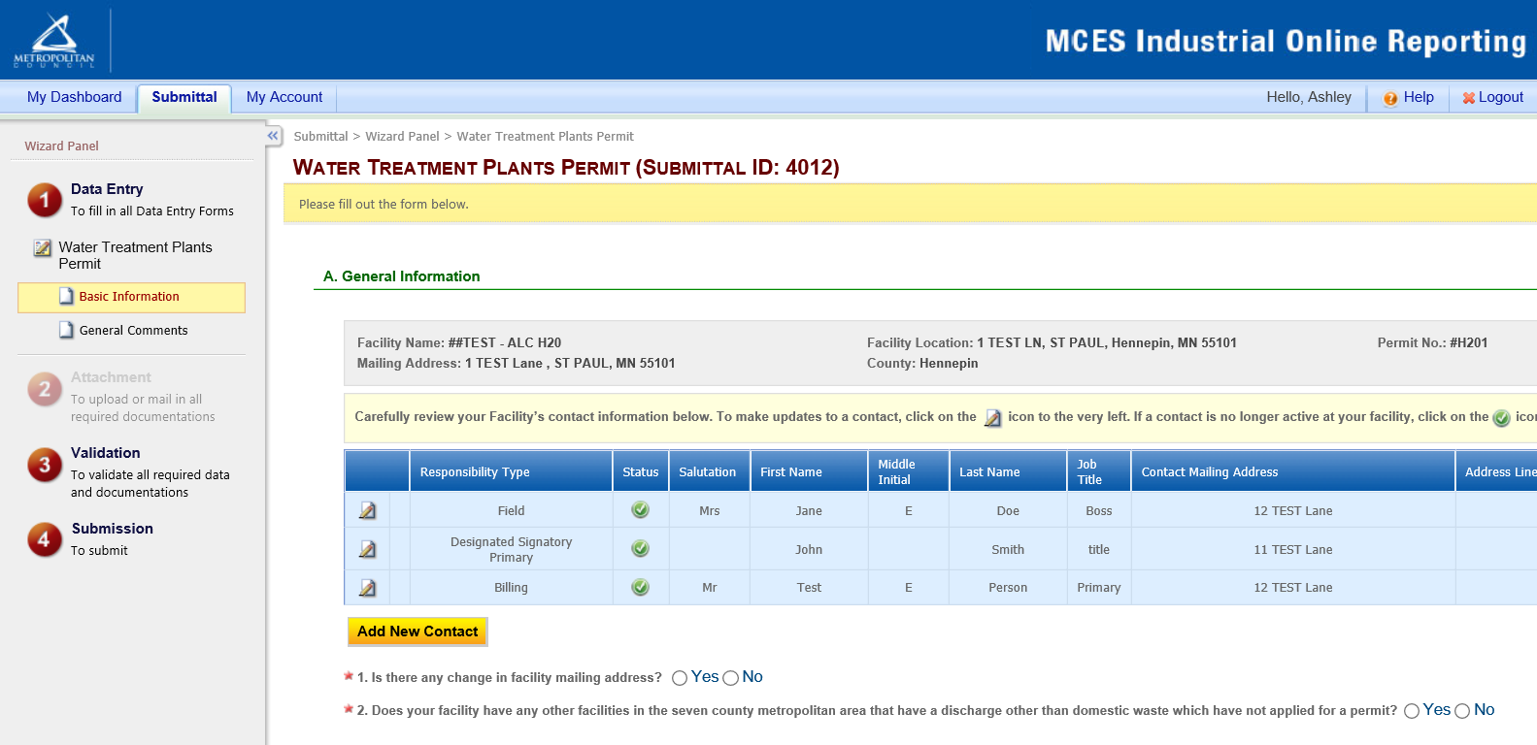

Data Entry
The grey header displays the facility’s basic information. Before adding any information to the form, tab below, confirm that the information in this grey header is for the correct facility. If the information is incorrect, please go back to the previous page and select the correct submission.

Step 1: Basic Information
Below the grey header there is a blue table that displays the facility’s contact information.
Note: Scroll to the right of the screen to see all the information about the contact.
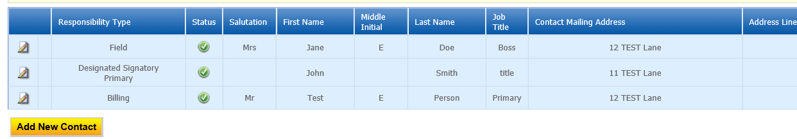
To remove: If the person no longer works at the facility change the status from “Active” to “Inactive” by clicking on the green check mark button in the status column of the table. The status will change to a red “X” mark.
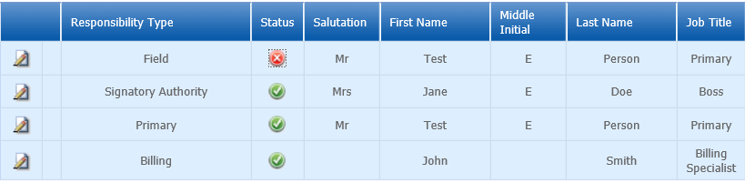
To add: Click on the yellow “Add New Record” button. The page will display a pop up window for you to enter in the contact information for a new contact person. The required fields of information are denoted with a red asterisk. Then click on the blue “Save” button.
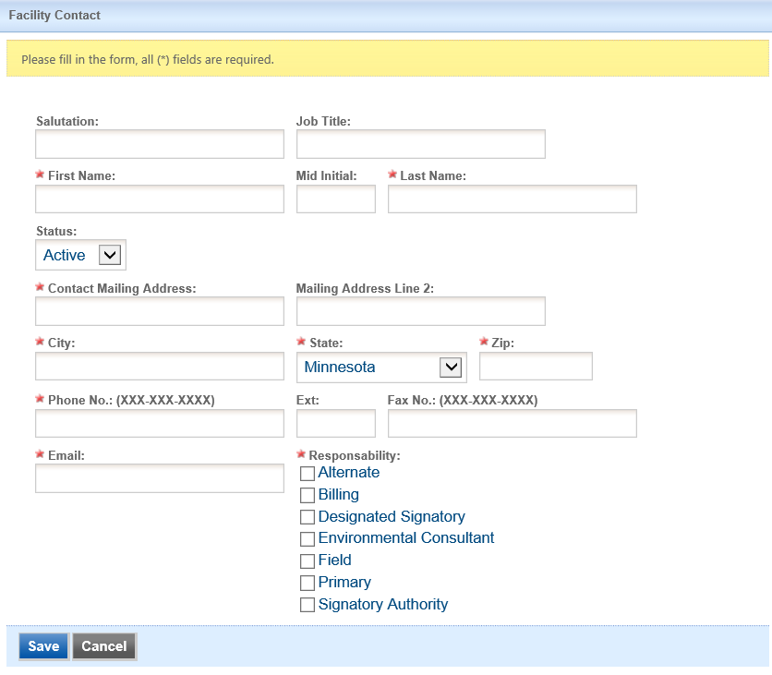
The blue table will be updated with the new contact person.
To edit: Click on the “edit” symbol (far left column) in the row of the respective person who’s contact information needs to be updated. The page will display a pop up window for you to enter in the updated information. The required fields of information are denoted with a red asterisk. Then click the “Save” button.
Name Change: If the person listed has a change in their name or you need to make a correction to the spelling of the name the form will not allow you to make the change. To make the correction, enter in the correct name in the box provided. Please also include a reason for the name correction.
To save the record, click on the “Save” button.
The blue table will be updated with the information that was provided in the pop-up window.
Answer questions 1 and 2 (question below the blue table) by selecting the appropriate radio button. Depending on the selection, the system may require you to add more information. The required fields are denoted with a red asterisk (*).

Step 2: Operations
- Number of employees per shift
Enter in the number of employees for each shift in the fields provided. Add/update the times for each shift.
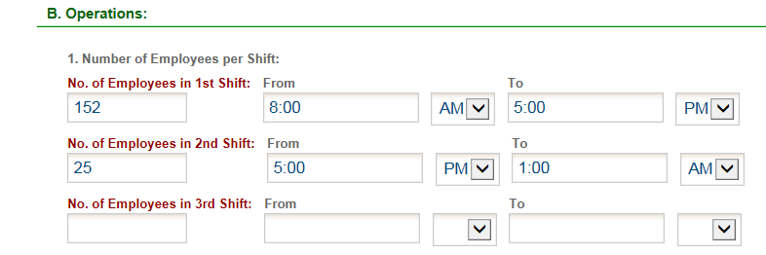
- Hours of Operation
To add: Click on the yellow “Add New Record” button and an empty row of the table will appear for you to enter information.
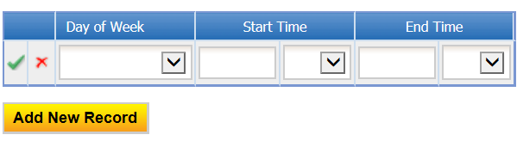
In the row, select the day of the week from the drop-down menu, enter start time, select AM/PM, enter end time, select AM/PM and click on the green check mark to complete editing.
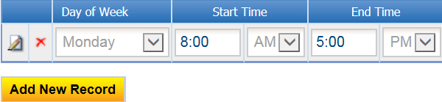
To edit: Click on the “edit” symbol in the far left column of the table next the respective row. Make the necessary changes and click on the green check mark to complete editing.
Note: Only one row of the table can be edited at a time.
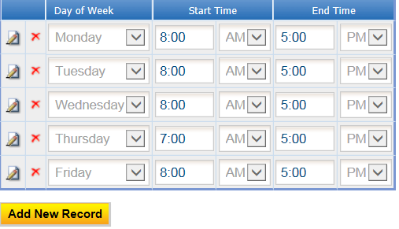

Step 3: Production
- NAICS Code and Description of Operations
To add: Click on the yellow “Add New Record” button and a row in the table will appear for you to select information.
In the row, select the appropriate NAICS code from the drop-down menu. Once selected, the page will refresh. You will have to scroll back down to the NAICS code table. The NAICS code will be displayed and the description of operations will be completed.
Note: You can also generate the NAICS code by selecting the appropriate description of operations. The NAICS code will generate once a description of operations has been selected.
If this is the primary operation at the facility, click on the “edit” button and check the box under primary. Then click on the green check mark to complete editing.
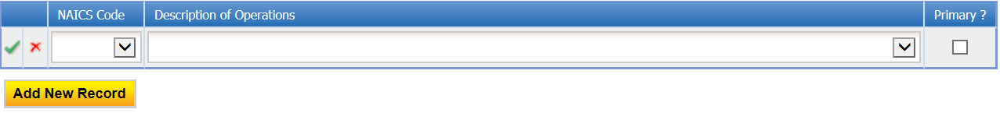
To edit: Click on the “edit” symbol in the far left column of the table next to the respective row. Make the necessary changes and click on the green check mark to complete editing.
Note: Only one row of the table can be edited at a time.
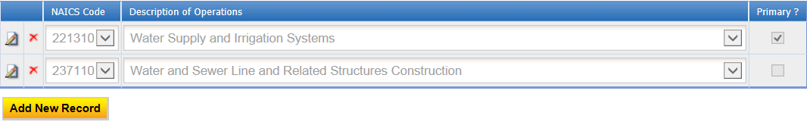
- Principal Chemical Used
You may request that information regarding principal chemicals be classified as confidential if you consider the specific information to be “trade secret information” as defined by the Minnesota Government Data Practices Act (Minnesota Statutes § 13.37).

To make this request, check the box “Yes”. You’ll need to submit a Confidential Business Information request form and a list of principal chemicals with quantities used. Both of these will need to be submitted via a secure method. See Attachment section for more information on the request process.

If “No” is selected, a table to enter in the raw material(s) information will appear.

To add: Click on the yellow “Add New Record” button and an empty row of the table will appear for you to enter information.
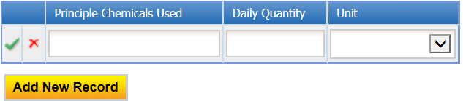
Enter the name of the chemical used, the daily quanity (integer), and select the units from the drop-down menu. Then click on the green check mark to complete editing.
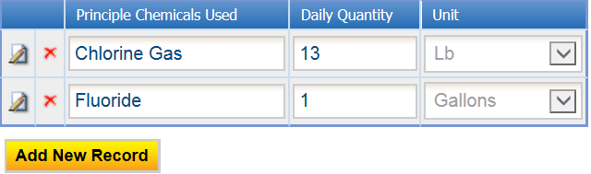
To edit: Click on the “edit” symbol in the far left column of the table next the respective row. Make the necessary changes and click on the green check mark to complete editing.
Note: Only one row of the table can be edited at a time.
- Principal Products
To add: Click on the yellow “Add New Record” button. The page will display a pop-up window for you to enter information on the principal product produced at the facility. Then click on the Save button.
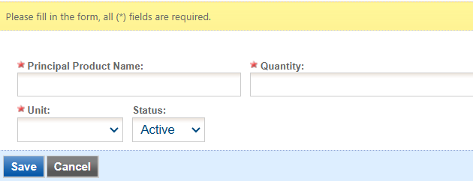
To edit: Click on the pencil and paper icon in the row you want to correct. This opens up the principal products window. Make the necessary changes and click on Save button.
Note: Only one row of the table can be edited at a time.
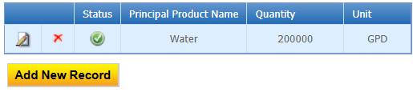
To remove: If the product is no longer made at the facility, please change the status from active to inactive by clicking on the green check mark button in the satus column of the table. This will change the status to a red “X”.

Answer questions 4 through 7 using the radio buttons provided. If any question is answered “Yes,” a field will be provided for you to enter an explanation. The explanation is a required field.

Step 4: Wastewater
- Sources of Industrial Waste
To add: Click on the yellow “Add New Record” button.
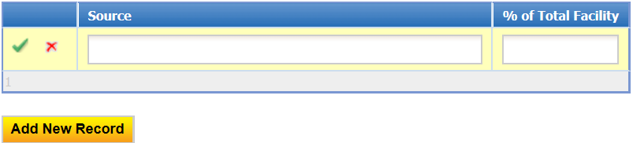
In the row, enter the name of the source and the percent of the total facility discharge that source contributes. Then click on the green check mark to complete editing.
To edit: Click on the “edit” symbol in the far left column of the table next the respective row. Make the necessary changes and click on the green check mark to complete editing.
Note: Only one row of the table can be edited at a time.
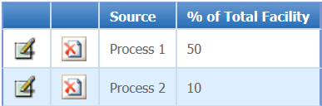
- Pretreatment Method
Answer the question using the radio button. If “No” is selected, proceed to the next question.
To add: Click on the yellow “Add New Record” button.
Note: Scroll to the right of the screen to see all of the information in the table. The complete table of information does not fit entirely on the viewing window.
In the row, select the method of treatment and the year installed. Next, enter the name of the wastestreams treated, paramter(s) treated and discharge rate (integer). Then select the discharge rate unit and frequency and enter the byproduct disposal method. Finally, click on the green check mark to complete editing.
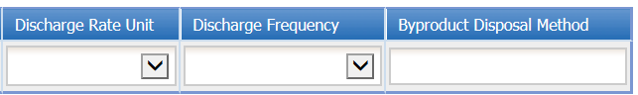
To edit: Click on the “edit” symbol in the far left column of the table next the respective row. Make the necessary changes and click on the green check mark to complete editing.
Note: Only one row of the table can be edited at a time.
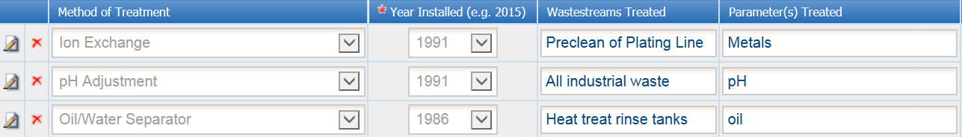
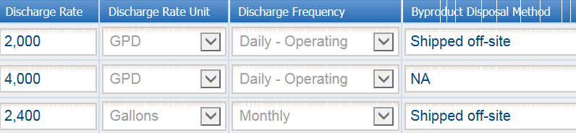
- Batch Discharges
Answer the question using the radio button. If “No” is selected, proceed to the next question.
To add: Click on the yellow “Add New Record” button.
In the row, enter the name of the source, charactersitics and quanitity (integer). Next, select the quantity units and discharge frequency and enter the pretreatment method (if applicable). Then click on the green check mark to complete editing.
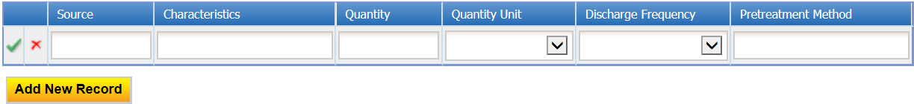
To edit: Click on the “edit” symbol in the far left column of the table next the respective row. Make the necessary changes and click on the green check mark to complete editing.
Note: Only one row of the table can be edited at a time.
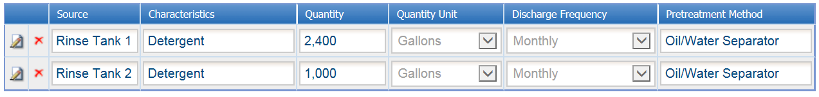
- Waste hauled off-site for treatment
Answer the question using the radio button. If “No” is selected, proceed to the next question.
To add: Click on the yellow “Add New Record” button.
In the row, enter the name of the wastestream shipped, charactersitics, and quanitity (integer). Next, select the quantity units and shipping frequency. Then enter the company who either transports this waste or where this waste is taken for disposal. Finally, click on the green check mark to complete editing.
To edit: Click on the “edit” symbol in the far left column of the table next the respective row. Make the necessary changes and click on the green check mark to complete editing.
Note: Only one row of the table can be edited at a time.
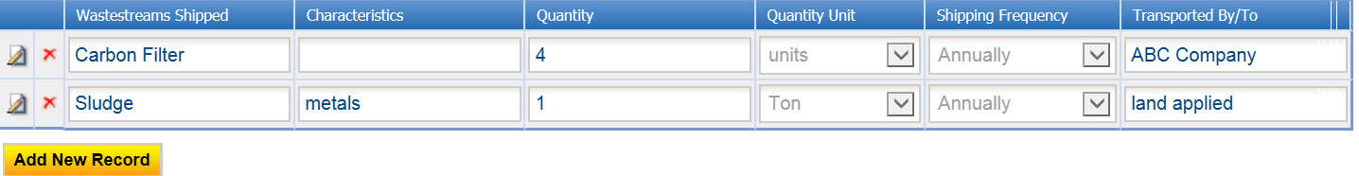

Step 5: Permits/Licenses
- Answer question 2 using the radio buttons.
If “No” is selected, a box will be provided for you to enter in the correct Federal Tax ID number for the facility.
- Answer question 3 using the radio buttons.
If “Yes” is selected, please enter the permit number in the field provided.
- Answer question 4 using the radio buttons.
If “Yes” is selected, use the drop down menu to choose the type of license. Click on the yellow “Add New Record” button. Next, enter in the Permit/License Number and the agency who issued the permit. The click on the green check mark to complete editing.
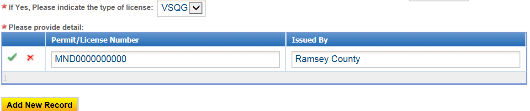
- Answer question 5 using the radio buttons.
If “Yes” is selected, a table will generate for you to complete about the hazardous waste discharge.Click on the yellow “Add New Record” button. Enter in the name of the hazardous waste discharge and quantity. Then select the quantity unit and discharge frequency from the drop down menu. Finally, click on the green check mark to complete editing.
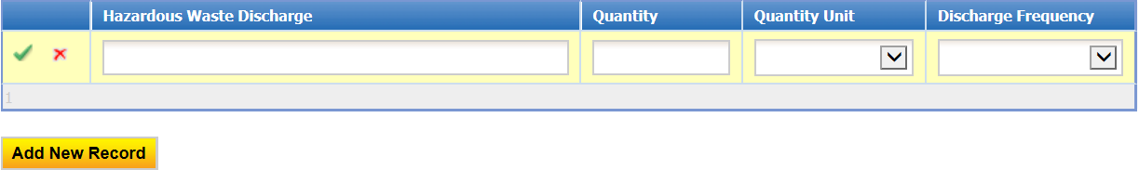

Step 6: Public Information Policy
Read the statement about the public information policy.

Step 7: Process Flow Schematic(s)
You may request that the process flow schematic be classified as confidential if you consider the specific information to be “trade secret information” as defined by the Minnesota Government Data Practices Act (Minnesota Statutes § 13.37).
Answer the question using the radio buttons provided.
If “Yes” is selected, you’ll need to submit a Confidential Business Information Request Form and the process flow schematic. Both of these will need to be submitted via a secure method. See Attachment section for more information on the request process.
If “No” is selected, you will either mail or attach the process flow schematic to this submission.

Step 8: General Comments
If you have any comments about the information provided, please enter the comments in the field provided.
Then click on the “Save” button before clicking on the “Next” button.

Attachment
The Attachment page allows you to select a method of attaching supporting documents for the Permit Renewal Application.
The attachment list for the Water Treatment General Permit is:
- Certification of Signatory Authority Form
- Facility Diagrams
- List of Chemicals Stored in Quantities Greater than 5 Gallons (Optional)
- List of Equipment or Processes that Use Non-Contact Cooling Water (Optional)
- Principal Chemicals
- Process Flow Schematics
- Supporting Documents (Optional)
More than one document can be uploaded to each attachment type.
Not all document types are “Required.” You do not have to select a radio button for attachments that are “Optional.”
To the right of each attachment type is a radio button to select how the information will be submitted.
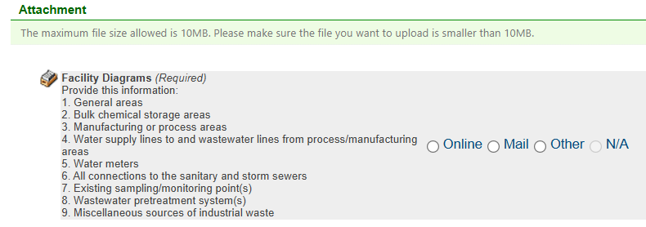
Online – If you select the “Online” option, the screen will show a red “Upload” button.
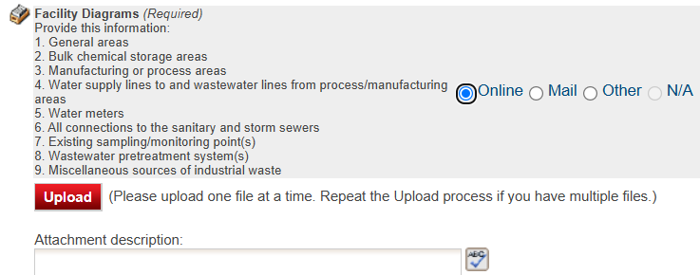
To proceed, click on the Upload button and the “Browse” button to search for the document that you would like to attach. Below the file name there is a comment field for you to add in a description about the attachment. The comment field is not required.
Click on the blue “To proceed, click on the Upload button and the “Browse” button to search for the document that you would like to attach. Below the file name there is a comment field for you to add in a description about the attachment. The comment field is not required. Click on the blue “Save” button to attach the document to this submission. The Attachment page will update and show the name and the description of the document that you entered.
Note: More than one document can be uploaded to each attachment type.
If you attached a document in error, please click on the red “X” button to remove the attachment.
Mail - If you select the “Mail” option, the page will update to show the address the document should be mailed to. Please mail documents to:
Industrial Waste & Pollution Prevention Section
Metropolitan Council Environmental Services
390 Robert Street North
St Paul, MN 55101

Trade Secret Information
Only the Principal Chemicals list and/or the Process Flow Schematics can be classified as “trade secret information”. If you selected that one or both of these are, the attachment page will show these on the page with “Submit via a Secure Method” in parenthesis.
In the description, you will see a blue link to the Confidential Business Information procedure and the request form. Click the link to download it. Then select either the Mail or Other radio button to specify how you will submit the request form and the required information. If you have any questions, please contact your Permit Manager.
Click on the “Save” button before proceeding to the next page.

Validation
The Permit Renewal Application must pass the system validation before submission.
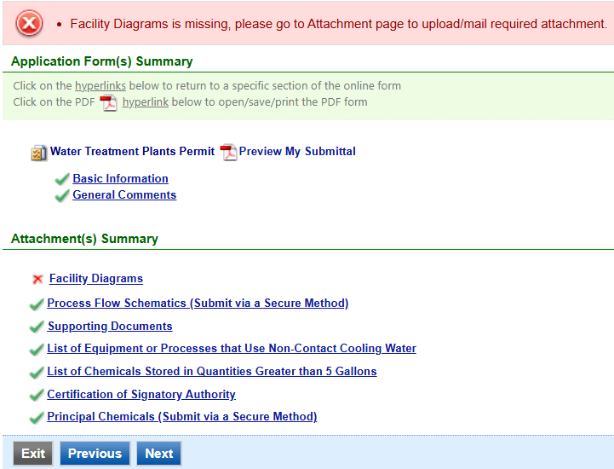
A red “X” indicates that this section of the form did not pass the validation.
To navigate to the error and make corrections, click on the wording next to the red “X.” Make the appropriate changes and save before going back to the validation page. You will not be able to submit the report until the red X is cleared.
A green check mark indicates that this section of the form passes the validation.
After passing all validation checks, proceed to the Submission page by clicking on the blue “Next” button.

Previewing your Submission
On this page, there is a pdf link for you to preview the submission. To view, click on the “Preview My Submittal” link. This will launch a window for you to view your submission.
Note: Viewing this pdf not mean that you have submitted the form. Look over the form but do not save a copy of the preview. When the form is successfully submitted, you will receive a final signed pdf version of the form via email.
After passing all validation checks, proceed to the Submission page by clicking on the blue “Next” button.

Submission
Only users with the account type Responsible Official (RO) can certify, sign, and submit reports using the online reporting system.
Consultants – If you are signed under an account type Consultant, you will see a green button “Notify owner ready for review and submittal.” Click on the button and an email notification will be sent to all Responsible Officials for this submittal stating that the submittal is ready for their review and submittal.
The Responsible Official must locate the submittal under the “Edit Pending Submittals” option from the “Submittal” tab on the home page. For instructions on how to find the submission, go to the “Editing an Unfinished Submittal” instructions to complete the submittal.
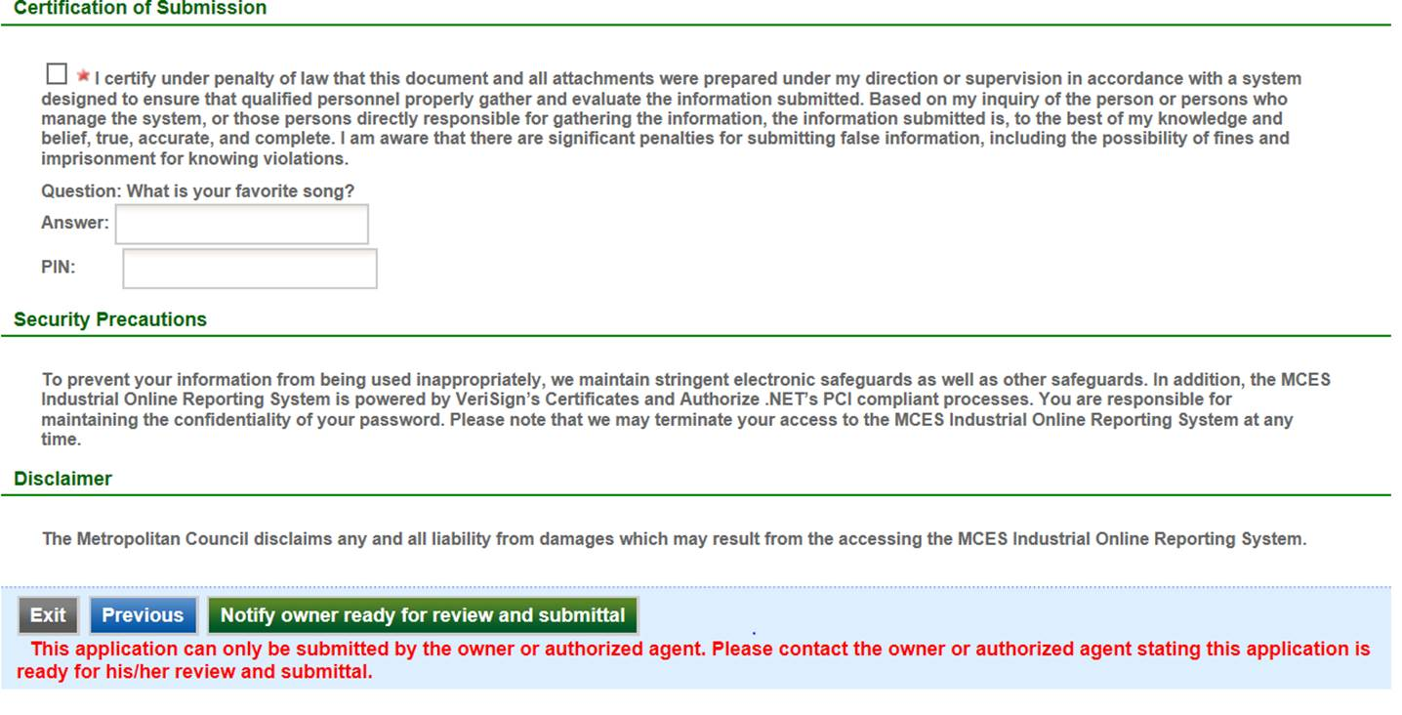
Responsible Officials – If you are signed in under an account type Responsible Official you can complete the submittal.
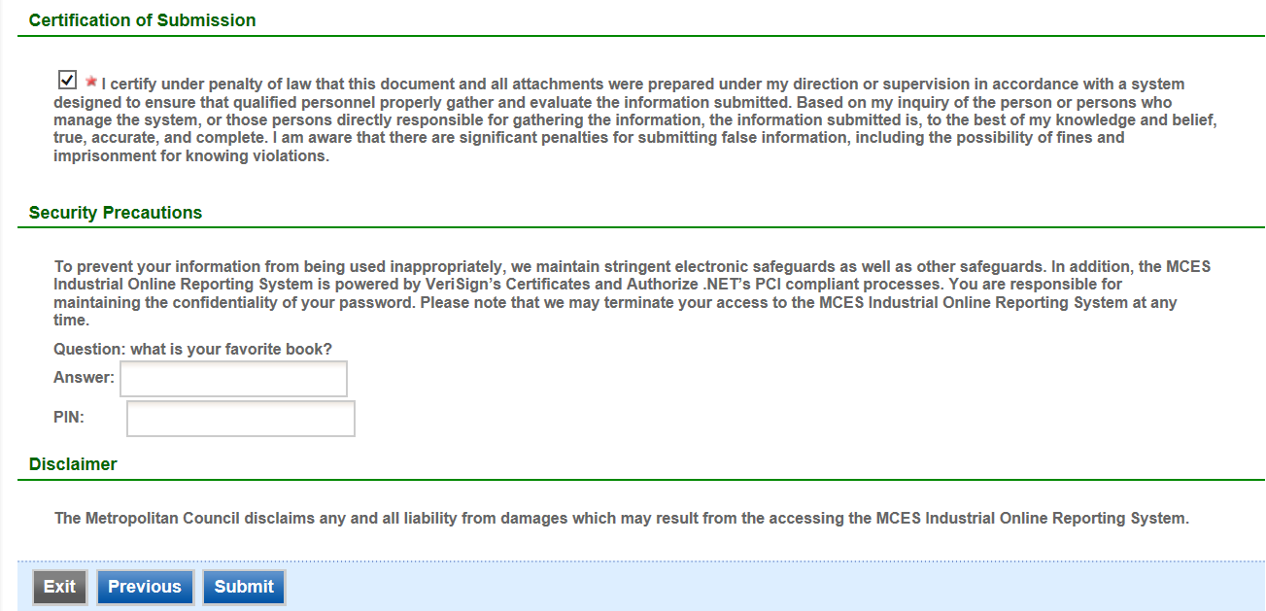
Please read through the certification statement and check the box.
Answer the security question and enter your PIN number in the appropriate boxes.
If you forgot your security question or PIN, hit exit and go to My Account. You can reset your security question answers and request a new PIN. After you have made changes, go back to the submittal to complete the submission process. For instructions on opening an unfinished submittal, see section Editing an Unfinished Submittal.
Click on the blue “Submit” button at the bottom of the page to submit the Permit Renewal Application.

Copy of Record
After submitting the Permit Renewal Application, you will see a Copy of Record (COR) receipt. The COR includes information on who submitted the form, which form was submitted, attachments, etc. You will also receive an email that includes this information. The email includes an Adobe Acrobat pdf file of the submission for your records.
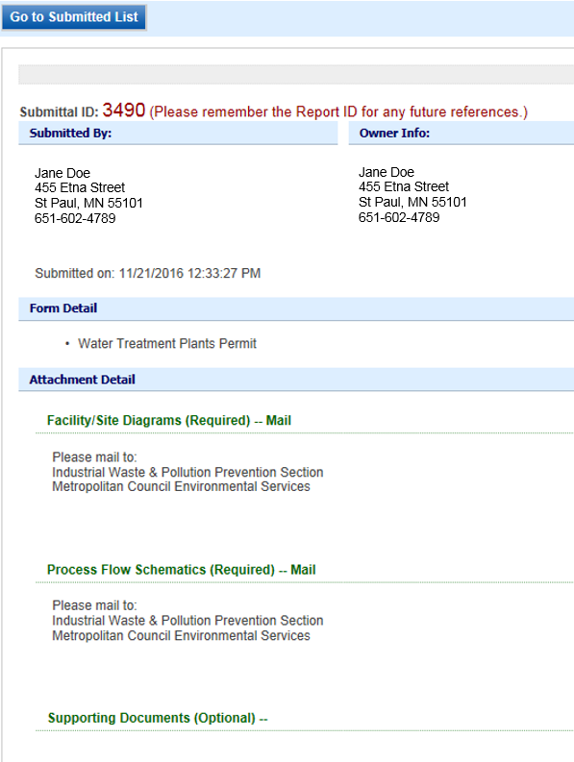

Viewing Submittals
From the home page, hover over the “Submittal” tab and select “Manage Submitted Cases.”
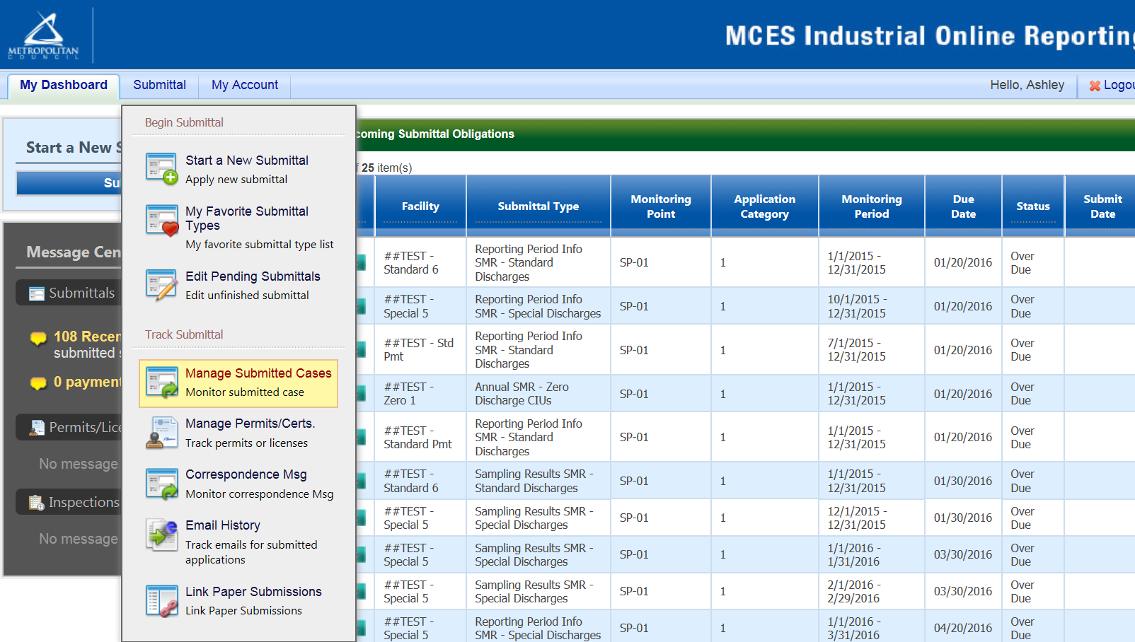
The grid view under the “Submittal List” shows details about the submittal, submitted date, review status, and monitoring period. The Status types are:
- Complete Submittal – Report has been submitted by the Responsible Official.
- Partial Submittal – Report has been submitted by the Responsible Official, however, the user designated that they would mail in an attachment rather than submitting the document online.
- Approved – Report has been accepted by the Metropolitan Council and is under further review.
- Revision Archived – You or the Metropolitan Council has requested a revision on the submittal.
To view a submission, click on the yellow “View” button.
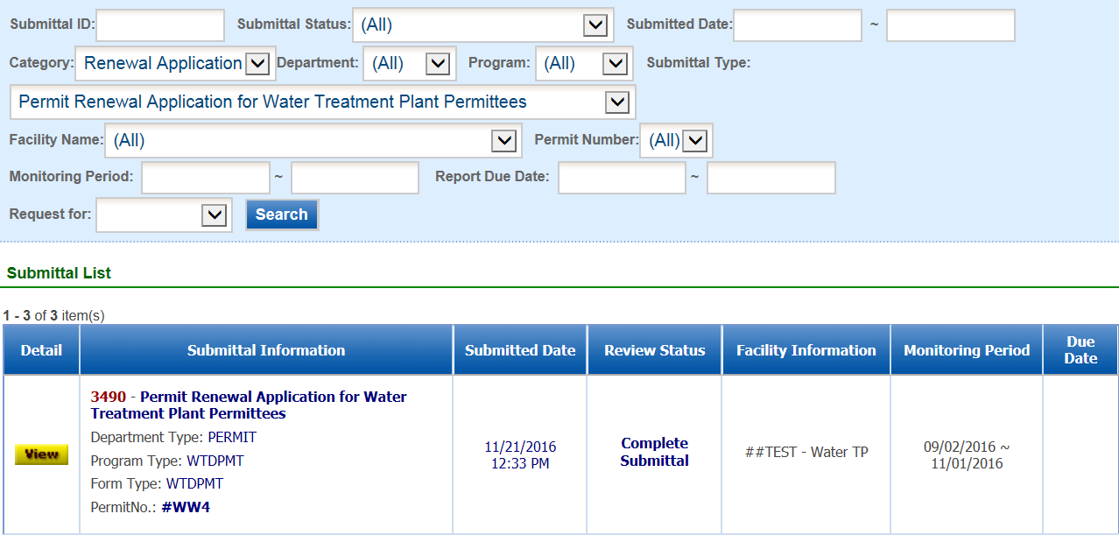

This page displays the basic information about the submittal with tabs to click on for further information.
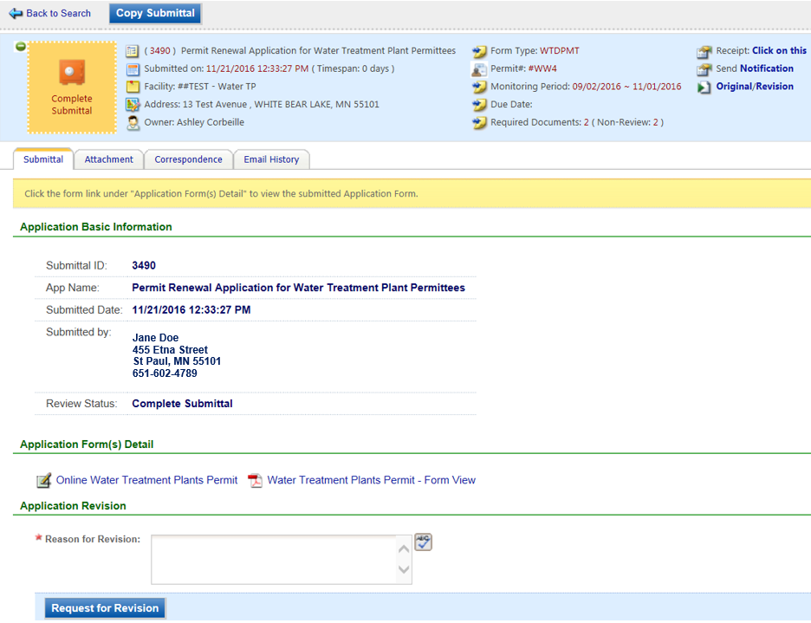
Submittal Information Tabs
- Submittal – for viewing the submission in an online form or an Adobe pdf file.
If you found an error in the information submitted and would like to resubmit, enter in a reason in the box provided under the heading “Application Revision” and click on the blue “Request for Revision” button. See “Editing a Completed Submittal” for further instructions.
- Attachment – for viewing documents that you attached to the submittal. If you choose to mail in the documentation, please mail to:
Industrial Waste & Pollution Prevention Section
Metropolitan Council Environmental Services
390 Robert Street North
St Paul, MN 55101
- Correspondence – for sending messages to your Industrial Waste & Pollution Prevention permit administrator.
- Email History – for viewing system generated emails that are tied to the submittal. You can click on the icon under the “Detail” column to see the contents of the email.

Editing an Unfinished Submittal
Log into the Industrial Online Reporting System at: metrocouncil.org/IORS
Hover the cursor over the “Submittal” tab and click on “Edit Pending Submittals.”
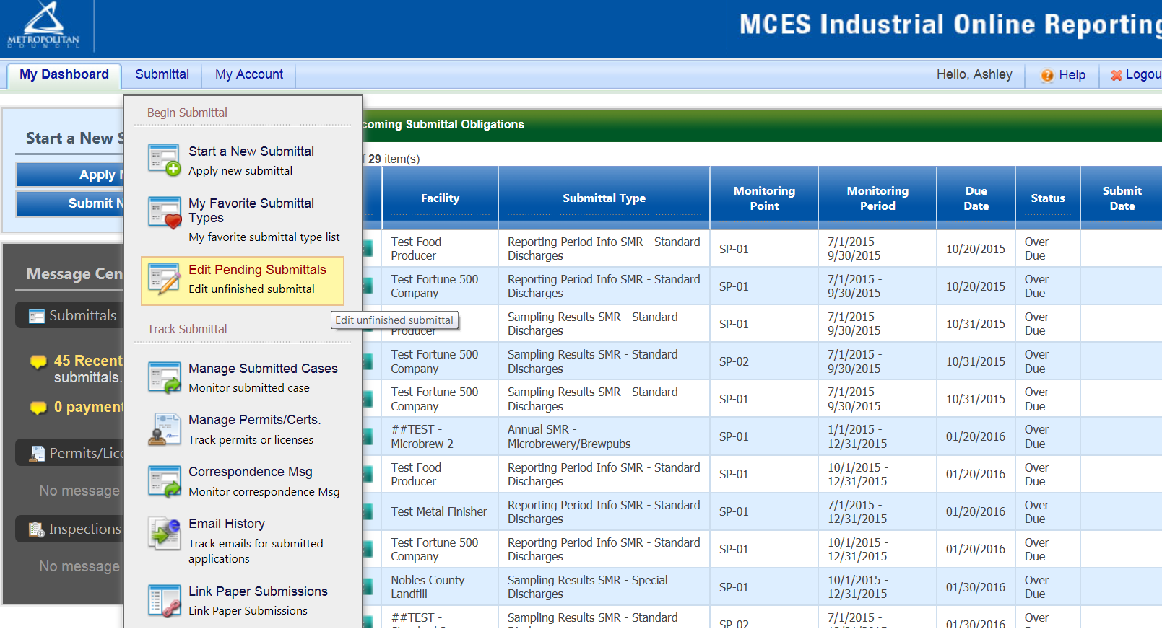
Use the search criteria to locate the Permit Renewal Application for Water Treatment Plants that was previously started.
Note: Click on the blue “Search” each time you make a change to the search criteria. The search feature only updates when this button is pressed.
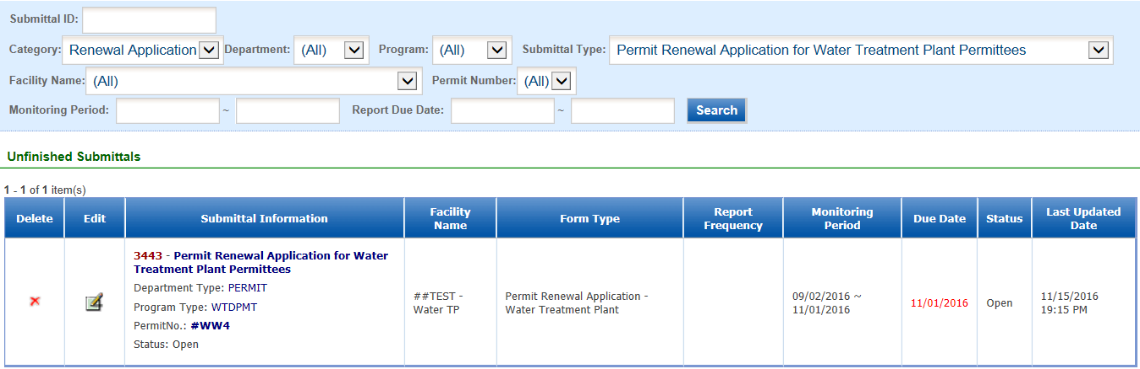
To open the unfinished submittal, click on the “Edit” button (pencil and paper icon). Proceed to the Completing the Permit Renewal section.

Editing a Completed Submittal – Request for Revision
Once you have made a submission, you will need to send a Request for Revision to the Metropolitan Council to make changes.
From the home page, hover over the “Submittal” tab and select “Manage Submitted Cases.”
Use the search criteria to find the submittal that needs revision.
Note: You will only be able to request a revision online if the Metropolitan Council has not yet reviewed and accepted the submittal (Review Status is Complete or Partial Submittal). If the submittal has the Review Status of “Approved” you will need to contact your Industrial Waste & Pollution Prevention permit administrator to make changes.
Click on the yellow View button adjacent to the submittal you want to edit.

From the “Submittal” tab, under the heading Application Revision click in the “Reason for Revision” box and provide an explanation for the revision. Click the blue button Request for Revision. This will send an email message to the Metropolitan Council.

The Metropolitan Council will review the request and send the User an email message approving or denying the request.
If the request is approved:
- log into the Industrial Online Reporting System
- hover the cursor over the “Submittal” tab and click on the “Edit Pending Submittals”
- search for the submittal with the status of “Revision” and click on the edit button
- make the change and resubmit the report
Note – The submission with the status of “Revision” is the exact copy of what you previously submitted.

